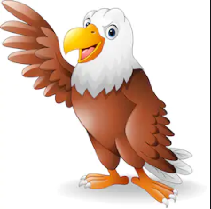
Grammar
Noun phrases
Adjective
Verbs
Adverbs
Pronouns
Prepositional Phrase
SMSC
New beginnings
Recognise self-worth
Seeing mistakes and making amends.

History
Stone age settlements
Ordering events
Stone Age diet
Computing
E-safety

DT
Design and make a woolly mammoth
Geography
Maps
Rocks
Science
Rocks - Types of rocks
- Grouping rocks
- Fantastic fossils
- Mary Anning
Times Tables
Review of 2,5,10
3 and 4 times tables

Cave drawings
Spelling
Revision of common exception words
I sound spelt y
U sound spelt ou
Music
Composition of music – soundtrack for Stone Age hunters and gatherers.
Golden Eagles
Term 1
Stone Age
Maths
Place value
Addition
Subtraction

English
How to wash a woolly mammoth (book)
- Stone Age Boy (book)
-Story settings
-Poetry – I was born in the -Stone Age.
-instructional writing

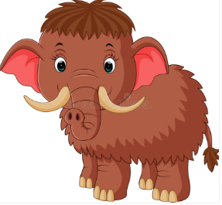
P.E
Tri-golf
R.E
Christianity
Faith and belief in action.
Community expression.

