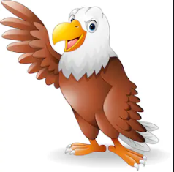
Cave painting to tell a story using own paint and paintbrushes.
Maths
Multiplication
Division
Money

Science
Electricity
- Circuits
- Circuit diagrams
- Conductors and insulators
- Switches
Grammar
Clauses
Subordinating Clause
Relative Clause
Commas
Bullet Points
Sub-Headings
Paragraph
SMSC
New beginnings
Recognise self-worth
Seeing mistakes and making amends.

English
The Wild Way Home (Book)
-Drama
- Non- Chronological report (the Stone Age people)
-Newspaper report (the first farms)
-Diary entry (Christmas – The naughty Elf)

Computing
Create PowerPoint presentation
Research

DT
Design and forage to make your own paint and paintbrush

Geography
Flint, copper and bronze
Spelling
Revision of common exception words
Homophones
Music
Stone Age rhythm
Golden Eagles
Term 2
Stone Age

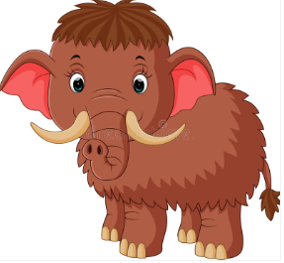
History
Stone age people
Bronze Age
Iron Age

Times Tables
Review of 2,5,10
3, 4 and 6 times tables

R.E
Christianity
Faith and belief in action.
Community expression.

P.E
Gymnastics

