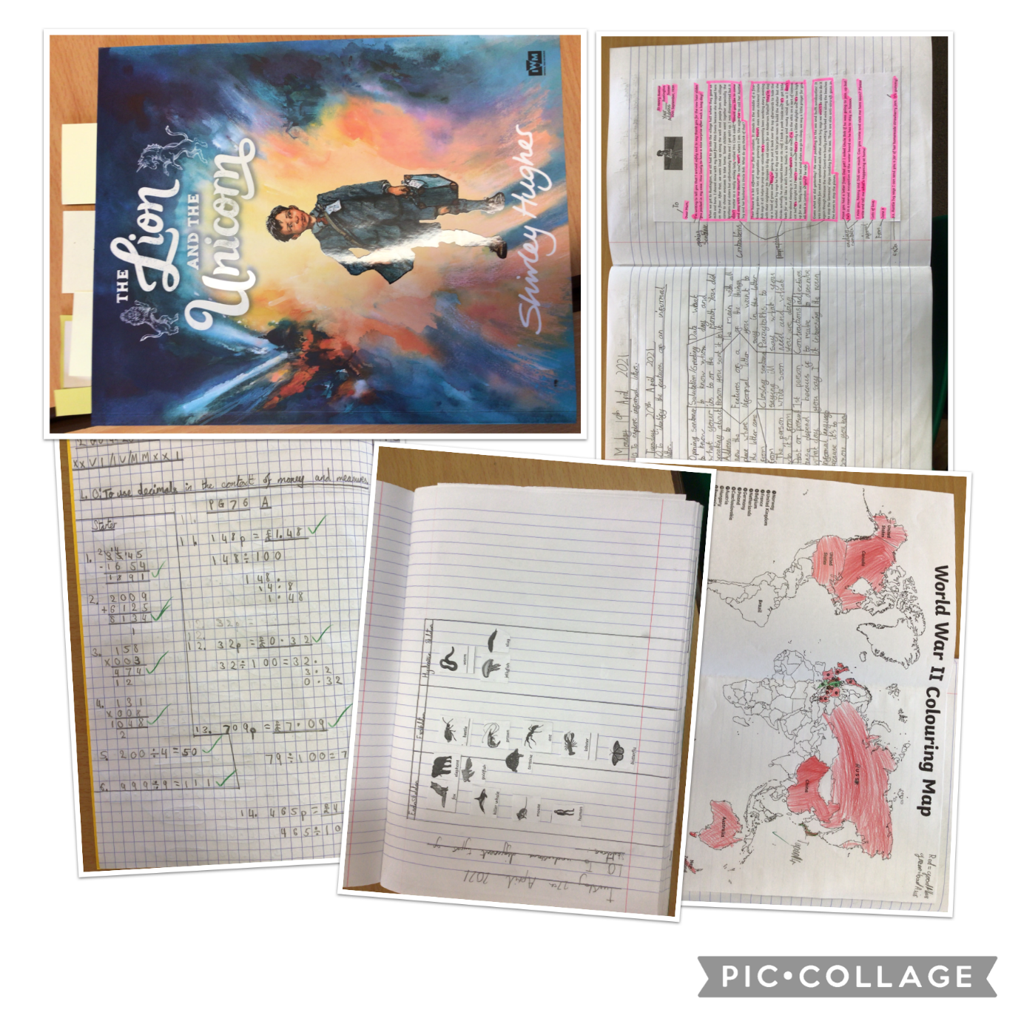
Golden Eagles Class
We are so impressed with Golden Eagles class this week, they have worked so hard as always. In Guided Reading, we have continued to focus on The Lion and the Unicorn, and looking at inference skills. In English, we have been focusing more on informal letters and the features, including grammar features such as adjectives and past/present tense. In maths, we have continued to learn about decimals, looking at putting them in order and also placing them on number lines. In science, we have learned about different types of skeletons and we discussed what the pros and cons were of each of these. In topic, we looked at the outbreak of WWII. We coloured in a map according to which countries were allies and axis powers.

