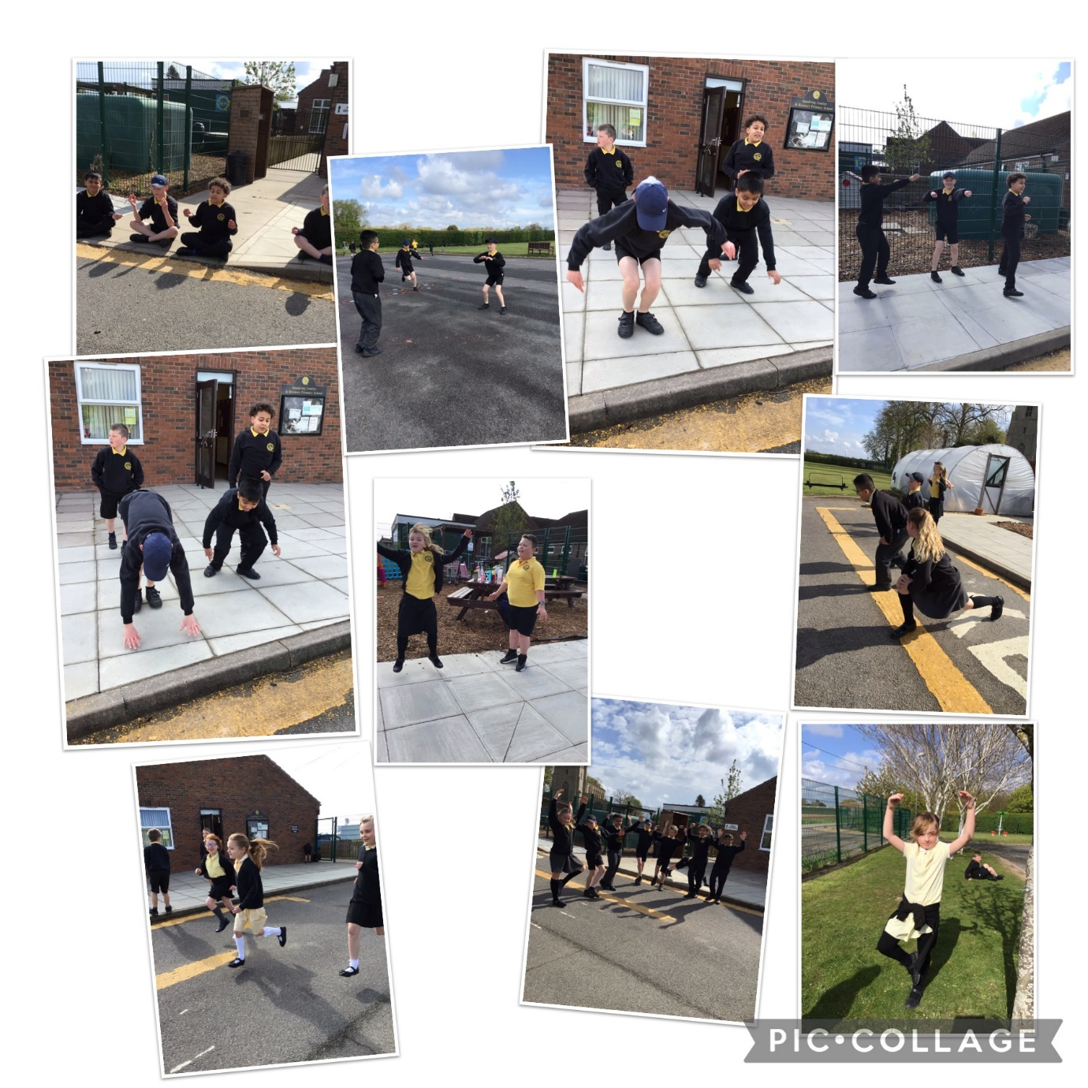
Captain Tom 100 Challenge – Golden Eagles
The children were set the challenge of completing 100 of an exercise of their choice. They thought of many different ideas and had no access to equipment, so we were very impressed with what they thought of! The children also had the choice of completing a chosen exercise for 100 seconds. The children really enjoyed getting active. Great work Golden Eagles!

