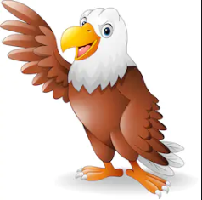
Spelling
Pre-fixes
Un
Dis
Mis
Re
Common exception words
SMSC

Grammar
Fronted adverbials
Commas for lists
Past and present tense
Determiners
Prepositions
Headings/
subheadings
Computing
Internet safety
Science
Forces and magnets
Pushes and pulls
Faster and slower
Magnet strength
Magnetic poles

Times Tables
Recap 2,3,4,5,6 and 7
Learn 8 and 9
Mola painting
Music
The Moldau- Bedřich Smetana

English
Pongo (book)
The Great Kapow Tree
-Create a story based on the pictures in the book Pongo.
-Pongo Character description
- persuasive writing (deforestation)
- Travel Boucher
Maths
Measure; Length & Perimeter
Mass and Capacity
Time

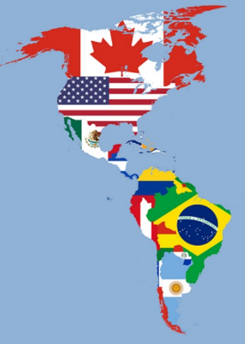
Geography
Continents countries and cities. (atlas work)
Layers of the rainforest
Orang-utan factfile (Pongo)
Position (longitude and latitude)
DT
Sculpture – Mount Rushmore

History
Development of American History

Golden Eagles
Term 3
North and South America
P.E
Gymnastics
R.E
Pilgrimage

