Thursday Home learning tasks
English Task
Todays task is to write your fact file. This can be complete on the computer or by hand. Think about your layout and presentation.
Grammar Activity
Prepositions (see video)
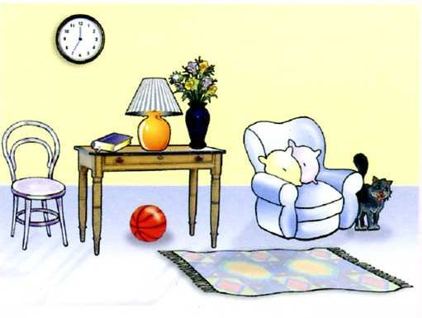

Can you write 6 sentences to include a preposition and adjectives. Can you underline the prepositions you have used?
Example: The black cat is stood beside the comfortable armchair.

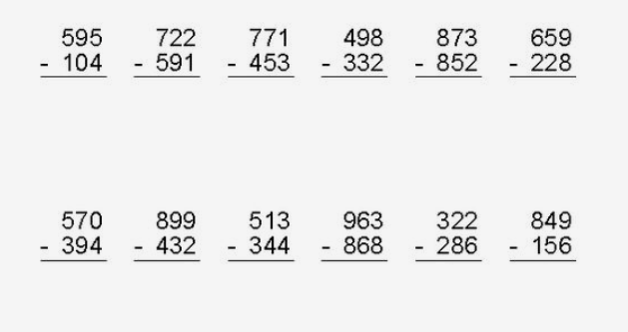
Maths Starter Activity

Main Task
Year 3: To solve word problems involving time page 95
Please continue with your learning from yesterday on page 95. There is an additional extension task on todays learning page if required.

Year 4: To solve problems involving time page 108
Please work from page 108 in your Target Maths book

Topic
Please complete your spelling test using the spellings from Monday.

P.E (see video)
Todays PE task is to think about what we have learned this term about yoga and try to create your own 15minute yoga session!
You could – write your own Yoga story
- Create your own yoga sequence

