Tuesday Home Learning Tasks
English Task

Todays lesson is to plan a fact file about St Lucia, using your research and the information provided.
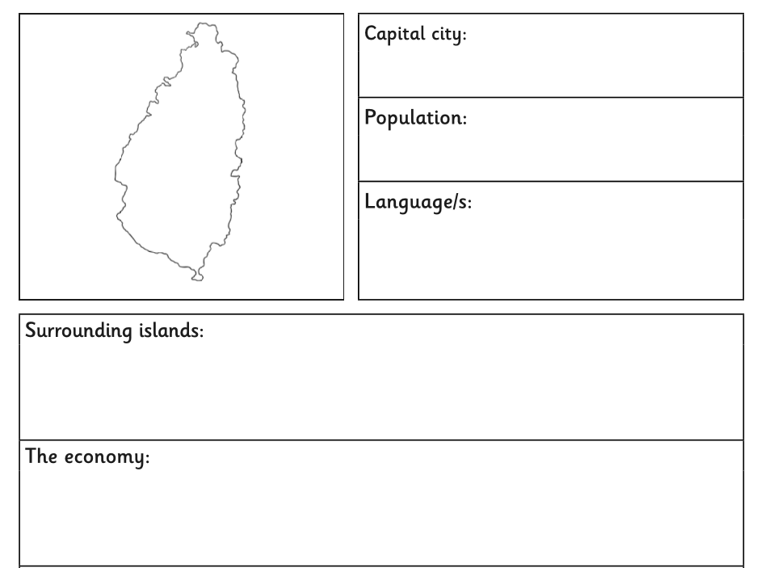
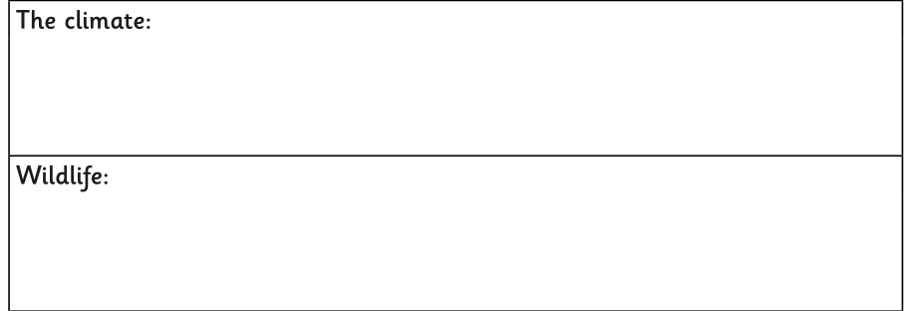
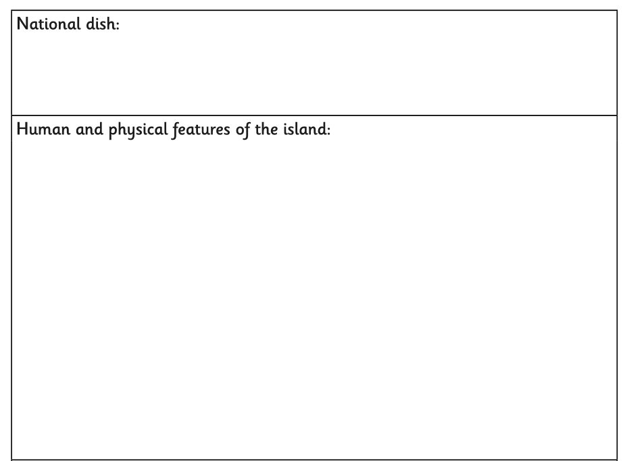
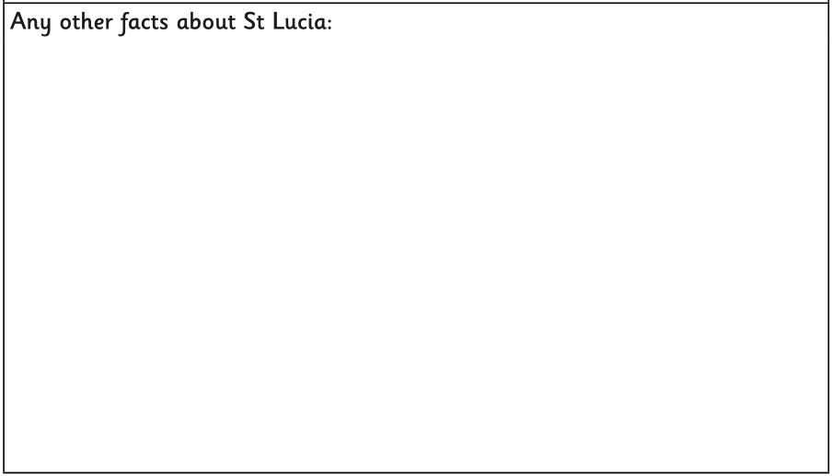

Maths activity
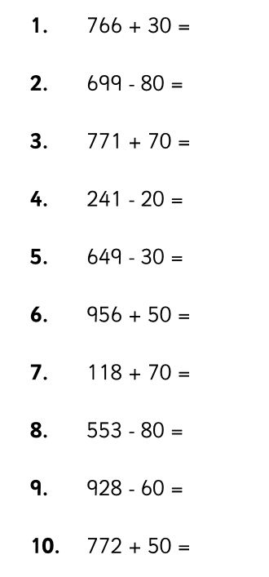
Starter task – adding multiples of 10 (try to do this mentally)

Main Task
Year 3: L.O To use information in a table to calculate length of time (page 94)
Please continue to work from page 94 continuing on from where you got to yesterday. There is also an extension task available on the class page for this week’s learning.

Year 4: To solve problems converting between units of time page 106 (see video)
Please complete page 106 in your Target Maths book starting with A.

Topic
Today is Safer Internet Day. Please watch the BBC Teach lesson on Safer Internet and complete the activity. The link for the lesson and activity can be found on today’s learning page. This lesson is also playing live at 11am on CBBC.

