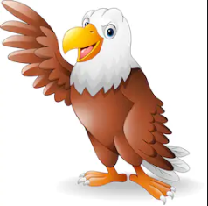
Grammar
Expanded noun phrases
Progressive tense
Perfect tense
Time, place and cause conjunctions, adverbs, and prepositions

English
The Lion and the Unicorn
-Informal letter writing (to mum)
-Comprehension – 5-parts of the story.
- rewrite Lenny’s escape story ending.
My Secret War Diary
Diary entry
Propaganda posters
Recount of events

SMSC
Family tree (My Secret War diary)
It’s my body

Science
Animals, including humans
- Think about food
- What is a balanced diet?
- Skeletons and bones
- Moving muscles
The War Horse
Silhouettes
Henry Moore
Maths
Decimals
Position & Direction
Area

Computing
Animation
Geography
Key Locations
Mapwork
Spelling
-sure
-ture
-sion

Music
Vera Lynn
Become a WW2 D.J
Golden Eagles
Term 5
World War II

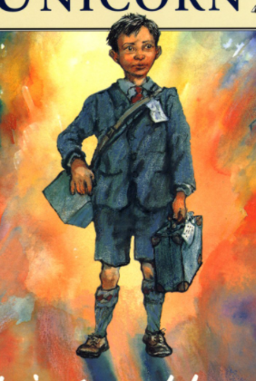

History
-The outbreak of war-The blitz
Holocaust

Times Tables
Recap all times tables and concentrate on recall speed
DT
War time recipes- meal plan.
Design a suitcase that reflects personal identity.
R.E
Big Questions
P.E
Orienteering

