Friday Home learning Tasks
English Task
Your task today is to edit and complete your fact file using the editing skills we have looked at this term.

Reading Task
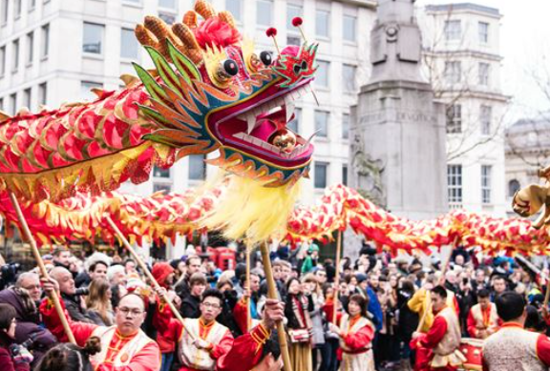

Please use the picture to write sentences for the following:
- 3 I can see sentences
- 3 I think that sentence
- 3 I know that sentences
- 5 questions you would like answering about the picture.

Maths
Starter activity
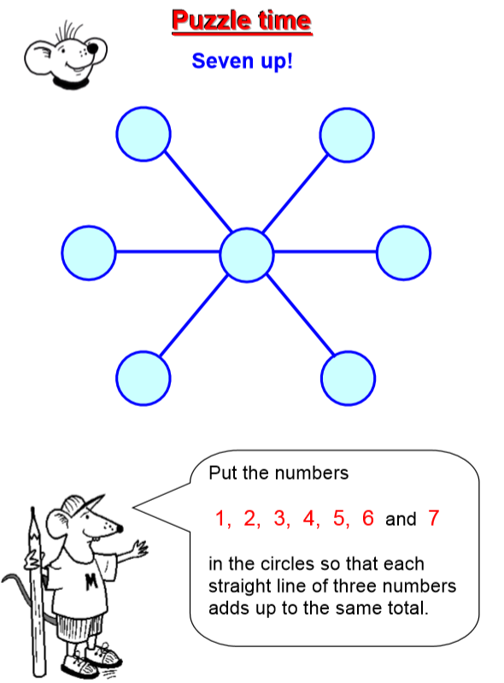

Main task
Year 3: To solve problems involving time page 96
Please complete page 96 in your Target Maths books starting with A.

Year 4: To solve problems involving time page 109
Please complete page 109 in your Target Maths book starting with A.

Topic
Computing
Please log in to your PurpleMash account and complete the 2do’s that have been set. You have two tasks to complete. The first is to write about Chinese New Year by using your researching skills and safer internet knowledge.
The second task is to design your own Chinese New Year’s Lantern.

