Monday Home learning Tasks

English (see lesson video)
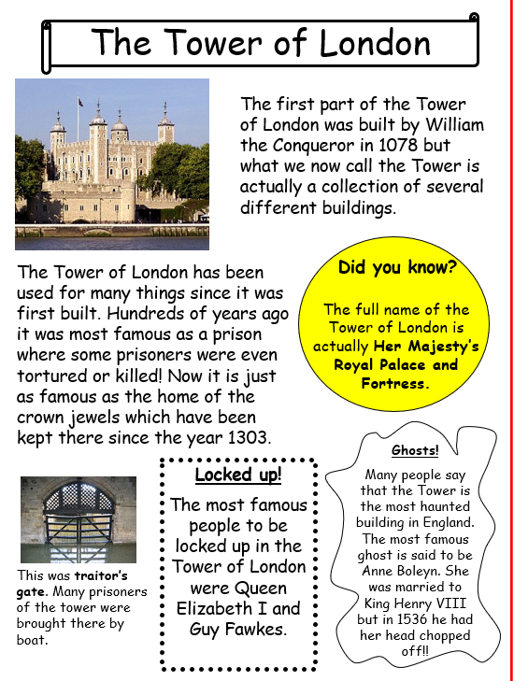
This week for English we are going to be writing a non-chronological report in the style of a fact file. In today’s lesson we are going to be identifying the features of a fact file. Below are two example of fact files. Your task is to read and compare the text to see if you can find the features. You have underline, highlight or circle the features you find.

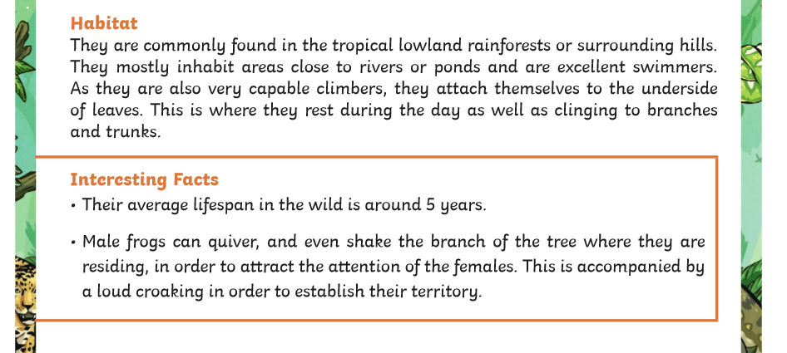
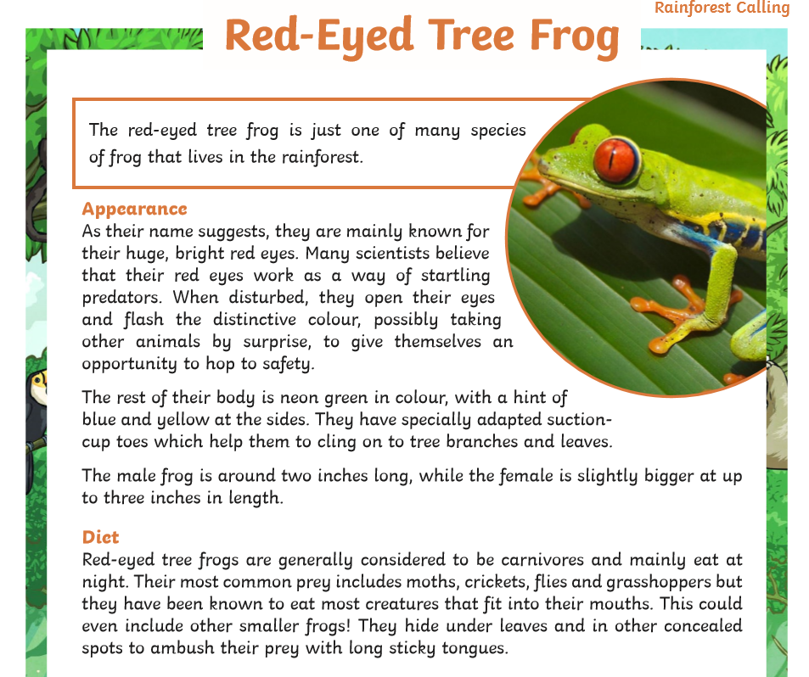

Maths activity
Starter activity – measuring capacity
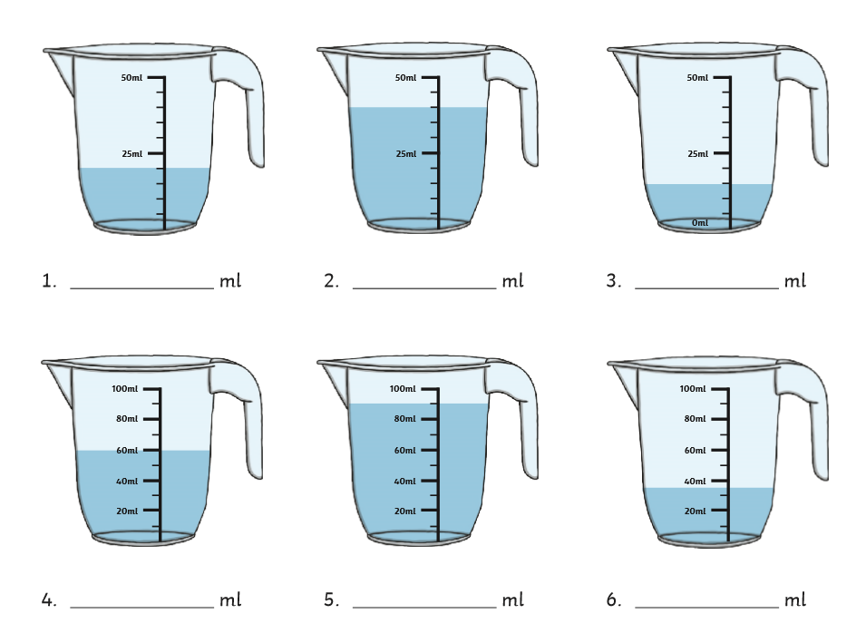
Main task
L.O. To use information in a table to calculate length of time (see video)

Please complete page 94 from the year 3 Target Maths book. Year 3 please complete section A.
Year 4 please complete section b (copy of the page can be found on the webpage).
Spelling
Please practice your spelling using the spelling menu using the words below.
- misbehave
- mishear
- mislead
- misplace
- misread
- misspell
- misunderstand
- misuse
- misadventure
- miscalculate
- misfortune
- misinform

Topic
We are learning about the Caribbean today, please watch the lesson video and use the information sheet to complete the following task.


