
SMSC
Understand refugee from the past and present
One World

Grammar
Clause/phrase difference
Subordinate clause
Word families
Standard English

Science
Animals including humans
The digestive system
Types and functions of teeth
Tooth decay
Food chains

English
My secret war diary
Spywatch
Letters from the lighthouse
Balanced argument
Drama- Evacuee day
Newspaper reports – The Blitz
Poetry – Wilfred Owen

Use colours and blending to create camouflage
Maths
Recap term
Shape (2D/3D)
Measure & Length
Money
Time
Computing
Hardware investigators
Geography
Movement of troops – Compass skills
Spelling
Recap key words and spelling patterns including common exception words.
Music
Call and repeat songs
Golden Eagles
Term 6
World War II

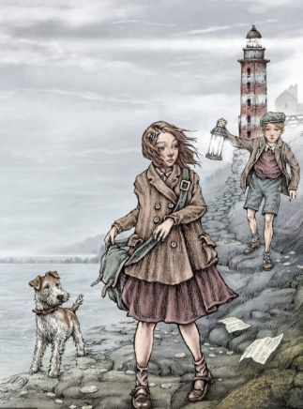
History
- Local effects
-Living in war time
- Holocaust
- The role of women

P.E
Sports day practice/ activities
R.E
Big Questions
Times Tables
Recap all times tables
Problem solving and word problems
DT
Design and build an Anderson shelter.

