Wednesday Learning Activities
English Activity (see video)
Today we are using our fact file plans to draft our ideas into clear sentences and paragraphs.
You can use the template below or create your own. Make sure you include the features of a non-chronological report and use sub-headings.
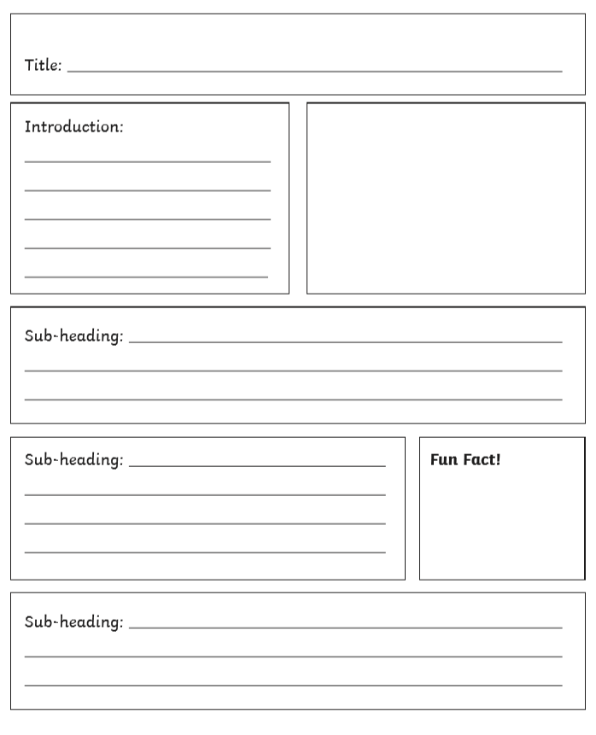
Reading task


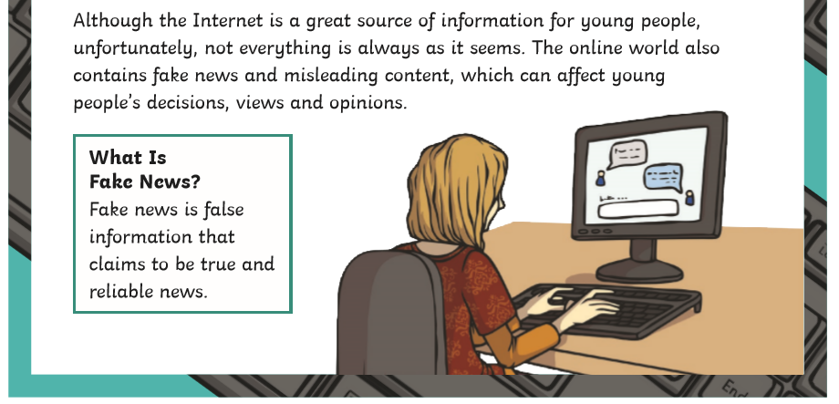

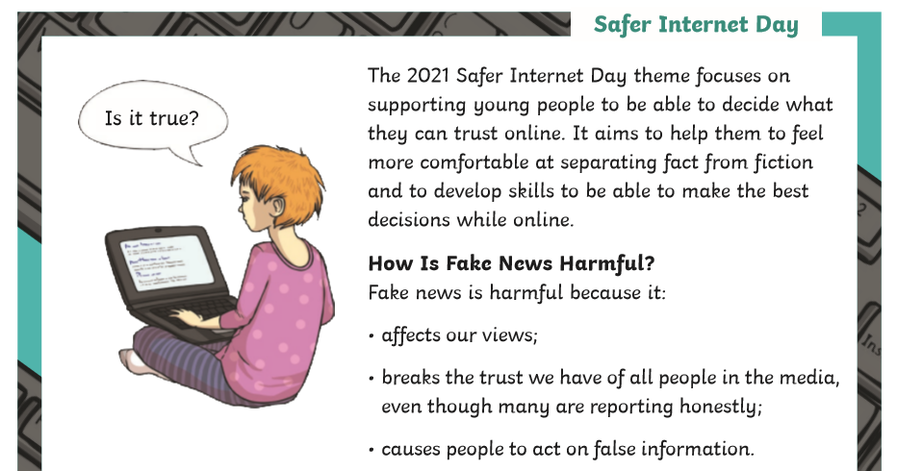
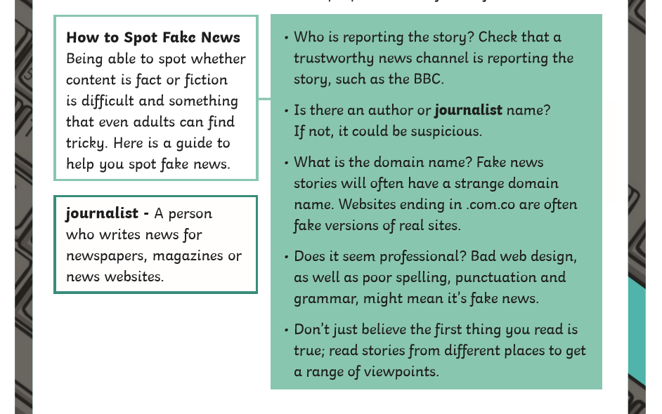
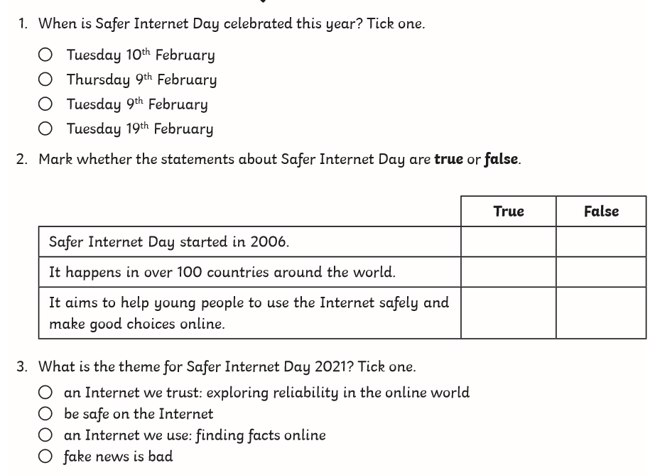

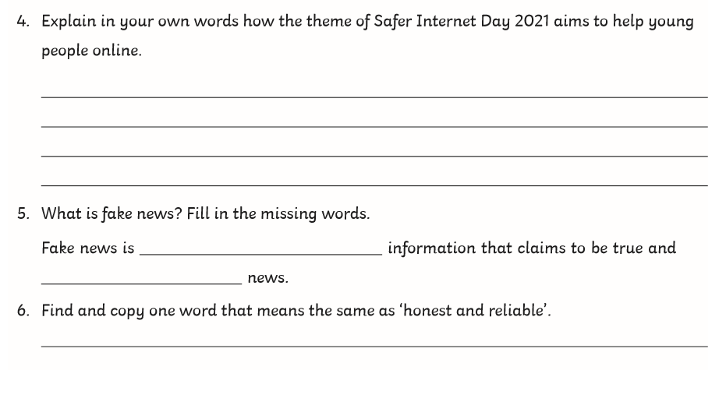

Maths
Starter Activity
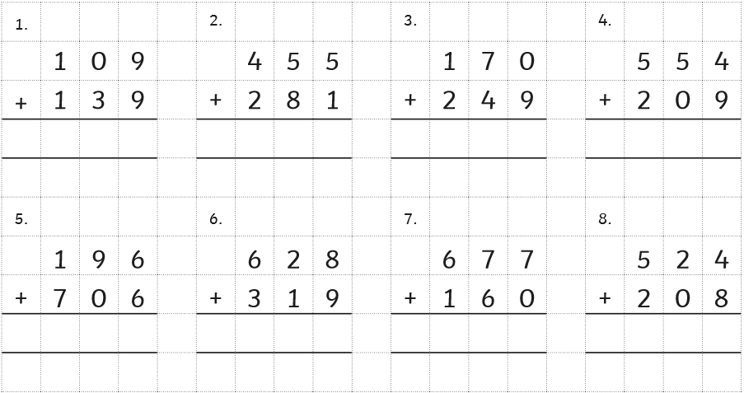

Main Task (see video)
Year 3: To solve time problems page 95
Please complete page 95 in your Target Maths books. Remember to take your time and read the question carefully. Use your RUCSAC

Year 4: To solve problems converting between units of time page 107
Please complete page 107 in your Target Maths books starting with B

Topic
Today we are learning all about longitude and latitude
Please watch the lesson video and complete the task below.


