Thursday 25.2.21
English Task
Now you now everything there is to know about postcards, you can write up your neat version of your postcard. Remember to look back and make sure you have included all the features.

Reading Task
Please complete Thursday’s questions from the PowerPoint of Meerkat Mail.

Maths
Starter
Match the times in words to the analogue clocks.
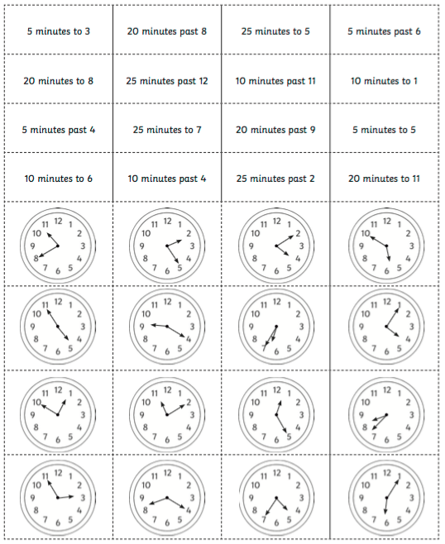

Main Task
We are continuing to learn about bar charts. Year 3 please complete page 126 and Year 4 please complete page 128 in your target maths books.
Spellings
Use the sheet below to practice your spellings. A grown up could test you on them too!

Look, Say, Cover, Write and Check!
Tick the columns as you follow the instructions from left to right. Make sure you spell the words in the ‘write’ column. If you spell the word incorrectly, write it again in the correction column.
 | look | say | cover | write | check | correction
refill
reform
Refresh
repay
replace
repay
return
reuse
revisit
redo
refresh
react

PE
Please use the links below to complete for your PE session. You can choose one or have a go at as many as you like!
https://www.youtube.com/watch?v=ke04O2ma7eI
https://www.youtube.com/watch?v=4dPXtS1aUII

https://www.youtube.com/watch?v=kRw6sGwN4U4
https://www.youtube.com/watch?v=LhYtcadR9nw

