Friday 26.2.21
English Task
Now you are going to complete, edit and improve your postcard. Please check and make sure you have all of the following features as this will make an excellent postcard:
Reading Task
Please complete Friday’s questions from the PowerPoint of Meerkat Mail.

Maths
Starter
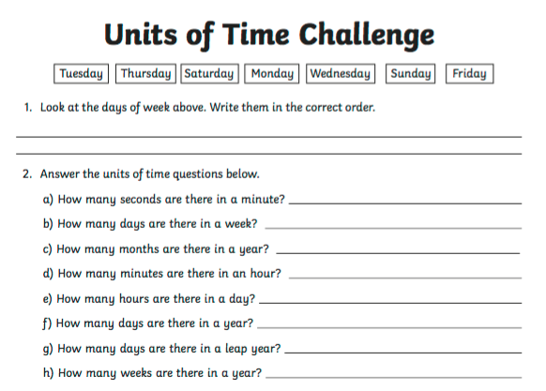

Main Task
We are continuing to learn about bar charts. Year 3 please complete page 128 and Year 4 please complete page 136 in your target maths books.
Grammar (see PowerPoint on inverted commas)
Please look through the PowerPoint on inverted commas, and then write out a conversation you would have with someone about your pilgrimage to India, using inverted commas correctly to punctuate the speech.
For example:
“My trip to India was incredible, it was sweltering and I had to make sure I didn’t go out at midday as it was so hot” explained Miss Paul.
“Wow that sounds interesting, did you visit any interesting places?” asked Mrs Wilson.
PSHE
Please see PowerPoint, then complete the Pyramid of Priorities below.

