Tuesday 23.2.21
English Task
Plan a postcard based on a pilgrimage to India. Use the template below to plan a postcard based on a pilgrimage to India (from yesterdays learning). Remember to use all the features we looked at in English yesterday.

Reading Task
Please complete Tuesday’s questions from the PowerPoint of Meerkat Mail.

Maths
Starter
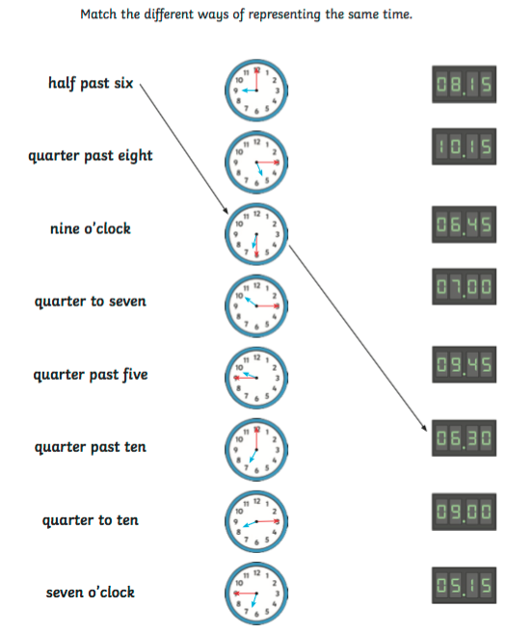

Main Task
We are continuing on our new topic of interpreting data from pictograms. Year 3 – please complete page 120 in your target maths books, year 4 please complete page 126 in your target maths books. You can re-watch the video from yesterday if you need a reminder of how to interpret data from a pictogram.

Times Tables
Please complete the sheet below to practise your times tables.
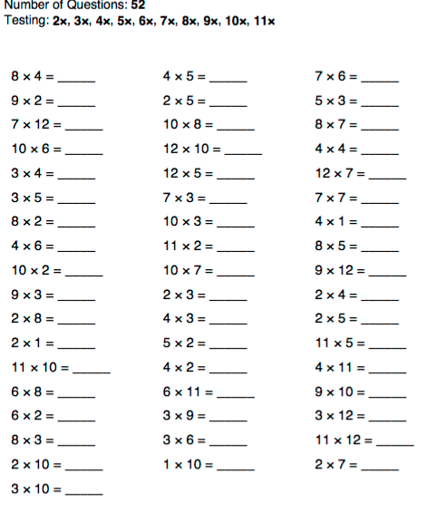

Science – Parts of a flower (see video)
Please watch the video on parts of a flower and then have a go at creating your own flower using card (or paper) and cotton ear buds. See below picture for an idea of what yours should look like.


