Monday 22.02.21
English Task (see video)
This week we are going to be writing a postcard linking to our R.E. learning.
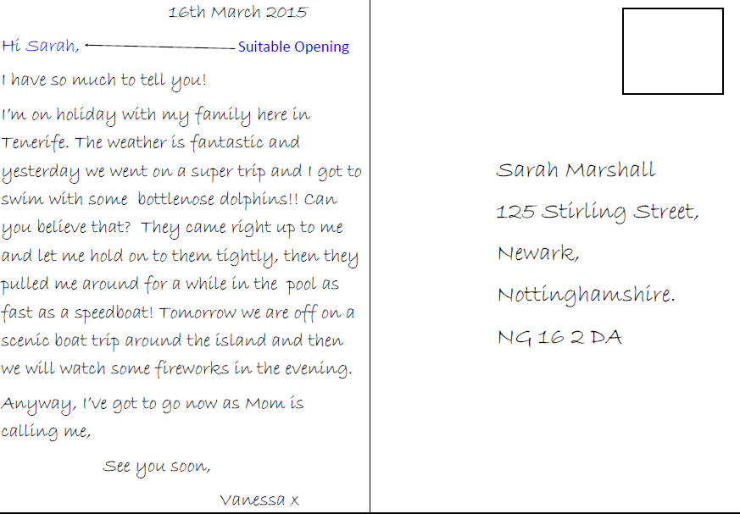
Today you are going to identify the features of a postcard. Have look at the postcard below and see if you can identify what the features could be.

Reading Task (see video)
Please see separate PowerPoint document and video for this weeks reading tasks on Meerkat Mail. There are questions for each day of the week set out on the PowerPoint (please note – you do not need to print this).

Maths
Starter
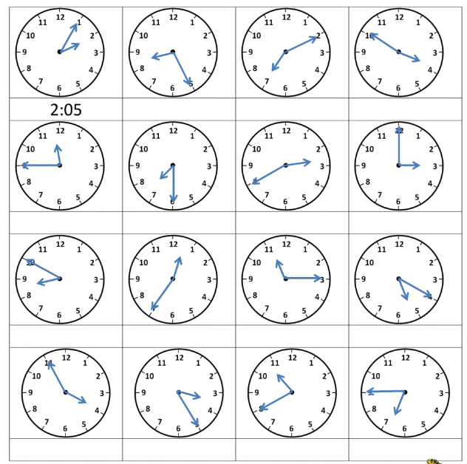

Main Task (see video)
We are starting a new topic on statistics for today’s lesson please complete page 118 in your Target Maths books (Year 3) Year 4 children please see additional sheet.

Spelling
1.refill
2.reform
3.refresh
4. repay
5.replace
6. replay
7.return
8. reuse
9. revisit
10. redo
11.refresh
12. react
Please practice spelling using the spelling menu.
Topic
R.E - Pilgrimage (see video)
L.O. To understand why Sikh’s go on pilgrimage to the Golden Temple in Amritsar, India.
Challenge 1
Imagine you have gone on a pilgrimage to India. What would you write home to your family?
Make a spider diagram of your ideas.
Challenge 2
Design a postcard cover (the picture) for The Golden Temple in Amritsar.

