Wednesday 24.2.21
English Task
Draft a postcard based on a pilgrimage to India. Use the template below to draft a postcard based on a pilgrimage to India. Remember to use all the features we have been looking at.

Reading Task
Please complete Wednesday’s questions from the PowerPoint of Meerkat Mail.

Maths
Starter

Main Task (see video)
We are now going to learn about bar charts. Please watch the video and then complete pages in your target maths books. Year 3 – 122 and year 4- 124.

Reading comprehension.
Please read the text below and then answer the questions on it.

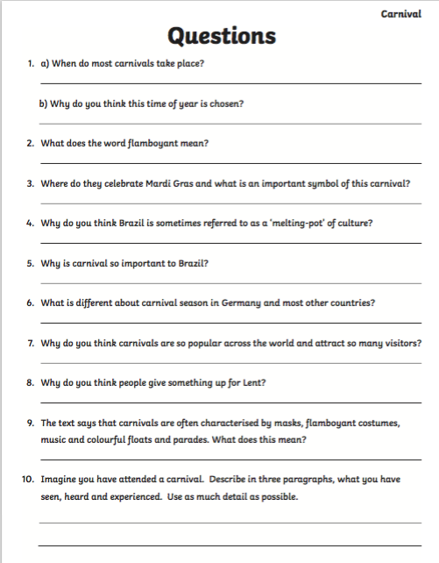

Topic - design a model of Mount Quadring.
We are going to be designing a salt dough model based on Mount Rushmore. Please click on the link below and read the information about Mount Rushmore. You are then going to design your own version using the template below called ‘Mount Quadring’. Think carefully about which faces you are going to put on you design!
https://www.sciencekids.co.nz/sciencefacts/engineering/mountrushmore.html

Mount Quadring Design sheet

This is Mount Rushmore National Memorial on the hills in South Dakota. Based on this, use the box below to design your version of this, named ‘Mount Quadring’.


