Monday 27.01.21
English task:
Think back to when we edited our character description, can you edit your letter to improve your work?
Questions to ask when editing:
- Have I used capital letters/full stops?
- Does it make sense?
- Have I included the features of a persuasive letter?
- Have I used emotive and formal language?
- Have I checked my spelling?
- Could I include any year 3/4 common exception words?
- Have I got enough detail?
- Could I read my work aloud to see if it would persuade them?
The most important questions is……
Is this my best work?

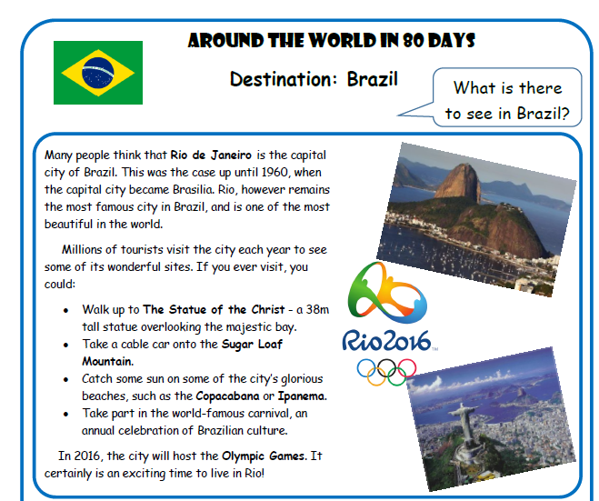
Reading task



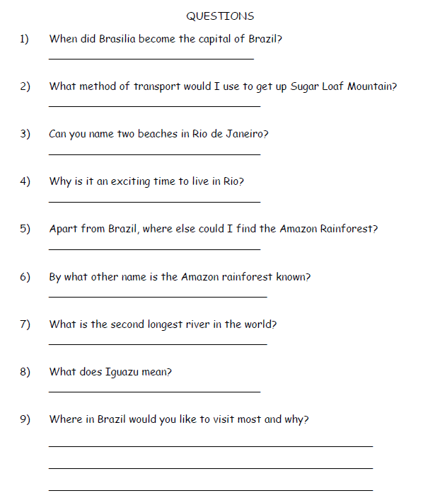

Maths activity

For Math’s we are moving on to learn all about time.
Starter activity
- 12 x 5
- 54 x 6
- 13 x 7
- 85 x 5
- 817 x 4
- 119 x 9
- 251 x 4
- 774 x 3
- 443 x 7
- 185 x 6

Main task
Please watch the video and then complete the following.
Year 3 - Target Maths book (3) page 88 a only
Year 4 – Target Maths book (3) page 89 (b and c) Please see the additional sheet on the class webpage.

Spelling
Please practice your spelling using the spelling menu.
- disorder
- disown
- displease
- disrepair
- disappear
- disbelief
- disbelieve
- disallow
- distrust
- disinfect
- disconnect
- discolour

Topic
As you are aware this week is mental health awareness week so we will be completing slightly different activities for our topic this week.
Today I would like you to watch the video of Mr Hall reading ‘The Beautiful Oops’
We are going to complete an art activity related to the story.

Can you ask an adult or your sibling to make a mark on a piece of paper. This can be anything they want from a scribble to a spill.

Your task is to turn this mark into something beautiful! This can do completed in any way that you choose. I am excited to see what you can come up with!

