Thursday Home learning Activity

English
Please complete the Children’s Mental health Week reading comprehension questions (see additional sheet).

Story telling challenge
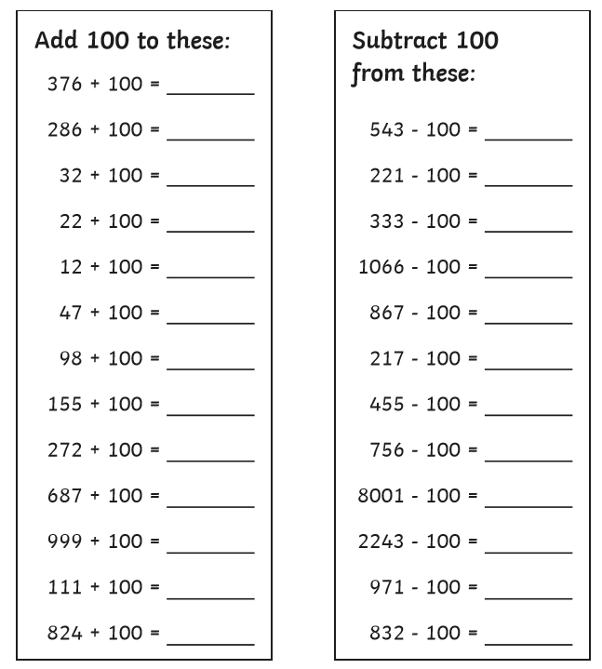
Maths starter activity

Main task (see video)
Year 3 – Please complete page 91 of your target maths book starting on B

Year 4 – Please complete page 105 in your target maths books starting on B

Topic
Please complete your spelling check using the spelling from Monday
Mental health activity
Be active!
Todays task is to get active, you can do this in any way you choose, go outdoors, explore, create an adventure. Other ideas you could do:
- Yoga
- Mrs Luffman’s dance videos
- Joe Wicks
- Mental health week’s get active workout
- Play football/rugby/basketball
- Go noodle
- Take a walk

