Tuesday Home Learning Activities
English
Today’s English task is to write up your letter into your neatest handwriting. Remember to include all of the features and use the correct layout.

Reading activity
The fox and the scorpion

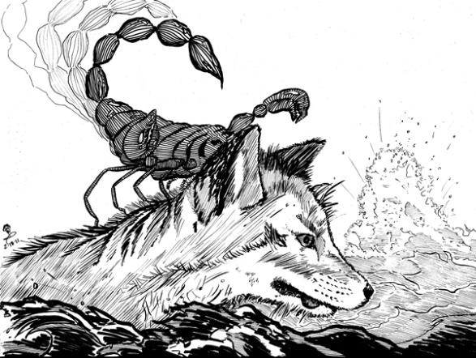

The forest was on fire and all the
animals swam across the river to
escape the fire.
The scorpion could not swim
and begged the fox to help
him.
“Please take me across the river on your back – or I will die.”
“I am not a fool” said the fox “you will sting me and I will drown”
“No” replied the scorpion “I promise that if you help me – I will not sting you – after all, if you drown then so will I”
“Okay” the fox agreed, and the scorpion climbed on his back.
Halfway across the river, at the deepest part – the scorpion stung the fox.
“Why did you do that” the fox shouted.
“I just couldn’t help it” cried the fox as they both drowned. “It’s just my nature!”

- Why were the animals swimming across the river?

- Why did the scorpion ask for help?

- Why was the fox worried?

- How did the scorpion get the fox to help him?

Challenge questions: What is the real meaning of this story?

Maths starter activity:
Revision of division

1. 90 ÷ 5
2. 104 ÷ 4
3. 98÷ 7
4. 72 ÷ 3
5. 360 ÷ 8
6. 294 ÷ 7

Main activity
For maths we are continuing our learning about time. (see video)

Year 3: Please go to your Target Maths books and complete page 89 starting with b.
Year 4: Please use the additional sheet and start with section b.

Topic
Please have a go at completing the 9 times tables worksheet then complete your times tables check.

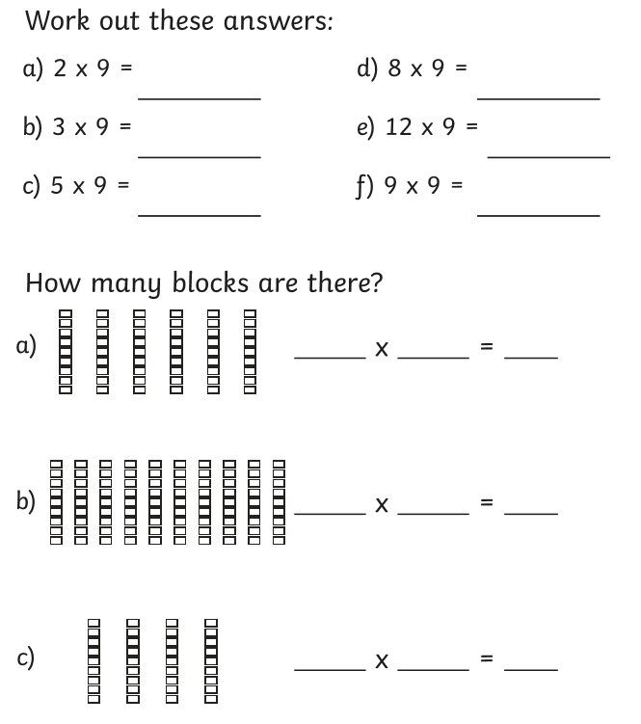
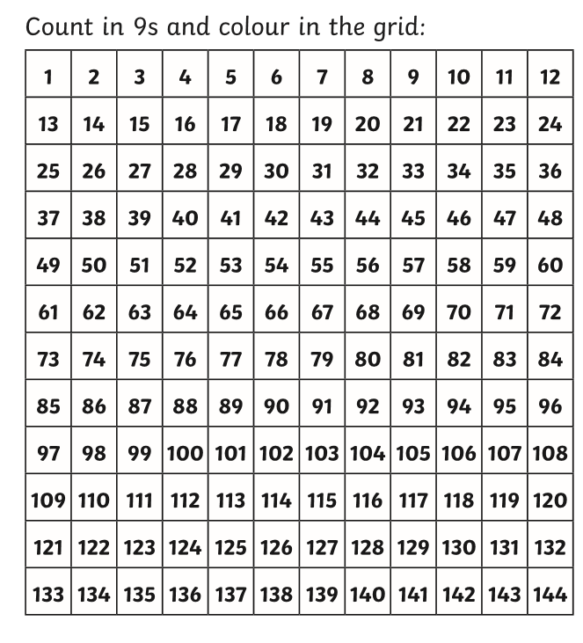

Mental Health and well-being activity

Board game Tuesdays!

Today’s task is to create your own board game to play with your family. Think back to when we played Mathopoly. Can you use a game you already know and change it into your own design?
Team points for those who can use this week’s learning in their game.

Some ideas could be –

Matching pairs (12hr and 24hr clock or analogue and digital clocks)
Multiplication bingo
Multiplication snakes and ladders
North and South America Quiz
Monkey trap (like mouse trap)

