Wednesday Home Learning Activities
English Task
Determiners – please watch the video on identifying determiners and then complete the following tasks.
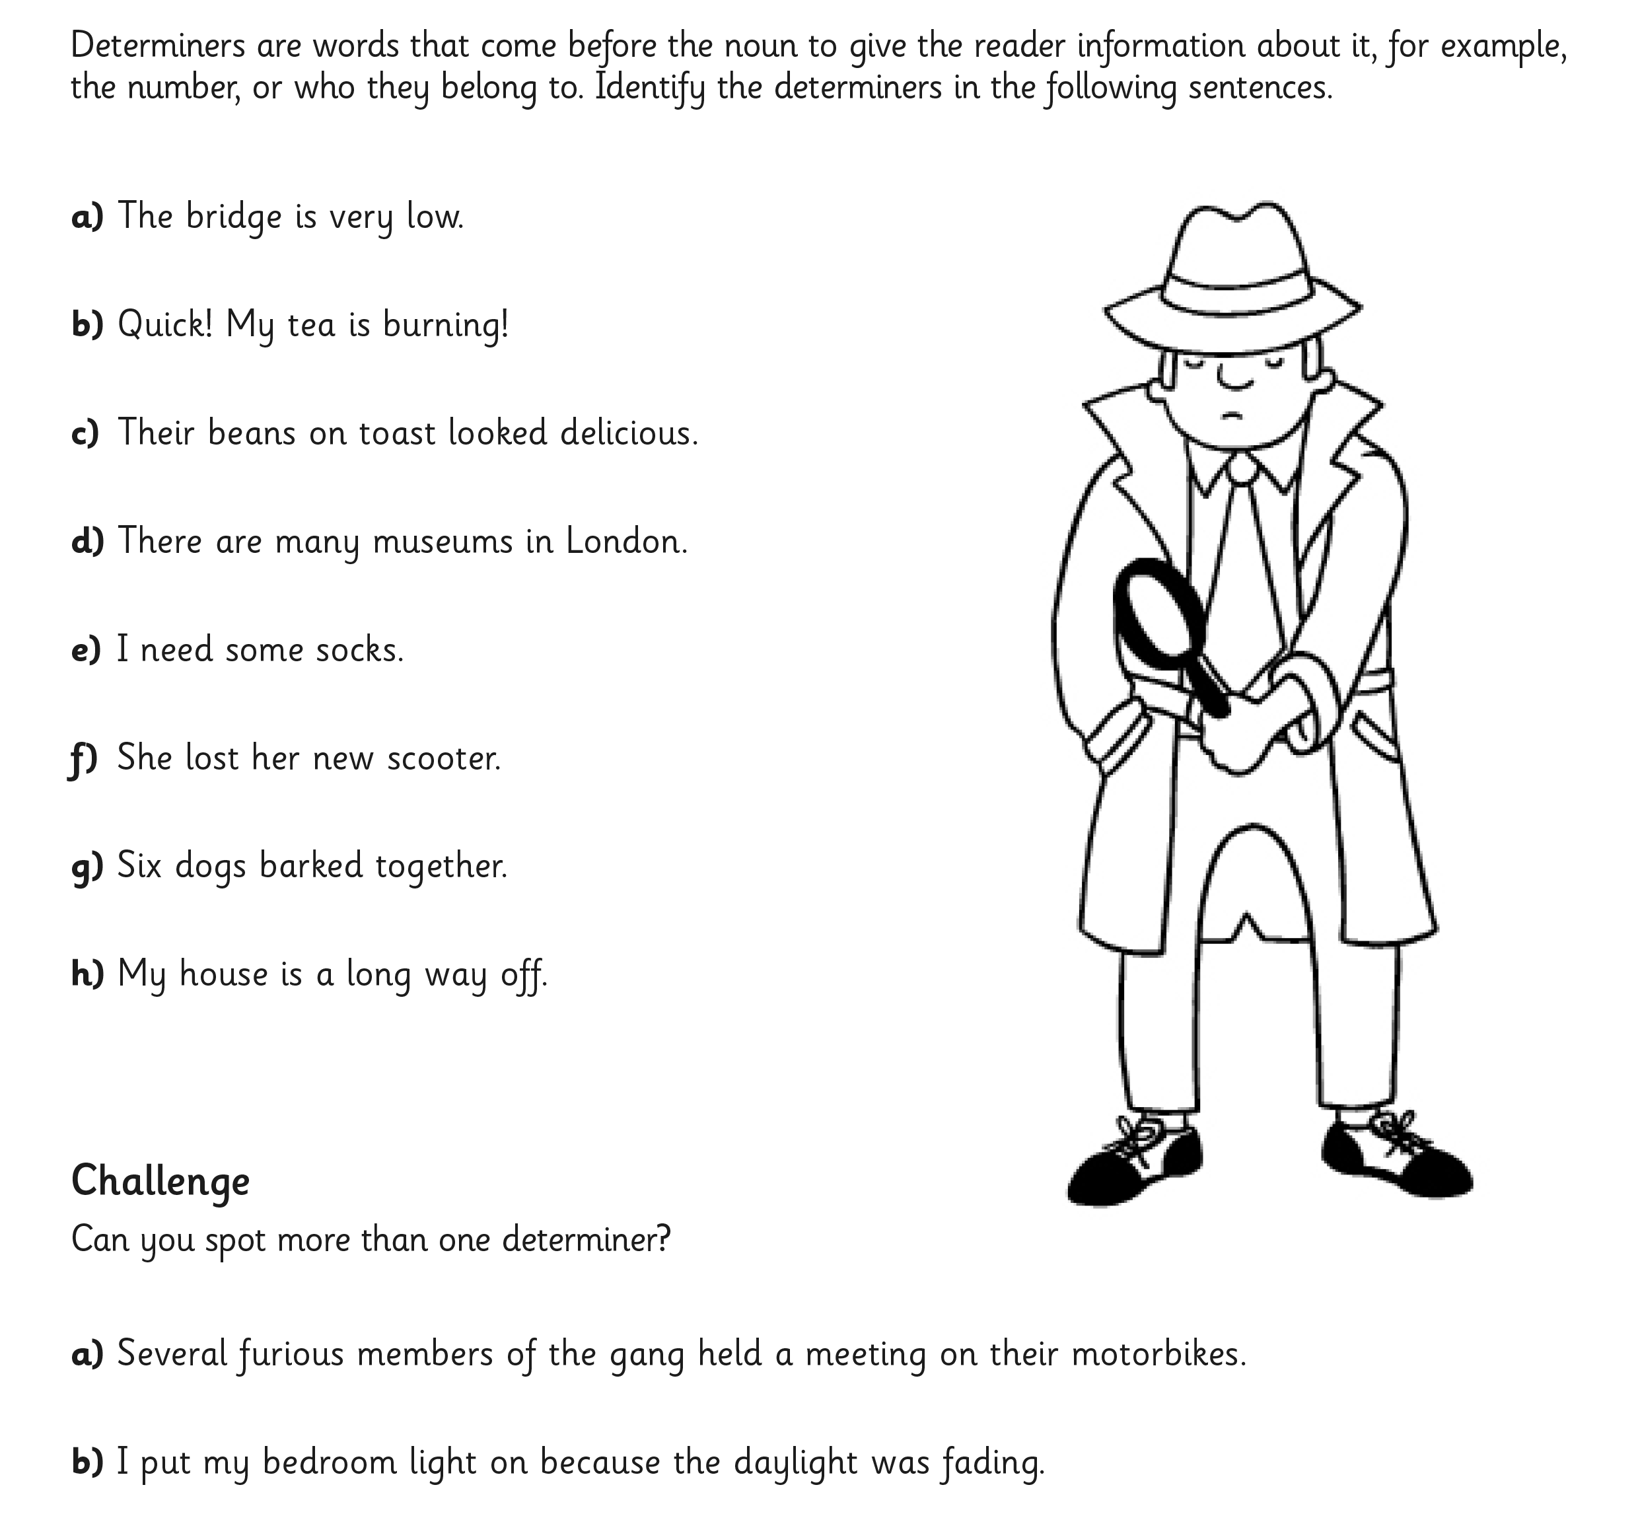

Challenge 2
Can you write sentences about the pictures (nouns)?
I would like you to try and use different determiners for each sentence and underline the determiner you have chosen.
Please include adjective, adverbs and verbs too to make your sentences sound exciting!







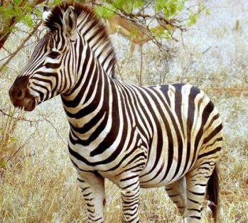




Maths Task
Starter

Colour 1 half of these shapes.

Colour 1 quarter of these shapes.

Label the shapes whole, half or quarters.

________________ ________________ ________________

Use a ruler to show half of the shapes below.

Use a ruler to split the shapes into quarters.

Tick which shapes have been split into halves and quarters equally.

Main Task (please see lesson video)
Year 3 – L.O. To practice reading the time
Complete page 90 in your Target Maths books (A only)
Year 4 –L.O. To read write and convert time between analogue and digital 12 and 24hr clocks
Please complete section A (only) page 104 in your Target maths books.

Topic
Mental health and well-being activity
Put your feet up, grab a snack and watch a movie!
This afternoon is about taking some time to relax and escape into your favourite movie. Please let me know what you are watching. In school we will be watching ‘The Wild’ which all about New York City zoo animals.

