Friday Home Learning Tasks
English Task
Next week we are going to be starting to write a fact file. The location we are going to concentrate on is; St Lucia
Today’s task is to research this location and find out more about it. Think about what you would like to know before going on holiday to somewhere new? I have put some information sheets onto the class page to help you with your research.
You could think about:
- Things to do
- Places to go
- Where to eat
- Typical weather
- Interesting facts
Use the table below to record what you find out.
Things to do
Places to visit
Where to eat (any food that are special to this location)
Weather
Interesting facts
Where is it located and how do you get there?

Maths Starter Task
Number bonds to 100 Challenge (what do you need to add to the number to make 100)
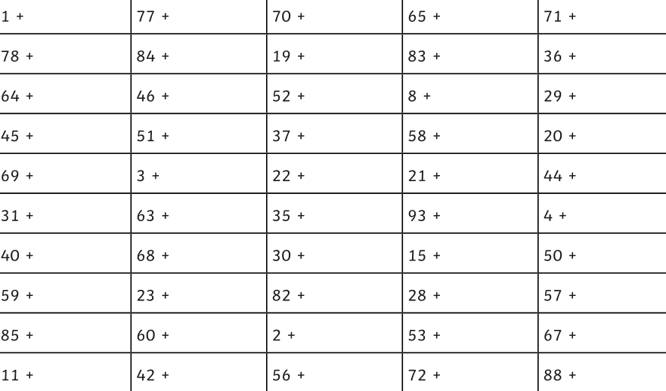

Main task (see video)
L.O. To know the number of days in each month, year and leap year.
Please complete page 93 in the Target Maths book (3). Year 3 start on A.
Year 4 please see the additional sheet and start on B.

Topic Activity
Friday Fun day!
Challenge 1
As we learning all about St. Lucia this morning for your topic task I would like you to think about who you would choose to go on holiday to St. Lucia with and why.
You can choose 10 people to take on your trip – think about why these people are important to you and why they should have a holiday to St. Lucia.
Challenge 2
5minute challenge – imagine you need to leave for the airport in 5 minutes – set yourself a timer and the write down what you would pack in your bag if you only have 5 minutes.


