
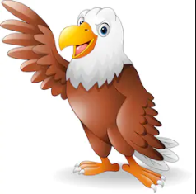
P.E
Swimming
Dance
R.E
Hinduism

British art and artists – Paula Rego and Howard Hodkins

Science
Living things and their habitats
-is it living?
- plants
- invertebrates
-fish and amphibians
-birds and reptiles
-mammals

Geography
Use maps to see where places in Britain are.
Types of settlements
Compass work
Times Tables
7 times tables
8 times tables
9 times tables
Review all

History
The first railways
Social history – crime and punishment
SMSC
friendships

Grammar
Fronted adverbials
Commas for lists
Past and present tense
Determiners
Prepositions
Headings/subheadings
Spelling
Revision of common exception words
Apostrophes

Music

Times tables songs
Traditional music from around the UK
Computing
Internet safety
Coding

DT
Design and make a habitat
English
- holiday brochure (UK topic)
- Performance Poetry
- Postcards – UK
- Information writing – Habitats

Golden Eagles
Term 3
The UK
Maths
Fractions
Measure; Length & Perimeter
Mass and Capacity

