Thursday 07.01.21
English Activity
Please listen to the video of me reading the story Pongo, then put the pictures into order of when they happen. Can you write one sentence next to explain what is happening at each point. You can just write the letter of the pictures in the correct order.

A | 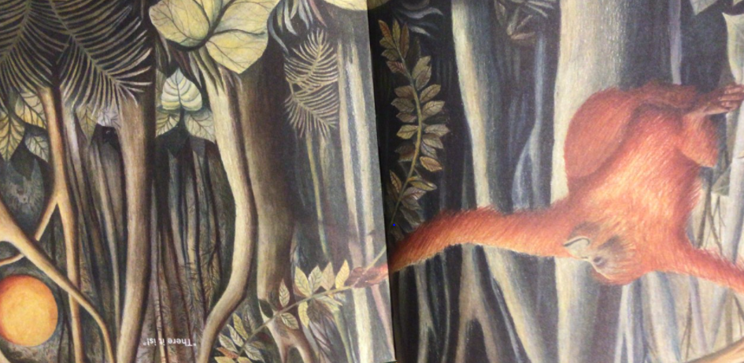
B | 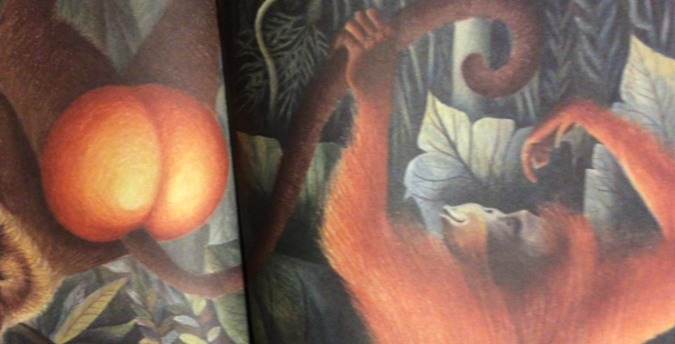
C | 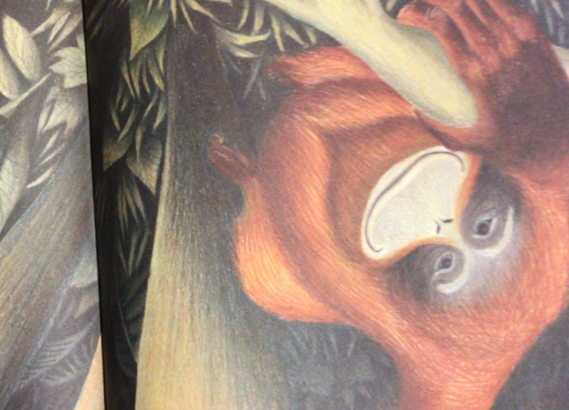
D | 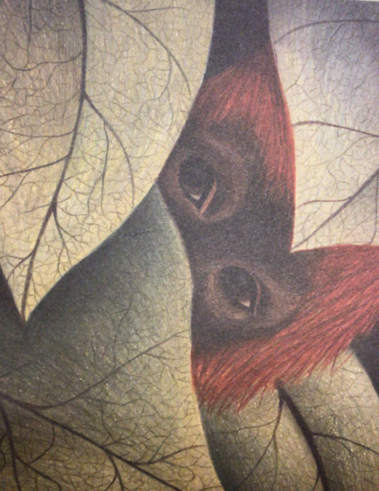
E | 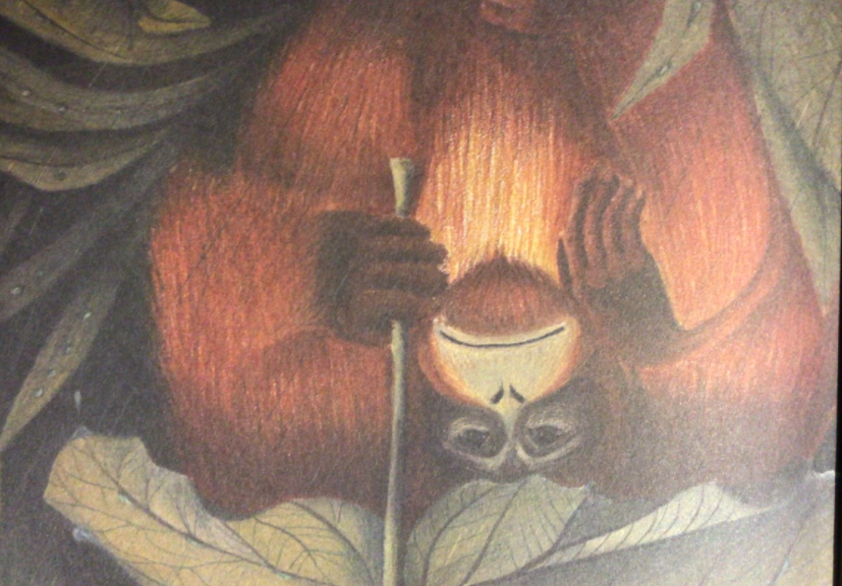
F | 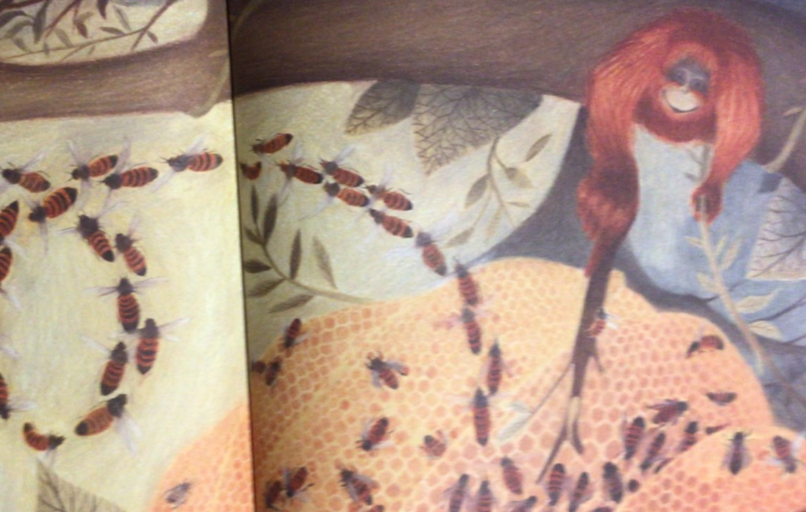
G | 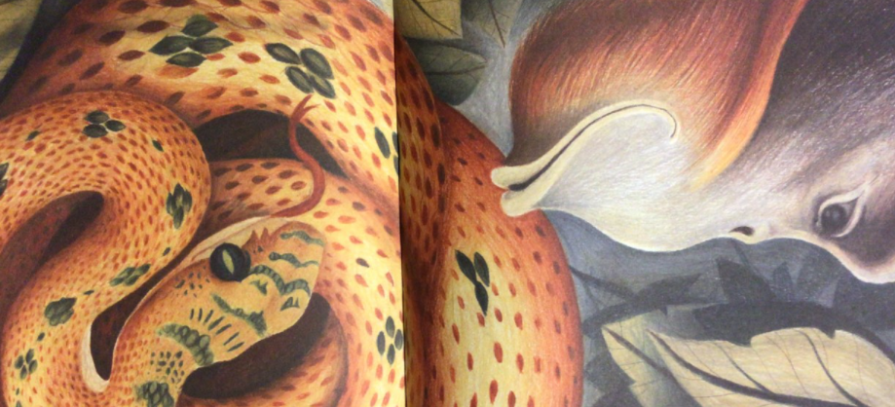
H | 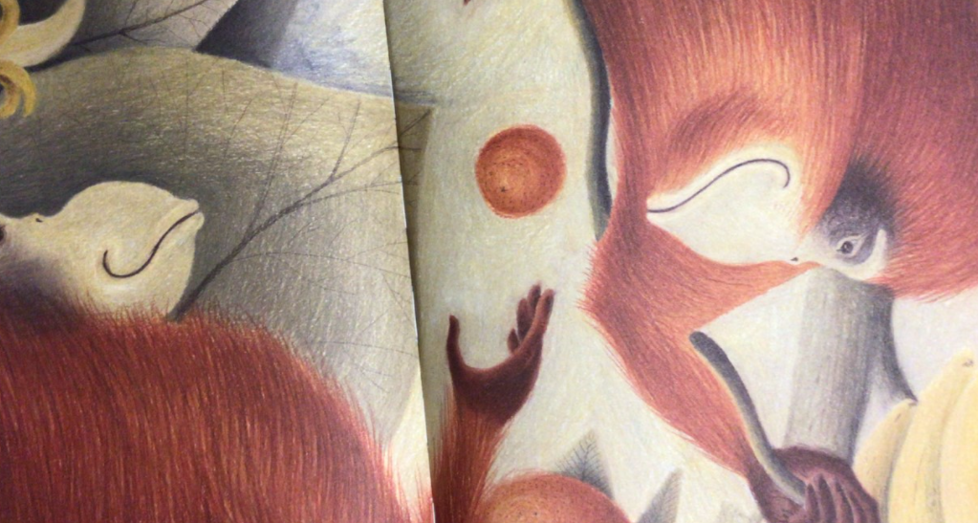
I | 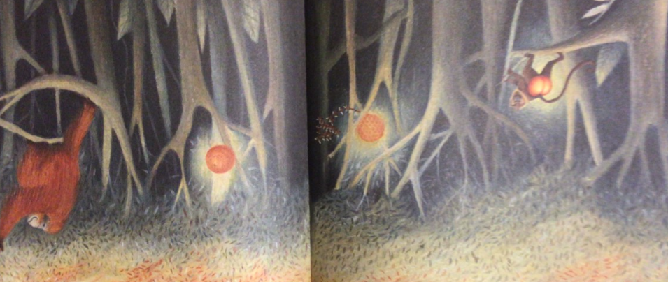
J | 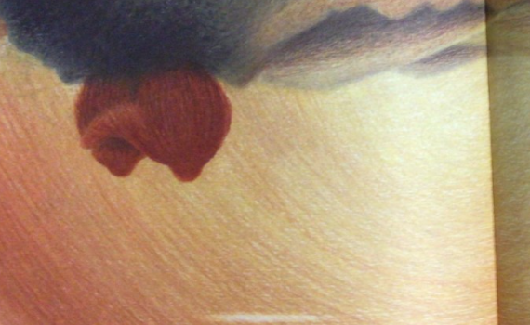

Reading Activity
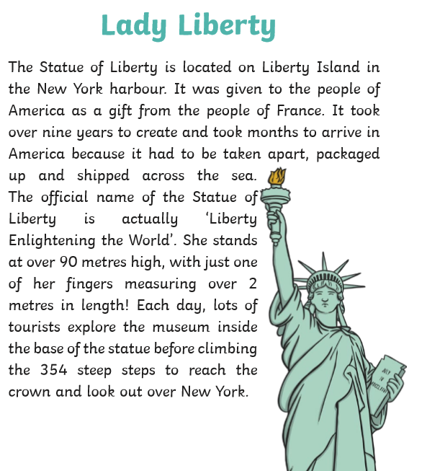
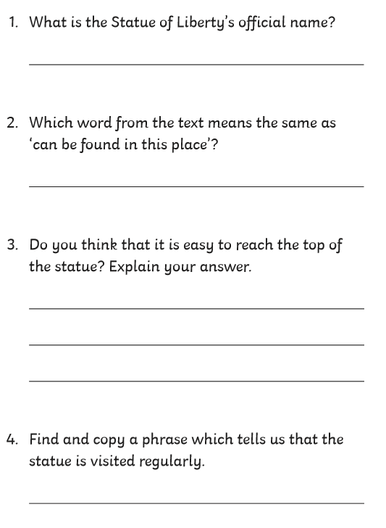

Maths Activity
L.O. To recognise equivalent lengths
Please watch the video to help you answer the following challenge. If the challenges become too tricky you can stop (but try your best!)

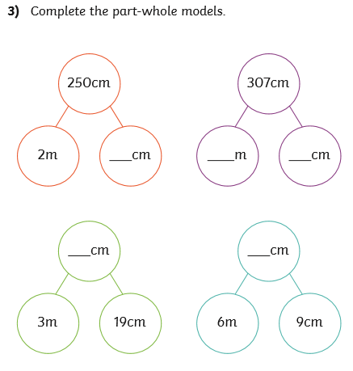
Challenge 1
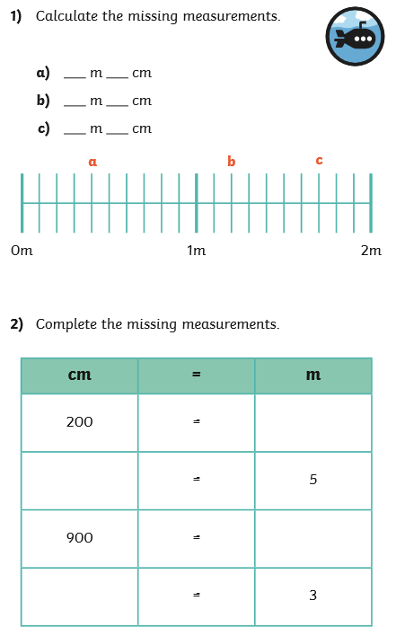

Challenge 2

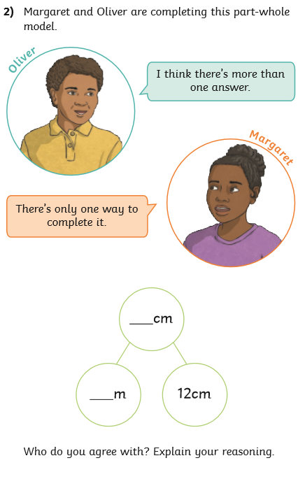
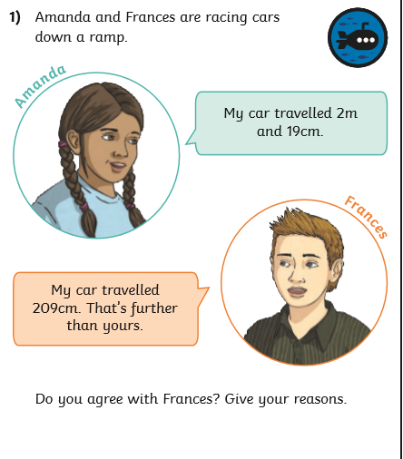

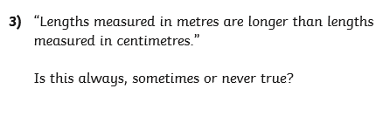

Challenge 3
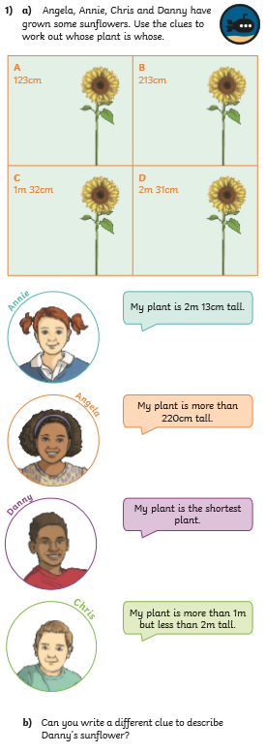

Times tables
https://www.topmarks.co.uk/maths-games/hit-the-button
Please use the above website to practice your 7 times tables? Can you achieve a new high score? (mine is 32!)

Spelling
Please complete your spelling check using the words below:
continent
country
climate
geography
residential
industrial
rainforest
America
city
business
retail
leisure

Topic
Thursday is our PE day and this term we will be concentrating on YOGA.
Please complete the yoga lesson in the following link:
https://www.youtube.com/watch?v=mz9Qq7vIUfw

