Wednesday 06.01.21
English Activity
Starter: Daily spelling - As we spoke about yesterday we will concentrate on 3 words each day. Today’s words are:
Geography
Residential
Industrial
1. Can you find the meaning for each of the words and then write what it means in your own words.
For example, if the word was CLIMATE: The climate is what the weather is usually like in a certain place.
2. 1-minute challenge: Using a minute for each word can you write it as many times as you can!
TASK
Look at the picture of Pongo (below) answer the following questions. Remember to EXPLAIN WHY you have come to this conclusion. Try to write in full sentences and include detail (You do not need to write the question).
- How is Pongo feeling?
- Why could he be feeling like this?
- Where do you think Pongo is?
- Can you make a prediction of what could happen next?
- Can you write 5 questions you would like answering from seeing this picture.


Reading activity
Remember to refer back to the text in your answer and explain why.
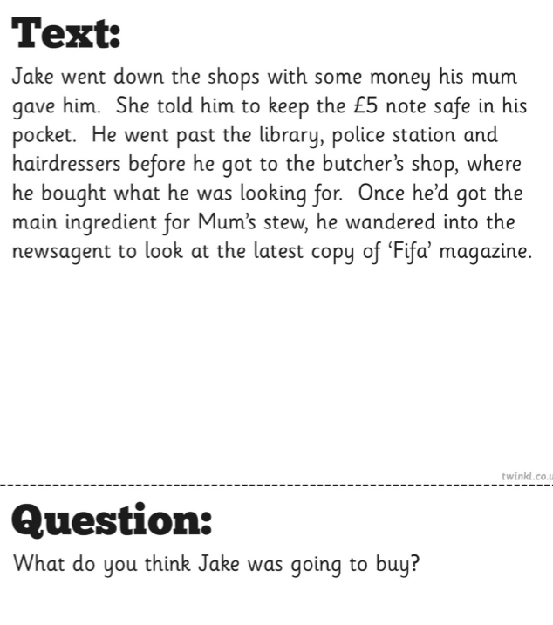

Maths activity
Revisit the 4 operations we have been learning about.
Complete the following Challenges – if they become too tricky you can stop. Use the following videos to help you; https://quadring.primarysite.media/playlist/golden-eagles-home-learning-videos
Challenge 1
53 + 15
86 – 24
64 x 4
81 ÷ 9
Challenge 2
652 + 241
354 + 127
654 – 278
827 - 138
712 x 6
635 x 8
128 ÷ 8
144 ÷ 6

Challenge 3
7261 + 2381
8734 – 6845
1353 x 8
944 ÷ 4

Challenge 4
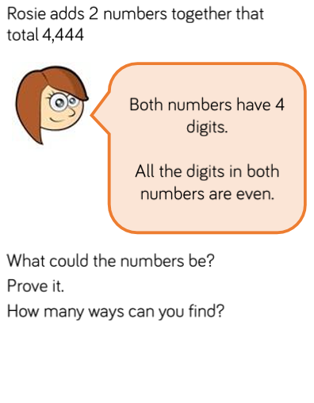
Times tables (10mins) https://www.topmarks.co.uk/maths-games/hit-the-button

Topic Activity
Please watch the video and read the information below, to answer the questions below. This does not need to be printed. You only need to write the answers.


