Friday 08.01.21
English
For our English learning today, we are going to use adjectives to describe a picture.
We need to try and create good sentences that include adventurous adjectives and a conjunction. Use my examples from the video to help you.
Year 3 – Can you write 5 GOOD sentences and include a conjunction (try to use a different conjunction each time but only if it makes sense).
Year 4 – Can you write 5 GOOD sentences and include a conjunction, verb and adverb. Additional challenge is to include a fronted adverbial.

Reading Activity
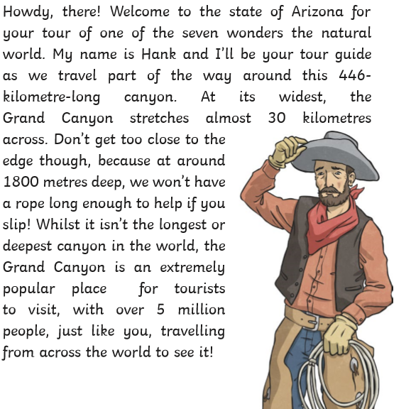

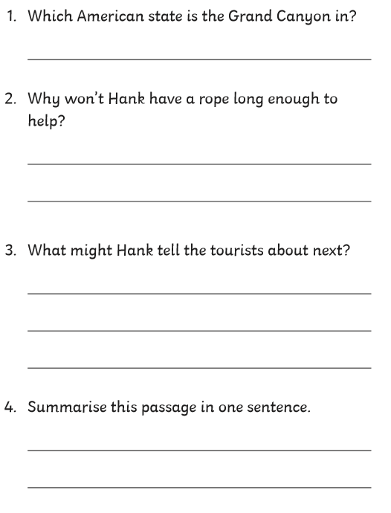

Maths Activity
L.O. To recognise equivalent lengths
Please watch the video to help you answer the following challenge. If the challenges become too tricky you can stop (but try your best!)

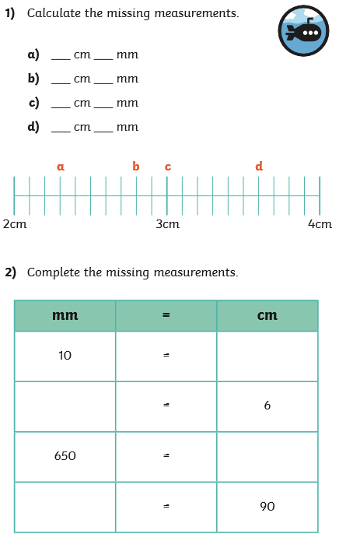
Challenge 1
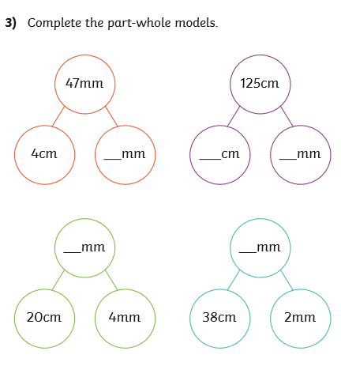

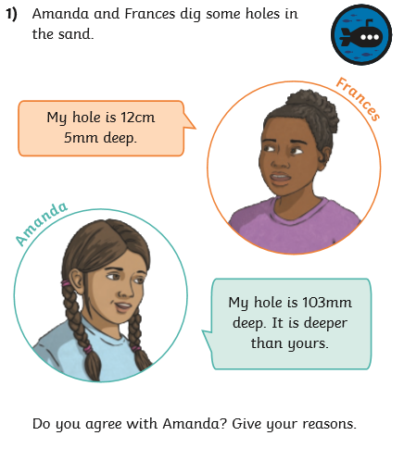
Challenge 2

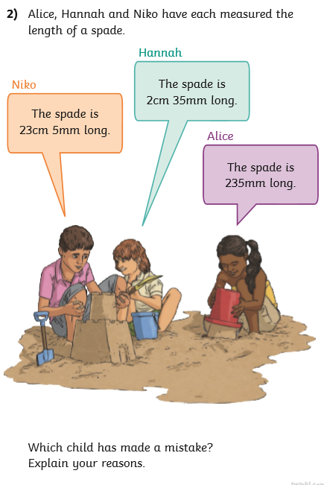

Challenge 3
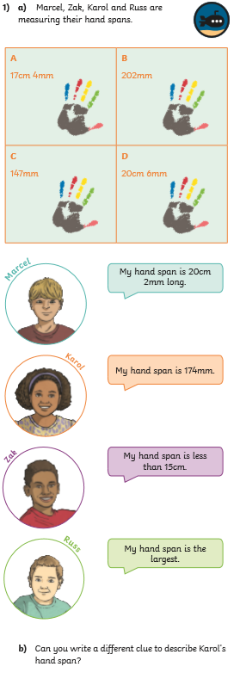Times tables
https://www.topmarks.co.uk/maths-games/hit-the-button
Please use the above website to practice your 7 times tables? Can you achieve a new high score? (mine is 32!)
Topic
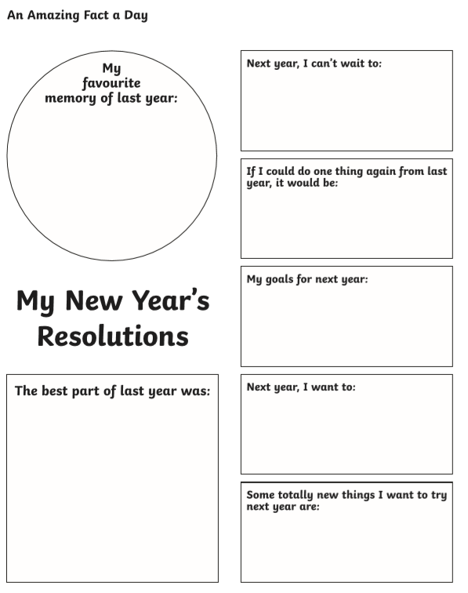
PSHE – Making New Year’s resolutions. Please watch the video about making New Year’s resolutions and then create a poster using the following template (it doesn’t have to be the same design).

Internet safety
Searching the internet
Please watch the video on being super searchers and then complete the activity below.
Your question you need to find the answer to is;
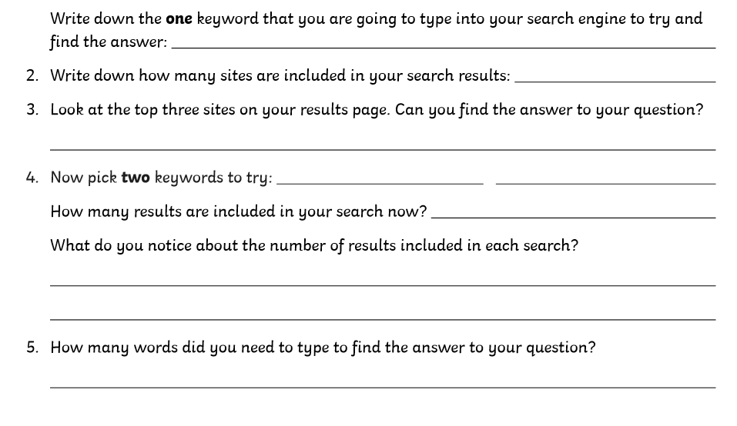
Can you find the four least populated areas in North America?


