Tuesday 05.01.21

Using crayons to draw Pongo
Please watch the video below and practice the 12 techniques.
Can you use these skills to recreate a drawing of Pongo (see image below.)
You may need to practice first and take your time!
You do not have to include the background but you can if you want to challenge yourself.
https://www.youtube.com/watch?v=p73ii5pKz78
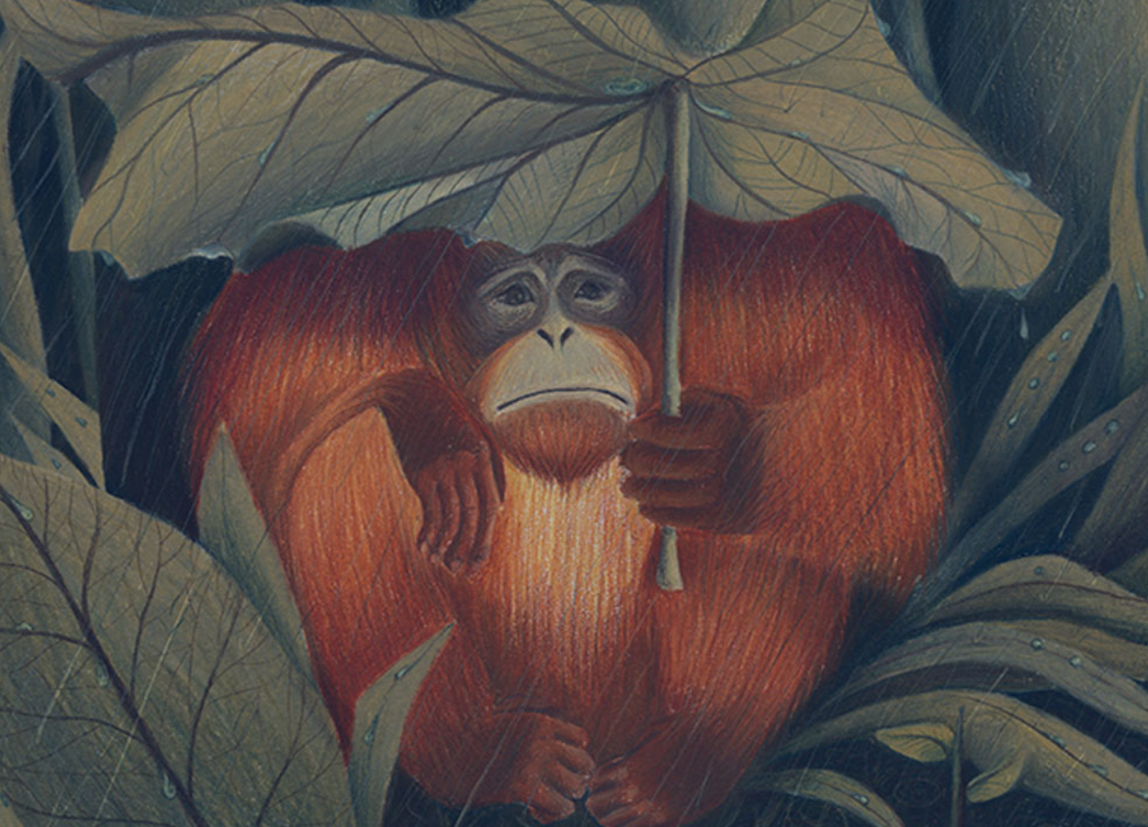

Additional activity

Please watch the below video based on the Amazon River – can you create a poster to show what you have learned.
https://www.bbc.co.uk/iplayer/episode/b0bx73pk/earths-great-rivers-series-1-1-amazon

