Thursday 14.01.21
English Task
Today we are going to start drafting our character description. Make sure you refer back to your planning and use the examples and lesson video to help you. This should include lots of details and be your best writing.

Reading activity
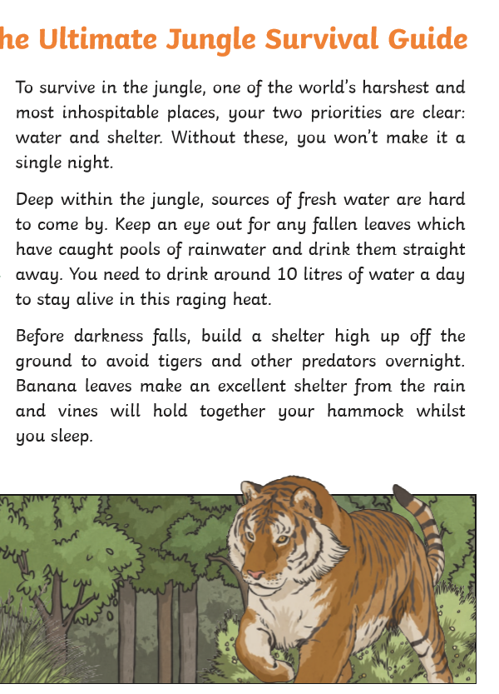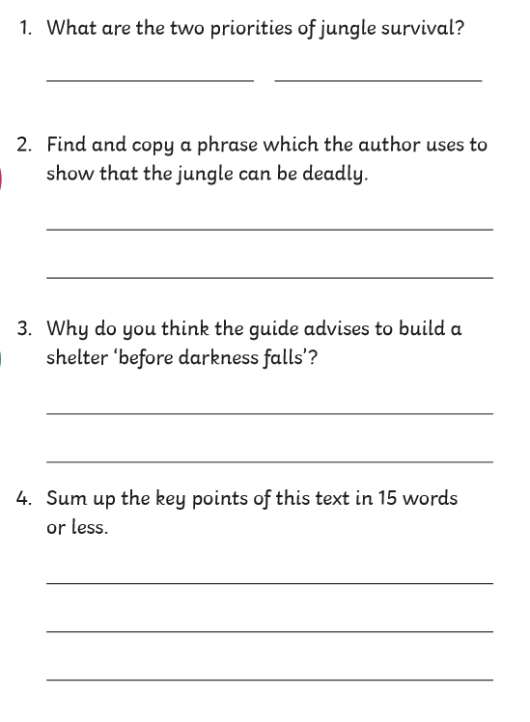

Maths task
YEAR 3 ONLY To compare lengths
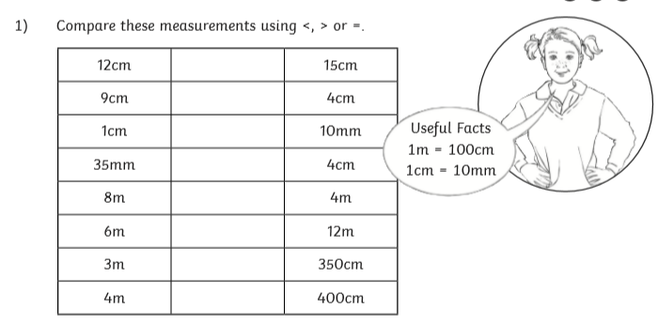
Challenge 1

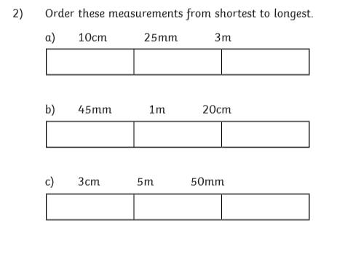
Challenge 2

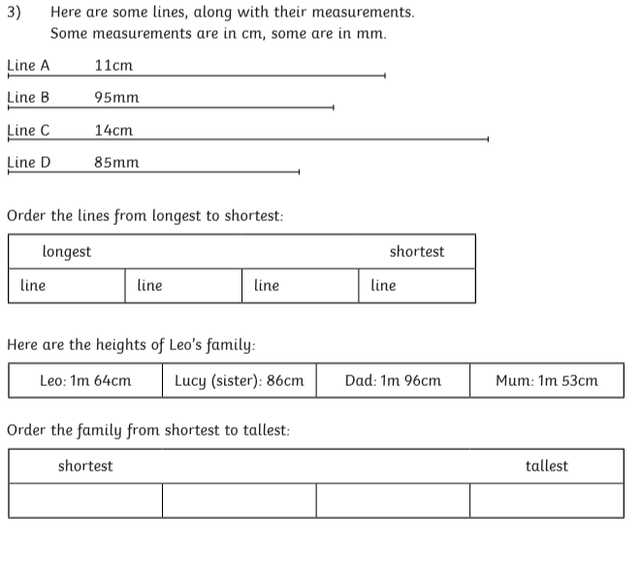
Challenge 3
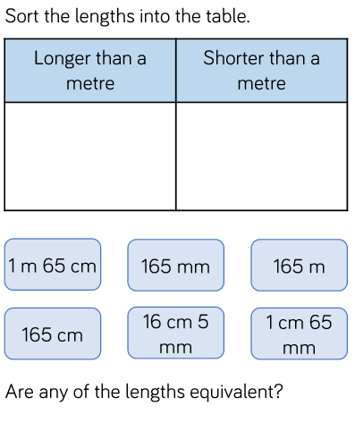
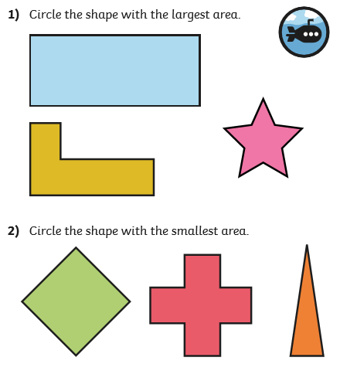
YEAR 4 ONLY
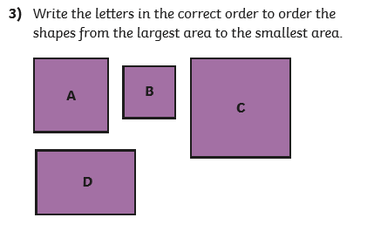
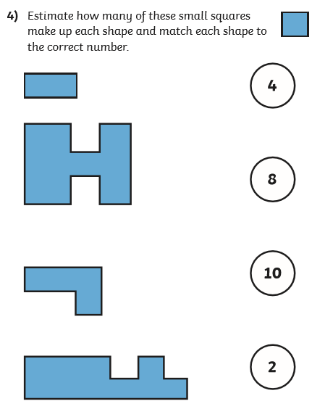
Challenge
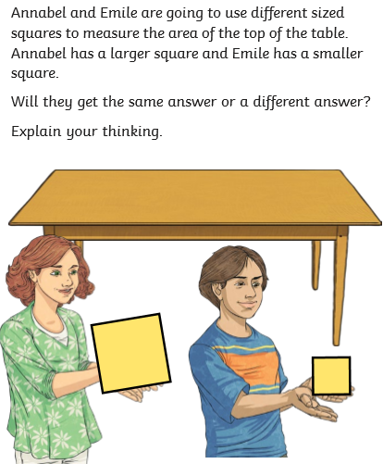

Multiplication word problems
- Hats : £18 Sunglasses : £26

How much would it cost to buy 5 hats and 3 pairs of sunglasses?

- Oranges : 32p Apples : 29p

How much does it cost to buy 5 oranges and 4 apples?

- Hotel Room : £36 Parking : £15

How much will it cost for me to stay in the hotel for 6 nights if I need to park my car each night?

- Television : £122 Mobile Phone : £24

The shop sells 10 televisions and 8 mobile phones during the day. How much money has the shop made?

- Chocolate : 32p Lolly : 26p

I buy 5 chocolate bars and 6 lollies. How much money will I have left from £4.00?

- Trainers : £24 Football Top : £18

The shop sells 5 pairs of trainers and 10 football tops. How much money has the shop made?

- The school is having a charity event. The target is to raise £500. 42 children have each raised £10 each. How much more money is needed before they reach the target?

- The church is having a charity event. The target is to raise £1000. 98 people have raised £10 each. How much more money is needed to reach the target?

Topic
Please can you complete your spelling check using the words from Monday.

PE

Complete the yoga story from the lesson video. Once this is completed I would like you to create your own yoga story! You can use the poses we have already learned or create your own pose that links to an animal.

Let me know how you get on by sending me a video/pictures or a copy of your yoga story.

