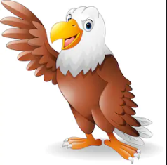
History
Who are the Egyptians?
Egyptian Gods
Tutankhamun
English
Create your own god
Sequencing
Fact file
Balanced argument

Grammar
Expanded noun phrases
Progressive tense
Perfect tense
Time, place and cause conjunctions
Adverbs and prepositions
Computing
Internet safety
Spread sheets

DT
Design your own language and symbols
Geography
Where did the Egyptians live?
Rivers
P.E
Cricket
Science
Solid, liquid or gas
Heating and cooling
Water cycle
evaporation
R.E
Islam

Times Tables
Review all
Recall speed

SMSC
Well-being

Egyptian silhouette art
Spelling
Revision of common exception words
Pre fixes – dis
-Un
-mis
Music
notation
Golden Eagles
Term 4
Ancient Egyptians
Maths
Money
Time
Statistics
Shape



