Tuesday 12.01.21
English task
Todays task it to start building your ideas that can help you write your own character description for Pongo.
Use the outline of Pongo (or draw your own) and then on the outside write how you are going to describe Pongo’s physical appearance (Orange is banned unless used in a metaphor/simile). On the inside write your ideas for his personality - think about what we learn from the book and expand on this. You can include:
- How he feels (and how this changes)
- What he does
- His personality traits (adventurous)
- What he likes
- How he moves
You do not have to write in full sentences but can use words/phrases
Use the example in the lesson video to help your ideas.

Make sure to use adventurous adjectives and make your work your very best!

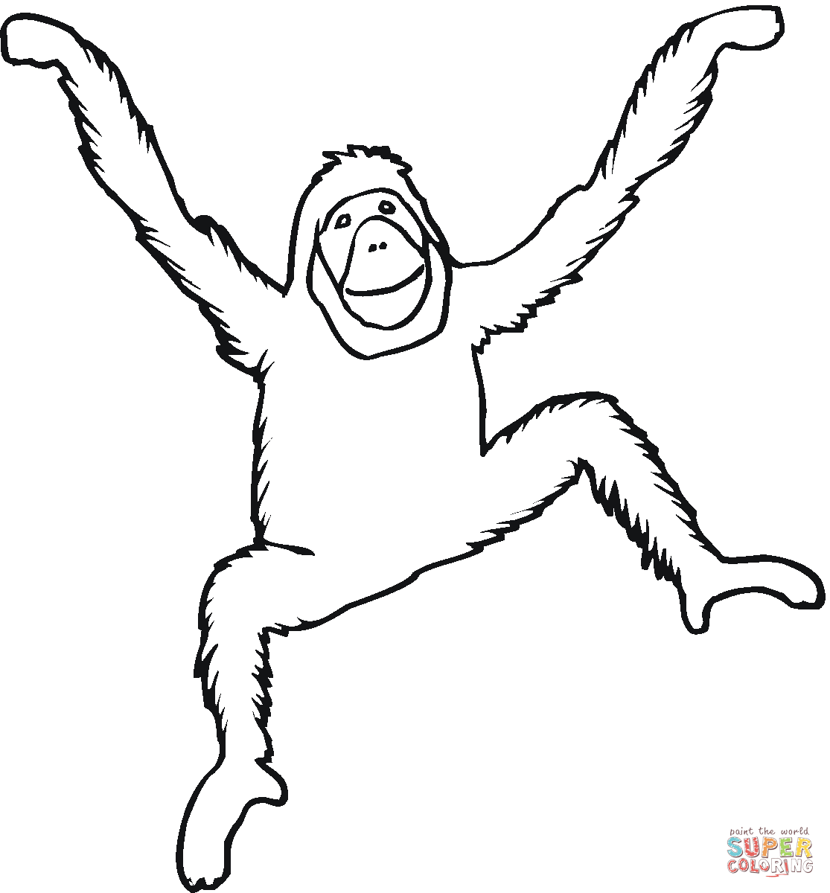
Reading activity
Tom’s exciting morning
Tom woke up early. He knew the taxi was just around the corner. He felt like it was Christmas morning but is was the middle of August. He grabbed his case and knocked on his parents’ door eagerly. They shouted back, “It’s nearly time Thomas, go and wake Olivia up!” Tom ran into his sister’s room and jumped on the bed. They both grinned and chatted about the week ahead.
A little while later, the taxi was outside so Tom grabbed his sunglasses and cap. He chuckled to himself because it was very dark and cold outside! Tom and Olivia sprinted to the back seat of the taxi whilst Mum and Dad threw the suitcases into the boot. Then, Mum made sure Olivia was secure in her special booster seat. Mum also went back inside to get Buster the dog!
Olivia’s face dropped and she poked her brother who also looked worried. “Where are you taking Buster?!” they both said cautiously. Mum smiled, “Just to grandmas. We’re going to be gone for a while!” Their faces relaxed and they giggled at how silly they had been!
As they approached their destination, Olivia tapped her brother on the arm and pointed outside. “They look like giant birds!” she said. Tom thought this was really funny and he laughed with his sister. Mum and Dad looked at their watches. Their faces dropped. They quickly got Olivia out of her seat and put her in her pram. Dad grabbed Tom’s hand and they paid the man quickly. “Come on guys!” Dad said sounding slightly worried.

Questions
- How do we know Tom felt excited in Paragraph One? Try and find all the clues.
- Why do you think Tom chuckled to himself when he went outside in Paragraph Two?
- Where do you think Tom is going? Explain why you think this.
- Pretend you are Tom. Write down how you are feeling and what you are thinking as you travel in the taxi.
- Why has Tom packed sunglasses?
- Why do you think Olivia and Tom were worried when Mum went back into the house to get Buster?
- What do you think Olivia was pointing to when she said “they look like giant birds!”?
- What do you think happened when Mum and Dad looked at their watches in paragraph four?
- Pretend you are Dad at the end of the passage. Write a few sentences explaining your thoughts and feelings.
Tuesday Maths activity
Today we are going to ESTIMATE and then measure the lines below using cm and mm. If you are working from a screen ask your adult (or someone else in your house) to draw 5 different length straight lines for you. Watch the lesson video to see how to estimate and measure accurately.
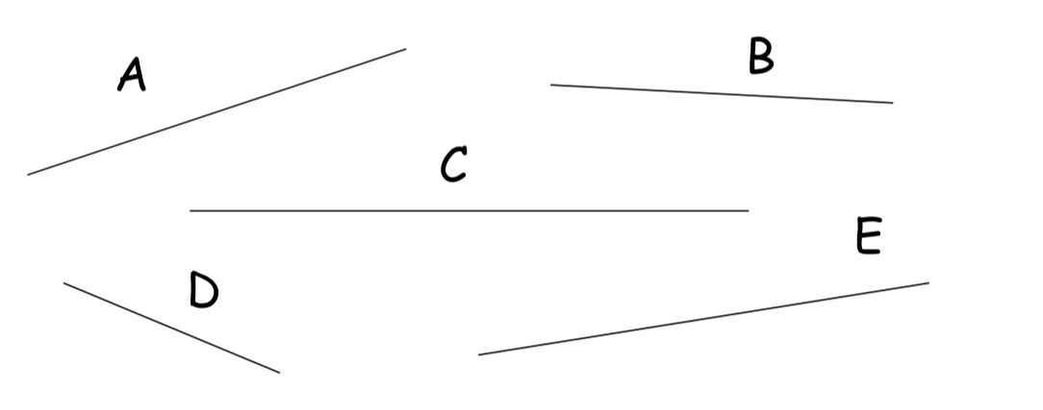
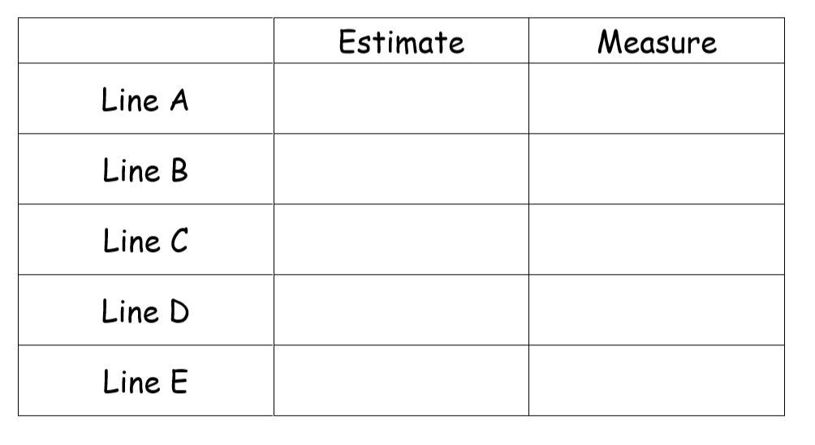
Draw the following lines:
- 13cm 5mm 4. 12cm 9mm
- 16cm 8mm 5. 1cm 7 mm
- 17cm 3mm 6. 6cm 2mm
Challenge: Can you draw the same length lines in 3 different ways.
Solve multiplication word problems
Challenge 1
- John wants to give 4 friends 3 sweets. How many sweets will he need altogether?
- 3 children need 5 colouring pencils each. How many do they need altogether?
- There are 4 football teams in a competition. Each team has 5 children. How many children are in the competition all together?
- Ruby has 10 children coming to her party. Each child needs 2 toys in their party bag. How many toys will she need?
- There are 5 bags holding a group of 5 hula hoops. How many hula hoops are there altogether?

Challenge 2
- John wants to give four friends 6 sweets. How many sweets will he need altogether?
- Five children need six colouring pencils each. How many do they need altogether?
- There are eight football teams in a competition. Each team has five children. How many children are in the competition all together?
- Ruby has eleven children coming to her party. Each child needs three toys in their party bag. How many toys will she need?
- There are seven bags holding a group of four hula hoops. How many hula hoops are there altogether?

Challenge 3
- John wants to give Bobbi, Ronnie and Eloise 6 sweets. How many sweets will he need altogether?
- Ruby, Polly, Bethan and James need a pack of colouring pencils. Each pack contains five pencils. How many colouring pencils do they need altogether?
- There are twelve 5-a-side football teams in a tournament. How many children are in the competition all together?
- Ruby has eleven children coming to her party. Each child needs three toys and two sweets in their party bag. How many toys will she need?
- There are seven bags holding a group of four hula hoops and three tennis balls. How many items are there all together?

Tuesday Science activity.
Today we are going to be completing an experiment. This is going to be a tricky activity and you will have to really think about how you are going to achieve this.
Please watch the video explaining the activity and how to complete the experiment.
Put on your super scientist hats and get to work!
Task
I can set up a fair test to compare how rolling objects move on different surfaces.
This is what we will do: (draw a picture and makes notes to explain)

My prediction:

To make it a fair test I will keep these things the same:

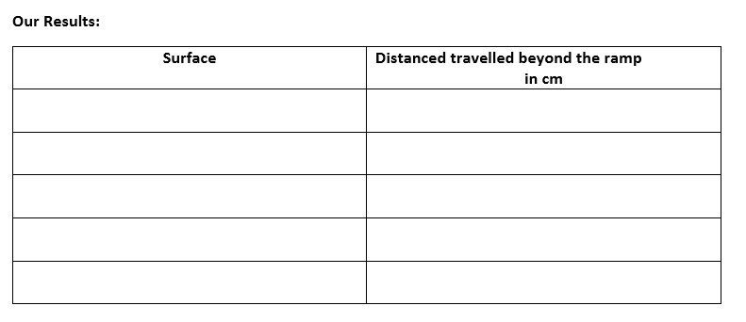
What I found: (Explain which types of surfaces caused vehicles to travel long distances and which types of surfaces slowed down or stopped movement on the ramp). Why do you think this happened?

How could you improve your experiment?

