Friday 15.01.21
English Task
Watch the video lesson on editing and the complete and edit your character description draft.
Questions to ask when editing:
- Have I used capital letters/full stops?
- Does it make sense?
- Have I included adventurous adjectives?
- Have I checked my spelling?
- Could I include any year 3/4 common exception words?
- Have I got enough detail?
- Could I read my work out loud to someone else and can they picture Pongo?
The most important questions is……
Is this my best work?

Reading activity
I would like you to use the following website and complete the authorfy challenge set by Angela Woolfe she is going to challenge you to create your own magical vehicle – made out of a vegetable!

https://authorfy.com/10minutechallenges/
I’m sorry the link will take you to a list of challenges but you need to select the Angela Woolfe one. Please see my video instructions if you can not find this.

Maths Activity
Today we are going to be adding lengths please watch the lesson video to help you.
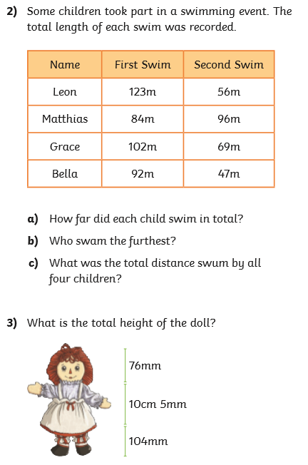
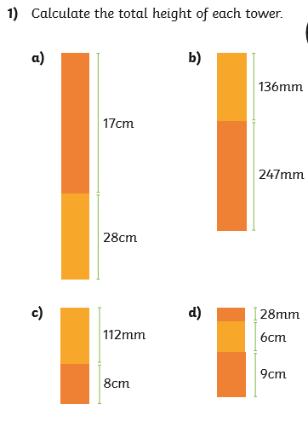
Challenge 1 (year 3 and 4)

Challenge 2 (year 3 and 4)
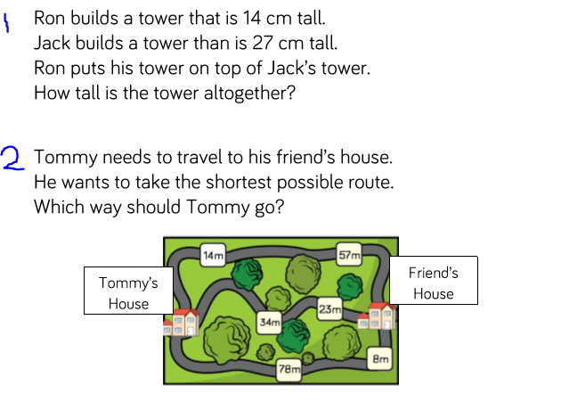
Challenge 3 (Year 4 )
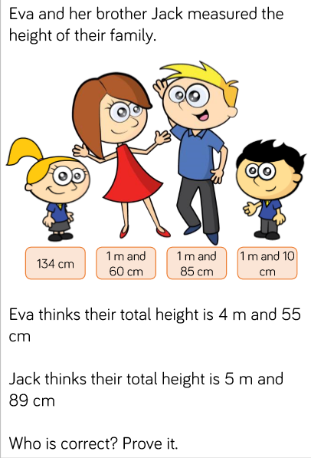

Word problems
Challenge 1
1. Jack has 25 conkers and he finds another 17 conkers. How many conkers does Jack have altogether?

2. In the hall, there are 52 children. Another 29 children enter the hall. How many children are in the hall overall?

3. 67 children are in the swimming pool. An extra 24 children enter the swimming pool. How many children are in the swimming pool?

4. 47 apples are on the ground. 13 apples fall to the ground from the apple tree. How many apples are on the ground?

5. In the library, there are 45 books. At lunch time, the children return 37 books. How many books are in the library after lunch?

Challenge 2
1. 627 children are in the swimming pool. An extra 44 children enter the swimming pool. How many children are in the swimming pool in total?

2. There are 134 children in Year 3 and 37 children in Year 4. How many children are there in Years 3 and 4?

3. In my lunchbox I have a sandwich and an apple. My sandwich weighs 378g and my apple weighs 103g. What is the weight of my lunchbox?

4. There were 433 people on the train at Orpington station. 68 people entered the train at Bromley station. How many people were on the train altogether?

5. In the library, there are 442 books. At lunch time, the children return 79 books. How many books are in the library after lunch?

Challenge 3
1. 1627 children are in the swimming pool. An extra 284 children enter the swimming pool. How many children are in the swimming pool in total?

2. There are 2134 children in Year 3 and 278 children in Year 4. How many children are there in Years 3 and 4?

3. In my lunchbox I have a sandwich and an apple. My sandwich weighs 1378g and my apple weighs 138g. What is the weight of my lunchbox?

4. There were 2423 people on the train at Orpington station. 388 people entered the train at Bromley station. How many people were on the train altogether?

5. In the library, there are 5442 books. At lunch time, the children return 769 books. How many books are in the library after lunch?

Topic

Grammar – Fronted adverbial
Please watch the lesson video for fronted adverbials and complete the task below.
Year 3 and 4
- James read the recipe carefully.

________________________________________________________

- The children played on the tree joyfully.

________________________________________________________

- Duncan quickly passed the ball to his teammate.

________________________________________________________

- The gang ran to the beach without a moment’s hesitation.

________________________________________________________

- The shadow sprawled across the wall slowly.

________________________________________________________

Year 4
- The elephant stomped through the jungle with all his might.

________________________________________________________
- The footballers grew tired after a while.

________________________________________________________
- Hector crept past the sleeping lion as quietly as he could.

________________________________________________________

PSHE activity


