Wednesday 13.01.21
English Activity
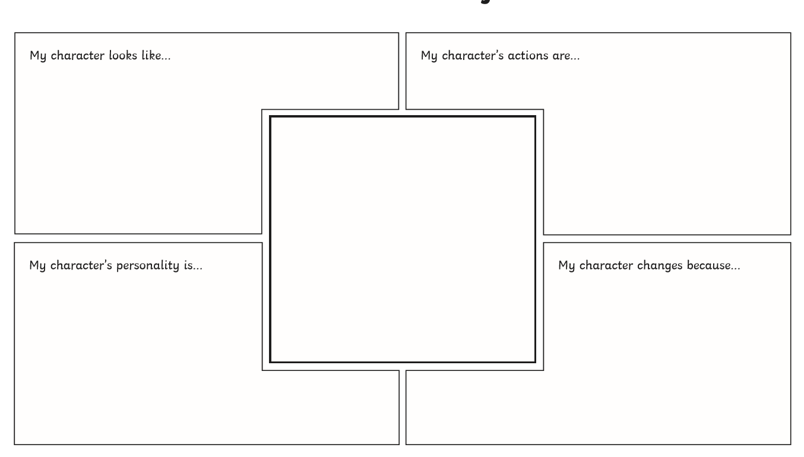
Today we are going to continue planning our character description. Use your ideas from yesterday to complete the activity below.
Reading activity

Competition time!
Choose one of your favourite books from home or school that you have read recently (try to think of one we may not already have at school)

Write your own blurb for a book you have read.

(The blurb is the bit at the back of the book that makes you want to read it)

Think about what you need to include and how you can make it sound exciting so others will want to read it.

*Use the blurb on the book to help you (but don’t copy it) If you do not have a copy of the book then you should be able to find the blurb through a google search.

The children who can make me want to read the book from the blurb will have this book bought for the classroom and featured on our bookflix display!
Maths activity
Today we will continue our learning on estimating and measuring using cm and mm. I would like you to find 10 items in your house and estimate the length. Then measure this item ( try to choose items that are no longer then a ruler). Can you then work out the difference between your estimate and the measured length.
Object | Estimate | Actual | Difference
Year 3 Challenge
Which objects have to biggest difference in size? What is the difference?
Which object has the smallest difference in size? What is the difference?
Year 4 Challenge
Can you convert all of your measurements into just mm? (for example 3cm10mm = 40mm)

Topic activity
Please carefully watch the lesson video for South America – You may want to pause this at certain parts or re-watch to make sure you have all the information to complete the activities below.

Task 1 – Label the countries A to O ( you can do this in a list)
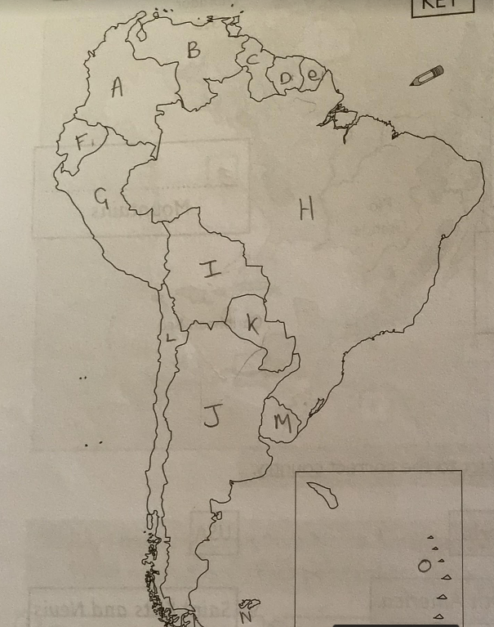

Task 2: create two list for counties that do and do not have a coastline.
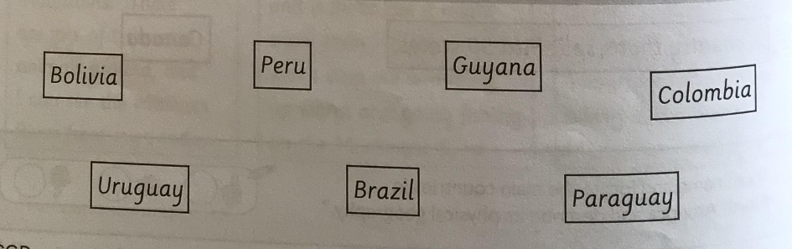

Task 3: List the 7 countries the Andes mountains run through.
Task 4: You can just right the answer for each.
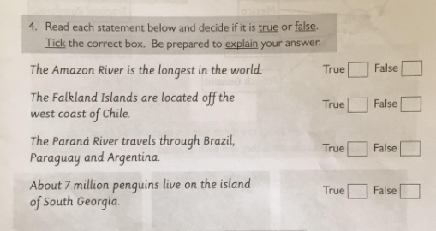

Task 5: Choose 1 country in South America you would like to visit and explain why.

