Monday 11.01.21
English task
L.O. To understand the features of a Character description.
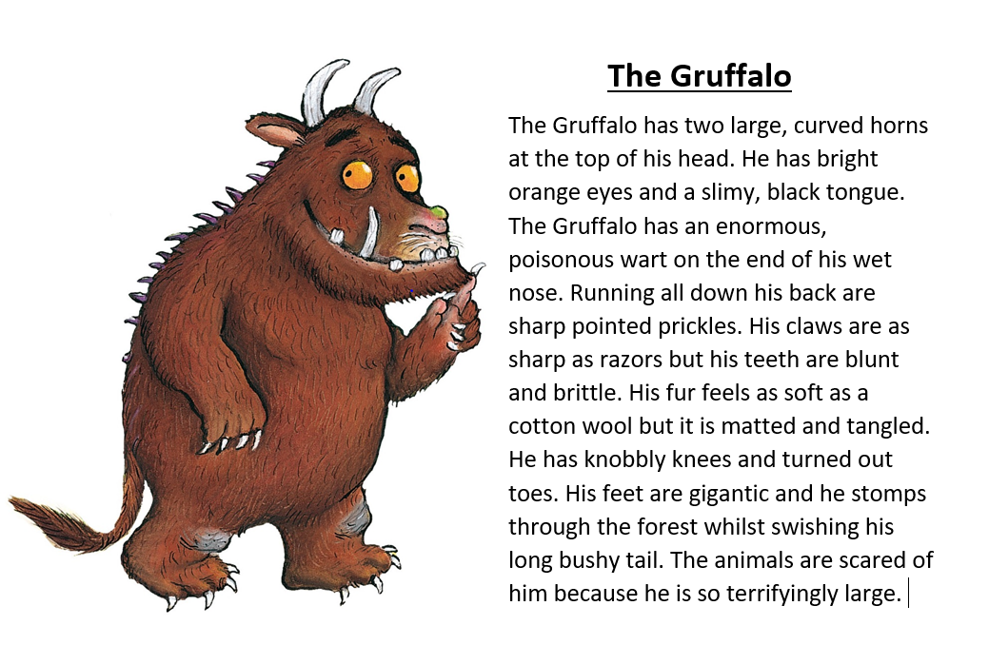
Please can watch the lesson video of identifying the features of a character description. Then read the descriptions below and underline the features you can find.
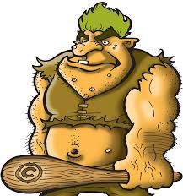
Deep inside the darkest cave lived a hideous creature known as Dink. Covered from head to toe in grotesque white pimples and crusty mud soaked skin, you can smell Dink before you can EVEN see him. On the very top of his head lives a family of lice that play all day in his bright green, unwashed hair. His enormous muscles escape from his tiny clothes which are soaked in sweat. Not only is Dink disgusting he also has a terrible attitude.
How are the descriptions different?
Which do you like better and why?
Reading task
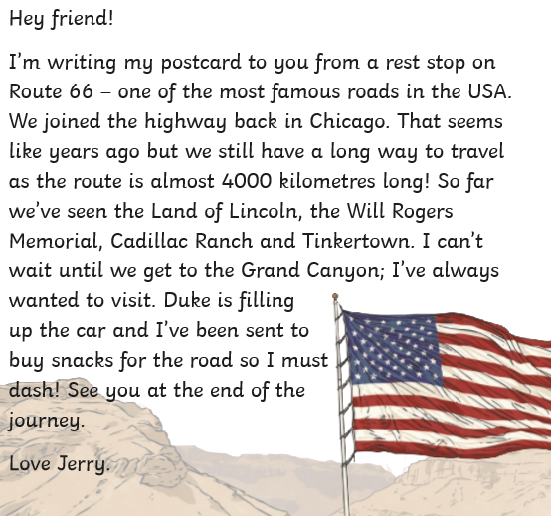
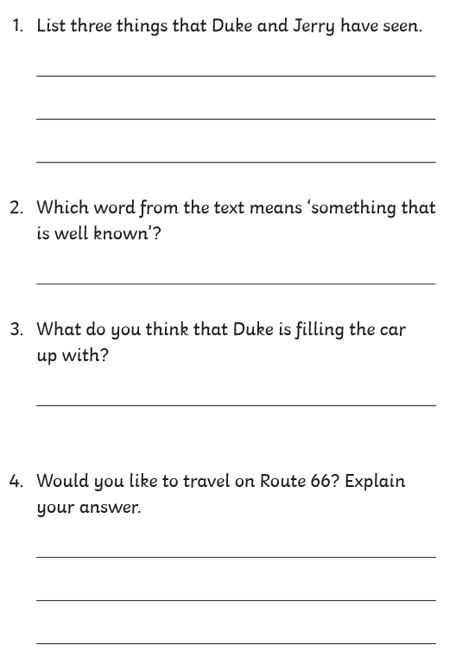

Maths task Monday 11.01.21
Year 3 only – L.O. To measure and draw straight lines
Please complete page 74/75 in your target maths book. Using a ruler. Start on sections A and work through the questions. If you start to find it tricky, you can stop after completing A.

Year 4 Only
L.O. To convert between different measures of length. – please watch the video lesson about converting between metric measurements before starting.

Please use your target maths books and complete page 82. Start on A – if you complete this without any concerns then go to B .
Challenge today is to complete C also!

Times tables (Year 3 and 4)
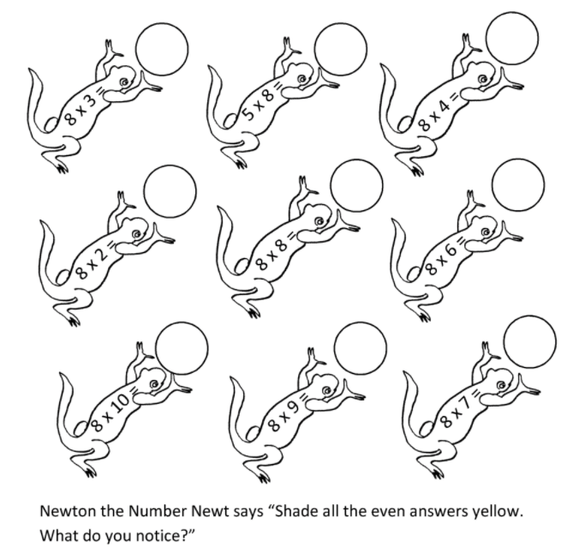

Please continue to use TTrockstars to practice your times tables.

Spelling
This week’s spellings are using the prefix ‘un’ use the video to help you understand what a prefix is.
- unable
- unbeaten
- unblock
- uncover
- uncut
- undo
- unfair
- unfit
- unlucky
- unfold
- unhappy
- unkind
You can practice your spelling using any method from the spelling menu on the class page.
R.E – Pilgrimage
Pilgrimage in undertaken in places that are special to us. For todays RE lesson we are going to think about a place that is special to you. This could be a place that you have visited for a special reason or just somewhere that you often visit, enjoy and feel safe.
Task: To choose a place that is special to you and write a paragraph to explain why your chosen place has special importance to you. (at least 4/5 sentences). The draw a picture of your special place.

