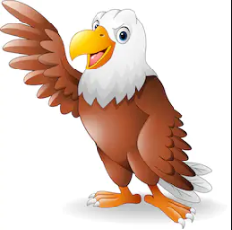
History
Mummies
Write like an Egyptian

English
Instructional writing (how to make a mummy).
Newspaper report
Poetry writing
biography
Grammar
Clause/phrase difference
Subordinate clause
Word families
Standard English
Computing
Internet safety
Spread sheets

DT
Create Egyptian pyramids
Geography
Where did the Egyptians live?
Rivers
P.E
Athletics
Science
Solid, liquid or gas
Heating and cooling
Water cycle
evaporation
R.E
Islam

Times Tables
Review all
Recall speed

SMSC
Well-being

Egyptian silhouette art
Spelling
Revision of common exception words
Suffixes
Recap spelling rules
Music
Egyptian music
Golden Eagles
Term 4
Ancient Egyptians
Maths
Position and directions
Recap division and multiplication



