Wednesday 27.01.21
English task
Today we are going to take our three argument and plan this into our letter. Please watch the lesson video and then complete the letter planning sheet below. Remember your plan is to put your ideas together but you can always add or change things later.
Think about:
- Your letter checklist
- Using formal language
- Using emotive language
- Use 3/4 spelling words
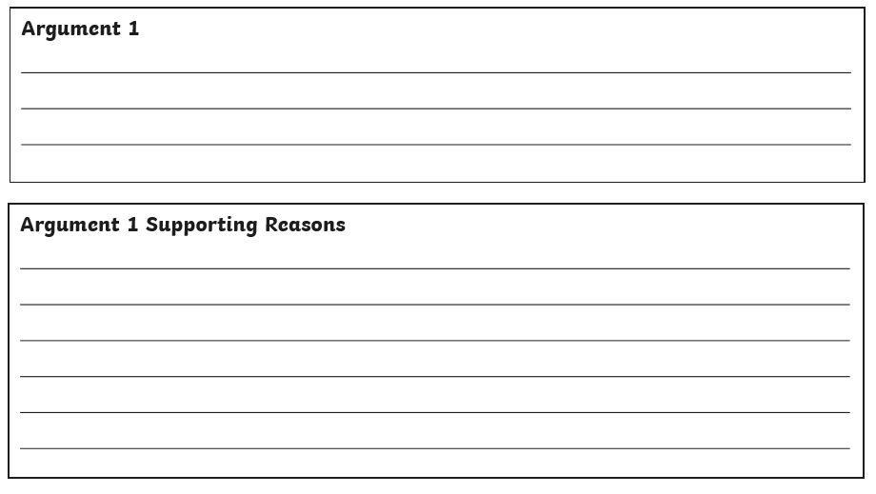
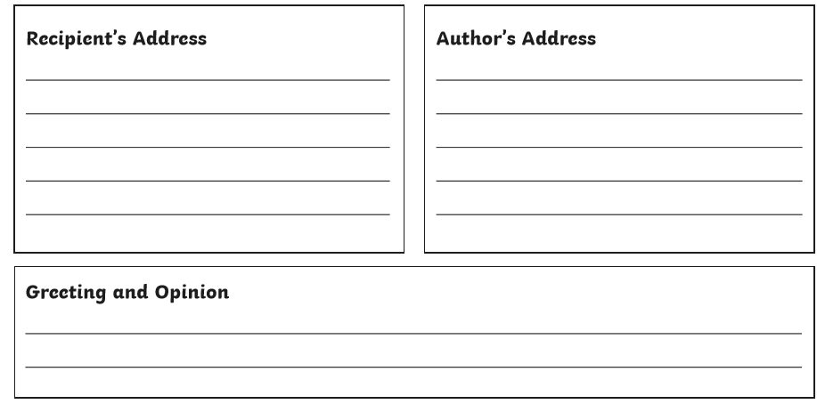
- Use fronted adverbials
- Use persuasive sentence starters (firstly, secondly, furthermore)
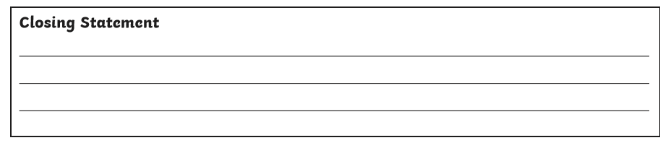
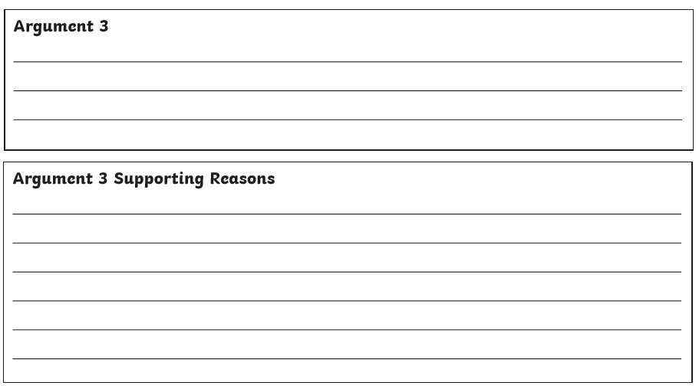
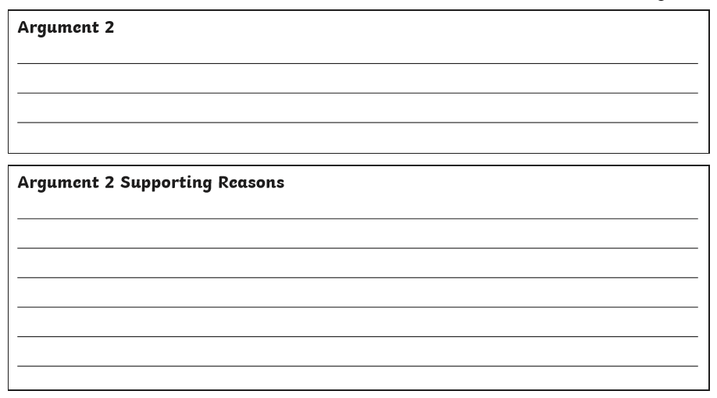

Maths Task
Starter activity
- 763 – 233
- 673 – 432
- 874 – 232
- 746 – 124
- 342-31
- 7634 -1763
- 3487 – 2394
- 9863 – 4231
- 8672 – 3243
- 3412 – 3276
Main task
Year 3 L.O. To compare and use mixed units of weight (see video)
Please complete page 81 of your Target Maths book – you do not need to complete all sections.

Year 4 L.O. To practice converting units of length
Please complete page 85 of your Target maths books – you do not need to complete all sections
Topic
Reading activity
Please complete the reading comprehension all about Shirley Chisholm that can be found on the separate sheet on the class page.
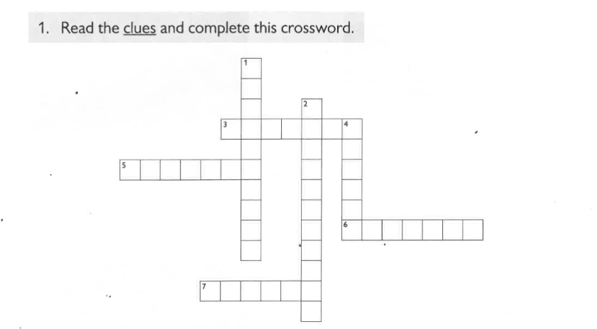
Coming to the Americas


