
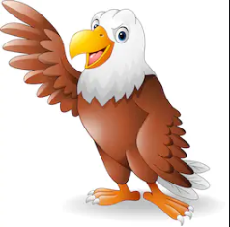
Science
Classifying vertebrates’ mammals
Reptiles
Amphibians
Fish
Birds
Classifying invertebrates
A guide to local living things
Messy maps
Howard Hodgkins
Computing
Internet safety
Branching databases

DT
Pancake day (history of pancake day in the UK)
Geography
Label human features (UK)
Label physical features (UK)
Identify features of a river
Identify features of a mountain
P.E
Gymnastics
R.E
Hinduism

Times Tables
11 times table
12 times table
Review all

History
Robert Burns
SMSC
What makes a family
Managing our emotions

Grammar
Pronouns (inc cohesion and possessive pronouns)
Speech punctuation
Apostrophes singular and plural possession,
Spelling
Revision of common exception words
Ending spelt – tion, sion, ssion, cian
Revision of common exception words
Music
Living sounds
Times tables songs
English
Persuasive letters (building on nature area)
Postcard
Fact file

Golden Eagles
Term 4
The UK
Maths
Measure- length and capacity
Perimeter and area
Mass and capacity
Time
Statistics

