Monday 25.01.21
English Task
L.O To understand the features of a persuasive letter.
Please watch the lesson video about the features of a persuasive letter. Can you read the example below and then pick out the features by underlining/colouring or writing where we find the features and examples?

Spring Primary School
Spring rd.
London
L2 3JK
21.01.21
4 Meadow Lane
Spalding
Lincs
PE 11 4TD
Dear Mr Smith,
Having been a pupil at Spring Primary for the last seven years, I feel it is now my duty to relate to you the feelings of your students towards wearing a school uniform. It has long been felt by myself, and my peers, that wearing a school uniform is an outdated and impractical notion, which we no longer feel is necessary. By writing this letter, I hope to convince you that this is the case, and begin negotiations on changing this rule.
My reasons for not wearing uniform are as follows:
To begin with, a recent survey conducted by the school council identified that an overwhelming majority of 79% of pupils would prefer to wear their own clothes to school. As a Head Teacher, it is your duty to listen to and consider any opinions of your students and to negotiate with them. As the school council are an elected body of students from all the classes in the school, it is important that you take heed of any information they discover about the wants and needs of the pupils.
Secondly, myself and my peers feel more comfortable and at ease in our own clothes. This is important as the more comfortable we feel, the better we are able to concentrate on the work we are doing. If we are constantly fiddling with stiff collars, itchy trousers and uncomfortable shoes, this distracts us from the task in hand. Moreover, this distracts us from learning. Therefore, wearing our own clothes would improve and lengthen our learning time and ultimately impact and improve our achievement in school. (The school’s position on the league tables would rocket – and OFSTED would see that the Leaders and Teachers in school are working hard and getting results)!
Finally, our parents would also benefit from the move to not wearing school uniform. Gone will be the excuses of not wearing uniform as our parents did not get it washed in time! Wearing our own clothes would mean there would be no lack of options. Parents would no longer have the mad Sunday rush of getting our uniforms washed and ironed in time for Monday. It would also reduce the amount that our parents have to pay towards clothing us. Good quality school uniform that lasts does not come cheap! Indeed – the money saved could be put towards school fund to buy new books, or stationary resources for our home, so we are able to effectively complete our homework.
As you can see, there are compelling arguments as to why the children of Spring Primary school should be able to abandon their uniforms in favour of more cost effective, practical and achievement boosting home clothes.
Please consider the points I have raised in this letter carefully. My fellow students and I look forward to hearing your response
Yours sincerely

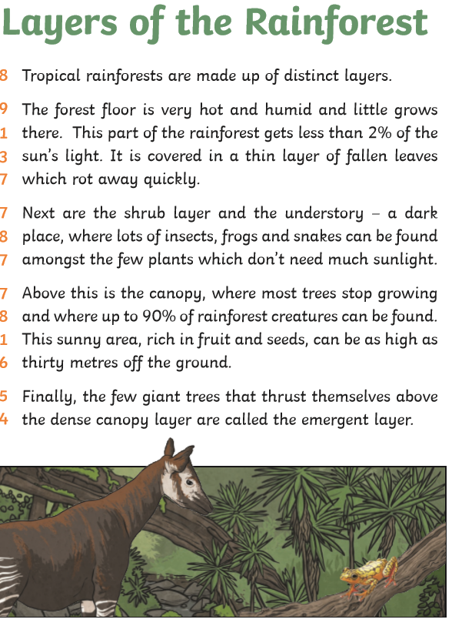
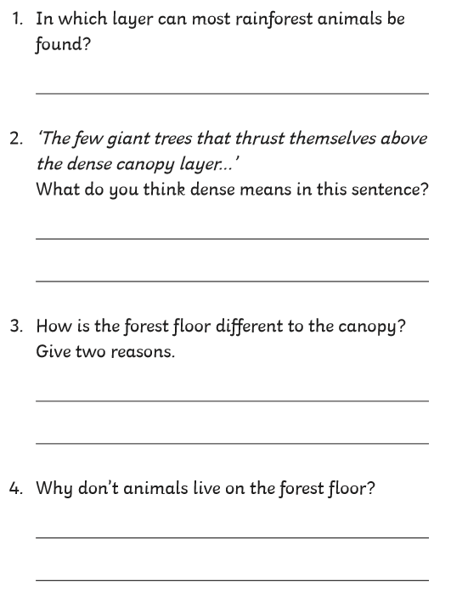
Reading task

Maths task
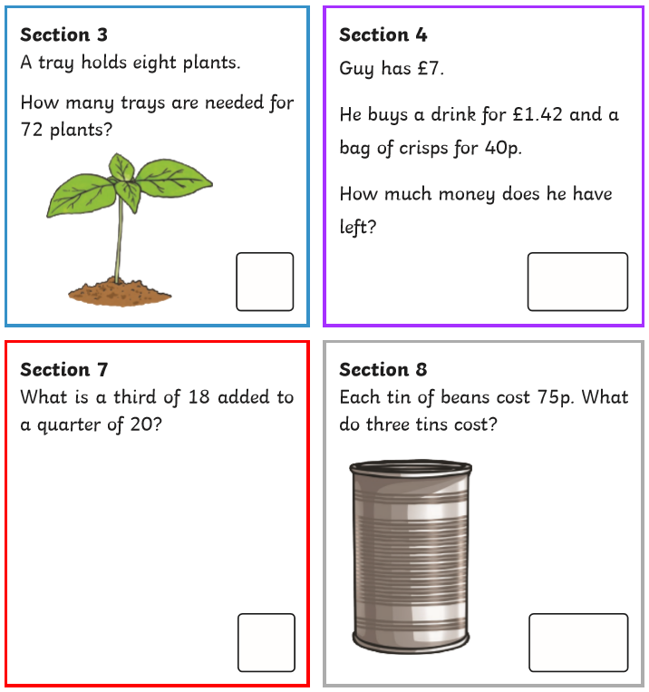
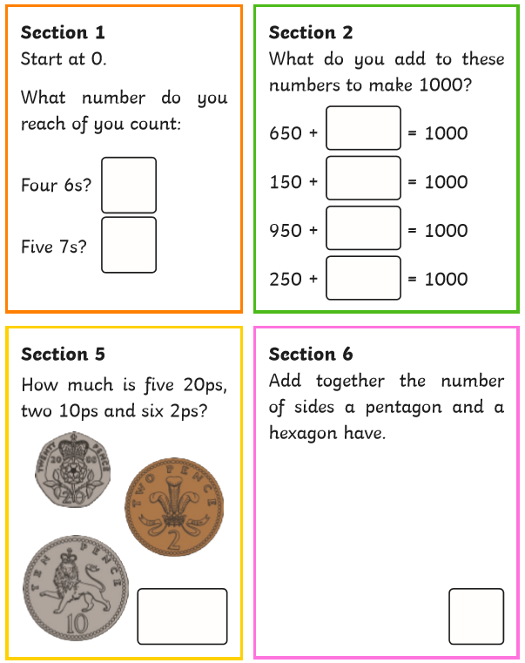
Starter Activity

Main task
L.O. To use a range of scales to measure weight and capacity
Please watch the lesson video and the complete page 73 in your Target Maths Book (Year 3 book) or see the copy below.
Remember to practice your times tables, this weeks check will be for all the times tables we have concentrated on so far (2,3,4,5,6,7,8 and 10).

Topic
Mola art

Please watch the lesson explanation video and the Mola art video.
Can you recreate your own Mola art for a t-shirt design. You can use any resources that you have at home (paint, crayons, black and white pencil)

Spelling
Please use the spelling menu to practice your spelling for this week. We are still focusing on prefixes. This week’s spelling include: un and dis.
uncomfortable
undisturbed
ungrateful
unpleasant
unpopular
unusual
disable
disagree
disarm
discover
disgrace
dislike

