Tuesday 26.01.21
English Task
Today we are going to start planning our persuasive letter. For your letter you need to have three clear arguments for why the company should stop cutting the forest down in the Amazon Rainforest. This needs to be clear and detailed. You need to select an argument and then have supporting evidence to back up your opinion.
For example;
Argument 1:
Deforestation causes more Carbon Dioxide to remain in the atmosphere.
Supporting evidence/ argument
Trees are the lungs of the world and convert carbon dioxide back into oxygen, which all living things need to survive. Tropical deforestation accounts for about 10 percent of the world's global warming pollution.

Use your knowledge and the facts sheets on the class webpage to come up with three arguments for deforestation in the Amazon rainforest to stop. Include supporting evidence and arguments to back up your claim (as with my example).

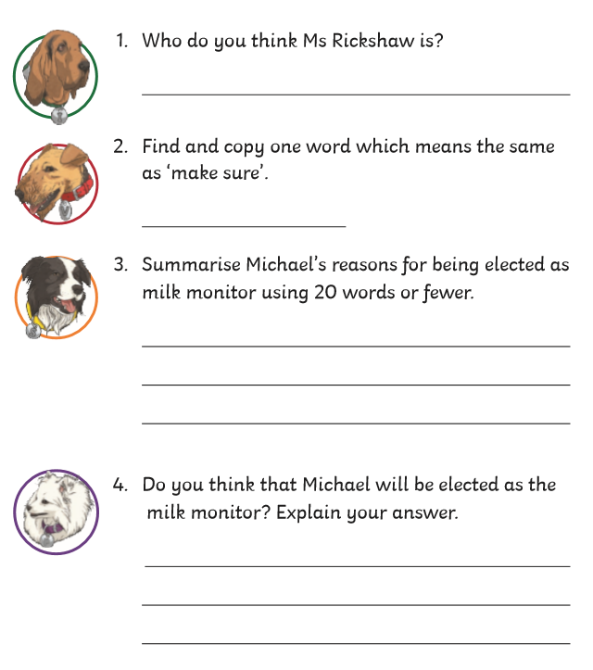
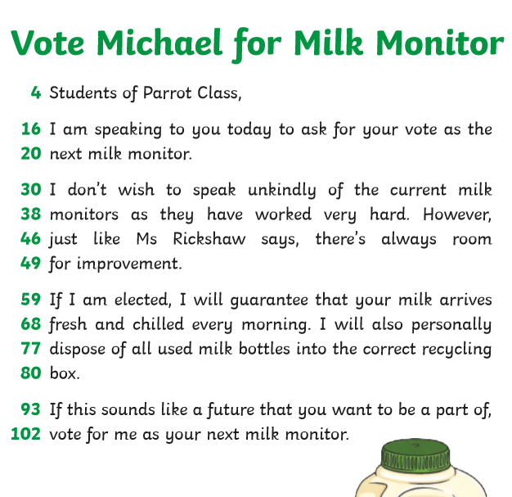
Reading activity

Maths tasks
Starter activity
Arrange the numbers to fit the criteria
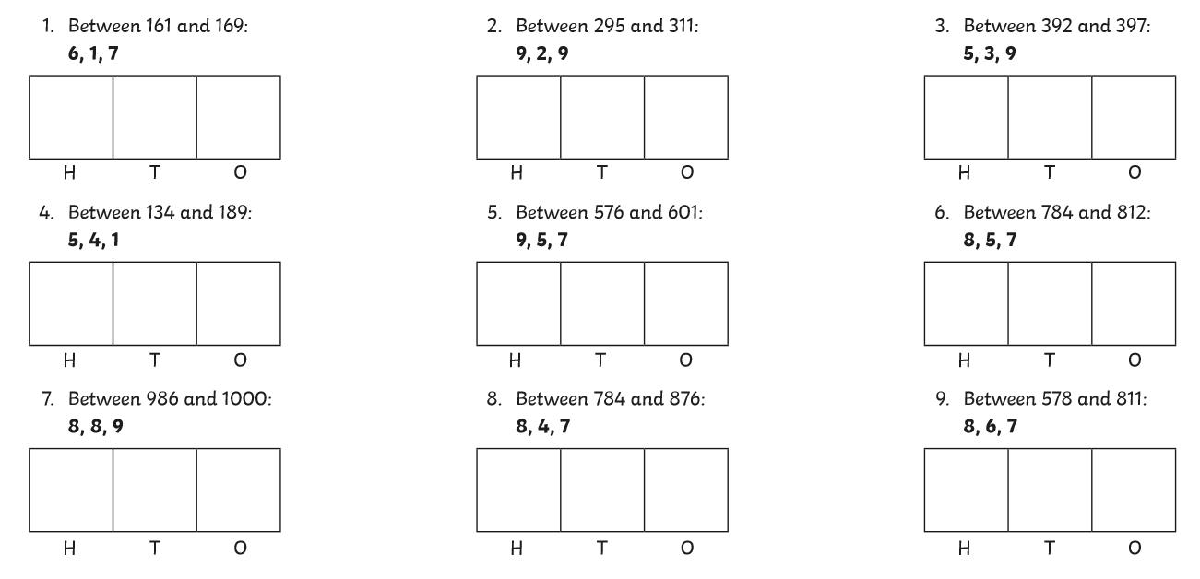

Main task
Year 3 – L.O. To compare and use mixed units of length (see video)
Please complete page 80 of your Target Maths book. You do not need to complete all sections.

Year 4 L.O. To convert between ml and l (see video)
Please complete page 84 of your Target Maths book. You do not need to complete all sections.

Topic
Times tables – Please complete your times tables check using the printable sheet or the online test – try to complete 52 questions on 2,3,4,5,6,7,8 and 10 times tables including division.

Science
Today we have two new tasks to complete for the scientist at P and L Toys.
The first task is to investigate how weight effects the amount of force needed to pull and object as the company is wanting to create new pull along toys. Please watch the investigation video and complete the task as shown, recording your results as below.
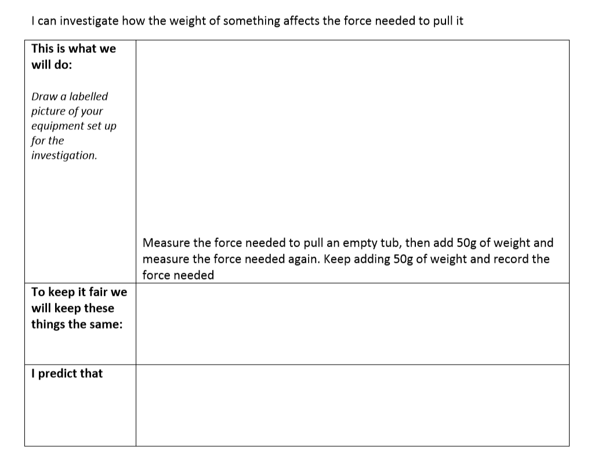
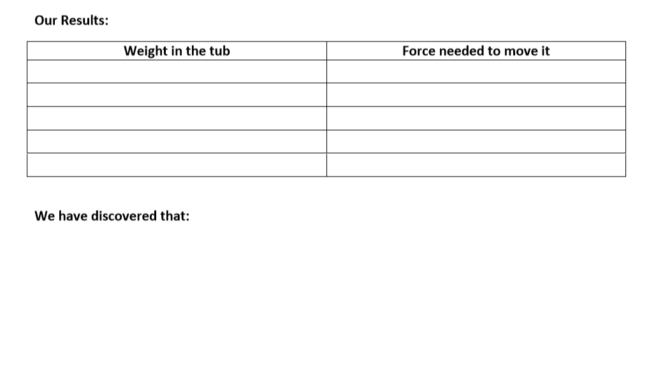


The second task is to investigate the forces need to make the toys we have work – Is it a push, pull or both? Please select a range of toys from your house and write if it needs a push, pull or both.

