Friday 29.01.21
English Task
Todays task is to complete your letter draft to include your next two arguments and conclusion. (please see lesson video to help you)

Reading task
‘Good gracious me!’ Aunt Spiker said, ‘What’s that awful noise?’
Both women swing round to look. The noise, of course, had been caused by the peach crashing through the fence that surrounded it, and now, gathering speed every second, it came rolling across the garden towards the place where Aunt Sponge and Aunt Spiker were standing.
The gaped. They screamed. They started to run. They panicked. They both got in each other’s way. They began pushing and jostling and each one of them was thinking only about saving herself. Aunt Sponge, the fat one, tripped over a box that she’d brought along to keep the money in and fell flat on her face.

Write the answers in full sentences:
- What did the peach crash through?

- What was the peach rolling towards?

- Write 3 things that the Aunts did when they saw the peach rolling.

- Which Aunt tripped over a box?

- What had the Aunt brought the box along for?

- What did Aunt Sponge fall on?

Maths Task
Starter
Have a go at answering the really tricky word puzzle.

A number has a 2 in the tens place, a 3 in the ones place and a 7 in the thousands place. It has 5 digits. The total of all the digits is 18.
What could the number be?

Main task
Year 3 L.O. To solve word problems involving measure
Please complete page 100 in your target maths books. You do not need to complete all sections.

Year 4 L.O To practice converting units of capacity
Please complete page 87 in your target maths books. You do not need to complete all sections.

Topic
Grammar
Using present and past tense verbs
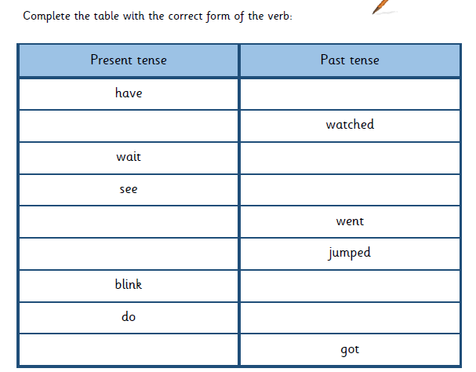
Please watch the video and complete the table below.

Can you correct the paragraph below
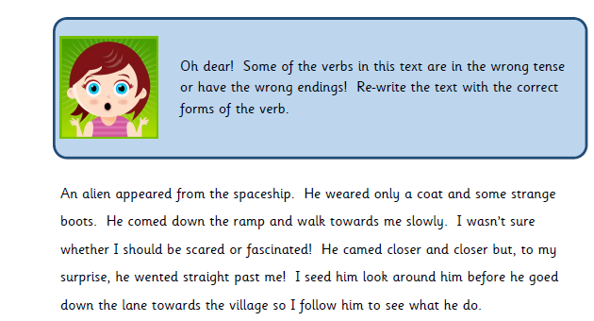

R.E Pilgrimage
Please watch the video about where Jewish people go on pilgrimage. Imagine that you visited the Western Wall.

Can you write a short message or prayer that you could place into the wall? This does not need to be read by anyone else or sent to me but is for you to think about and reflect on what you would say. You could even fold this up and put it somewhere safe that you can come back to in the future.

