Tuesday 19.01.21
English task
Please watch the videos and use your own research to find out the effects of deforestation on the rainforest.
Plants
Animals
People

Write one sentence for each of the 3 sections using something you have found out.
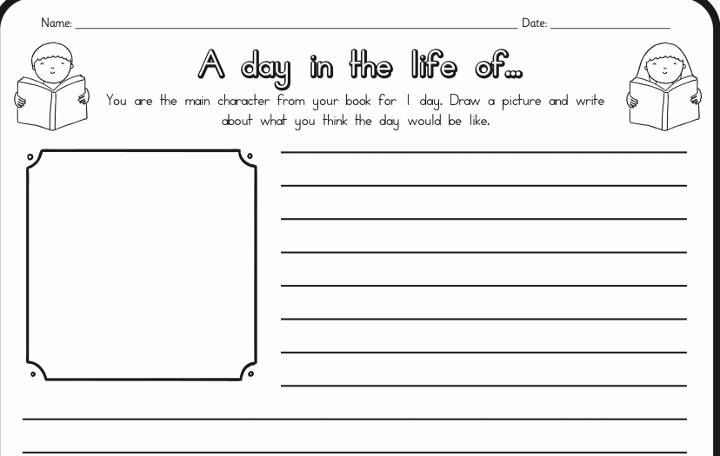
Reading task
Maths activity
Starter activity
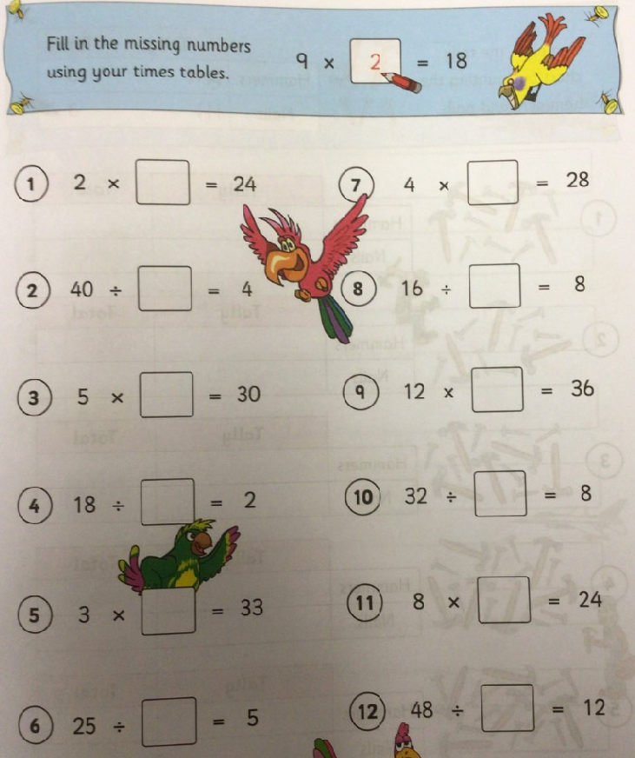

Main task
L.O. To find the area of irregular shapes by counting squares and to find their perimeters.
Today we are working from the year 4 Target maths book (year 3 please see copied page below) Please watch the video then complete page 94 starting with A. Typically, Maths lesson last 1hr (including times table work) so please complete as much learning as you can in this time. You do not need to complete A, B and C especially if you are finding this tricky.
Topic
Please complete your times tables check either using the online test or printing a paper copy from the school website.

Science
Starter activity: Think about what you already know about forces and magnet and put your knowledge onto the mind map. Use the question to help your think about your ideas (you do not have to answer the questions) – You can also include things your notices from your experiment last week.

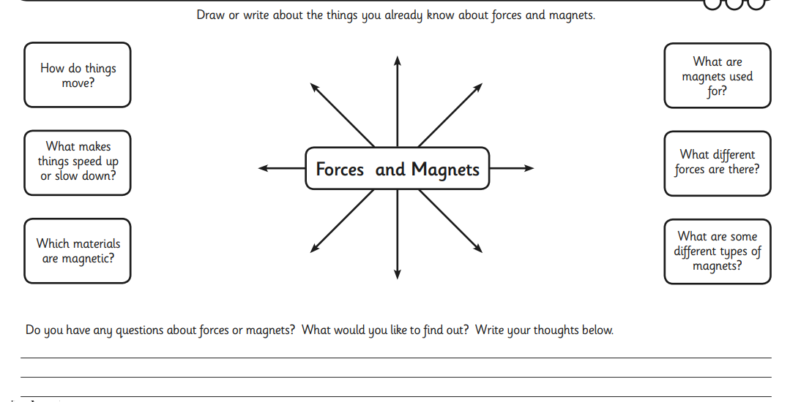

L.O To identify forces as a push or a pull.
Please watch the lesson video on pushes and pulls then complete the following task.


