Wednesday 20.01.21
English Task
Please watch the video on Deforestation in the Amazon Rainforest and answer the following questions:
- Is deforestation right?
- Do you agree that cutting down trees is necessary?
- What about people’s jobs?
- How could we avoid deforestation?
There is no right or wrong answer you just have to write what you think using the information from the videos or your own knowledge.
Please write your answers in full sentence and explain why you think this. For questions one you need to explain why you think deforestation is right/wrong and not just answer yes or no.
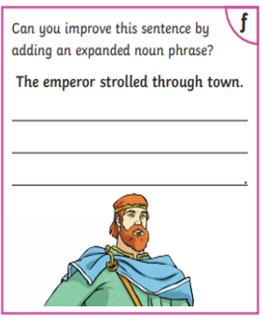
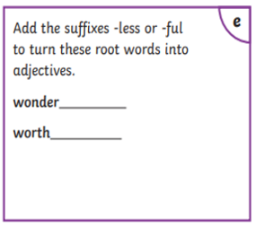
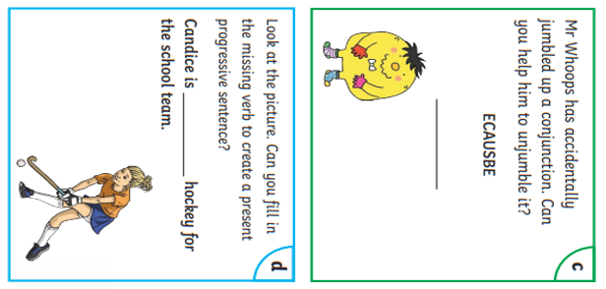
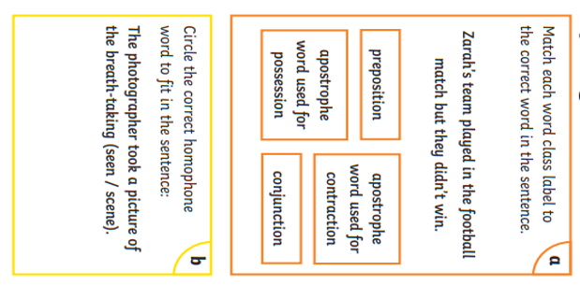
Spelling and Grammar activity

Maths Activity
Starter:
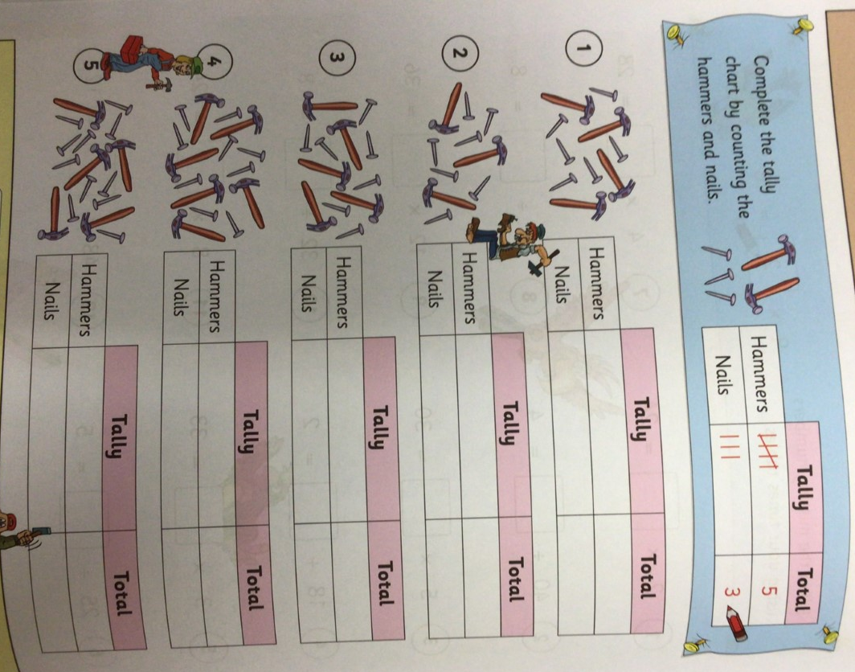

Main task Year 3 L.O To solve perimeter word problems.
You do not have to complete all of the challenges, please try to complete 1hrs worth of maths learning including the starter and times tables practice. Please watch the supporting video before starting the challenges.

Challenge 1
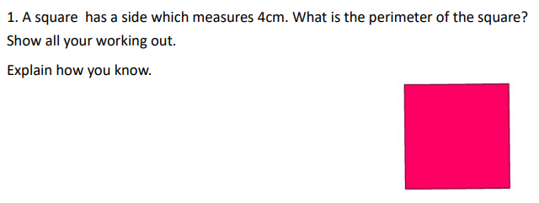
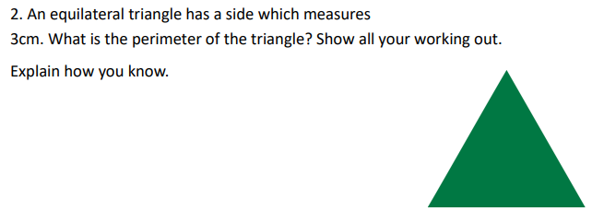
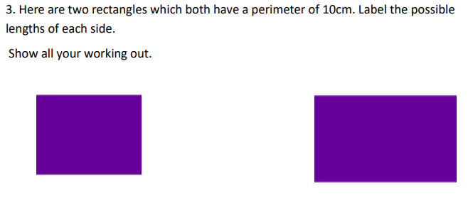
Challenge 2
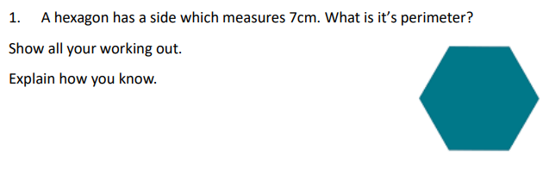

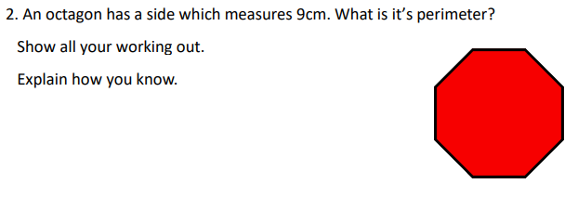

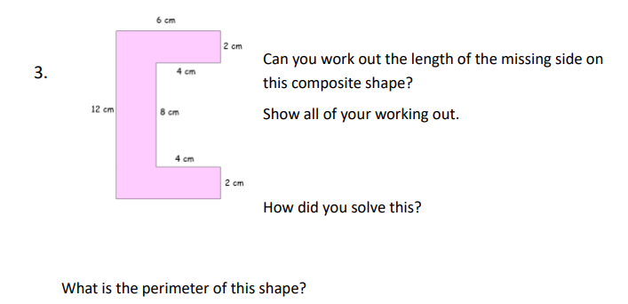
Challenge 3
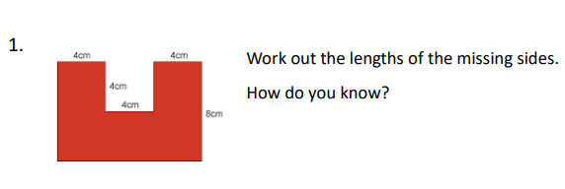
What is the perimeter of the shape?

Year 4 L.O. To calculate the perimeter of a 2D shape.
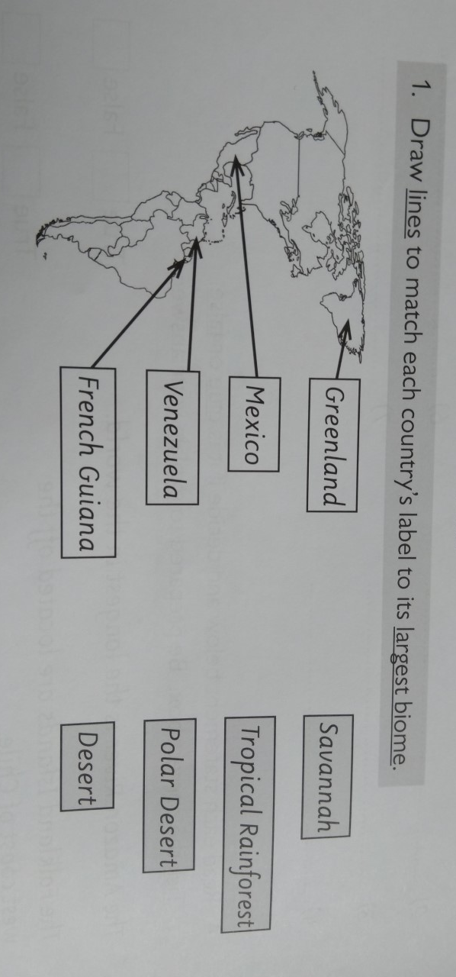
Please watch the video and work from your Target Maths book page 96. Start on A and work through the questions. You do not need to complete all of the sections.

Topic
L.O To understand the different biomes across North and South America

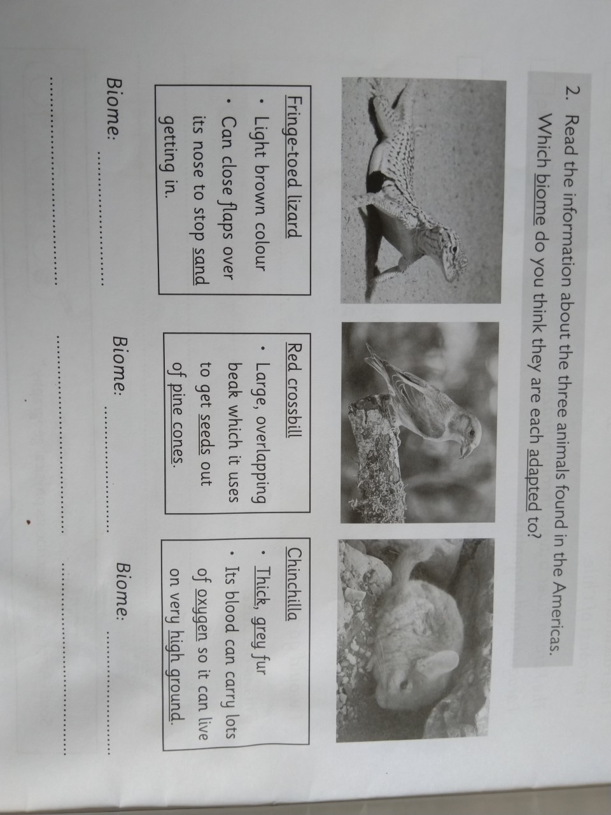
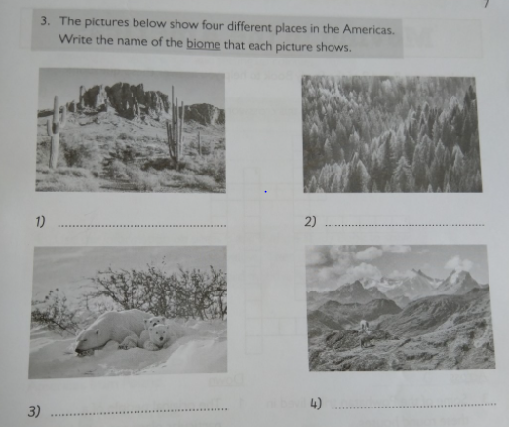
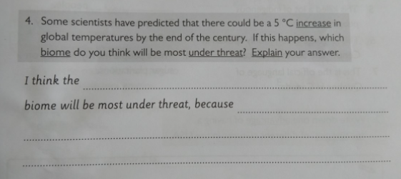

Extension task (optional)
Make a poster to show the 10 biomes within North and South America.

