Friday 22.01.21
English Task
Grammar L.O. To use commas when writing a list (See writing commas in a list video).
Task Take out the extra ands and put in the commas.
- The packet contained red and blue and green and yellow felt tips.
- At the top of the league were Birmingham and Manchester United and Crewe and Aston Villa and Walsall Town.
- Violins and recorders and drums and guitars were all set out in the music room.
- Britain is made up of England and Scotland and Wales and Northern Ireland.
- The tube was full of purple and green and yellow and red Smarties.
- George had sandwiches and crisps and chocolate and cakes in his packed lunch box.
- Leah had invited Alex and Josh and Matthew and Oliver and Denum and Danielle to her birthday party.
- The children loved it at the zoo. They saw monkeys and hippos and tigers and lions and a big polar bear.
Task 2 - Complete the sentence using the picture and include commas where necessary.
1. Courtney bought
A dress | a teddy bear | some chocolate
2. Amaree bought
an apple | a banana | a book | some sweets
3. Byron bought
A football | a bike | a video game | a hamster

Reading Task – L.O. To make inferences from a picture
Taking flight
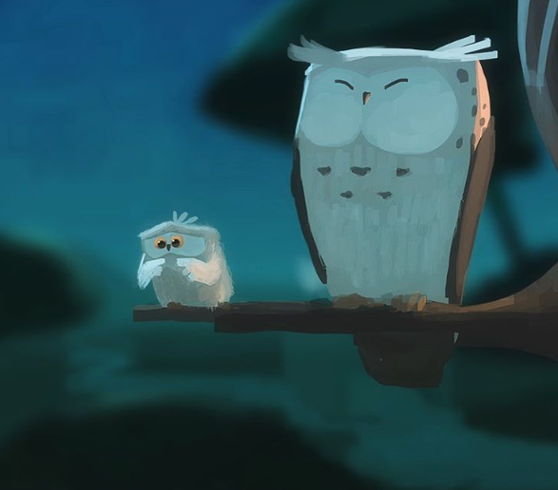

- How are the owls related?
- Which owl is about to take its first flight? How do you know?
- How does the young owl feel about flying?
- What might it be thinking? Add a thought bubble to the picture.
- Is the older owl worried?
- What advice might the older owl give to the younger one?
- Think of the first time you did something new. How did you feel about it before and after?

Maths task
Starter activity

L.O To use a range of scales to measure weight.
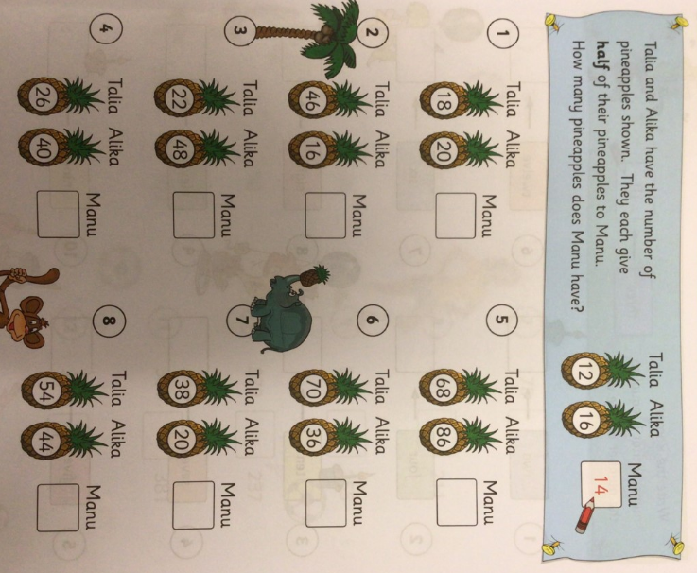
Main task:
Please watch the lesson video then complete the questions below (Year 3 TM page 72) Please start on A and work through the questions (please complete 1hrs worth of learning to include the starter and times tables learning).

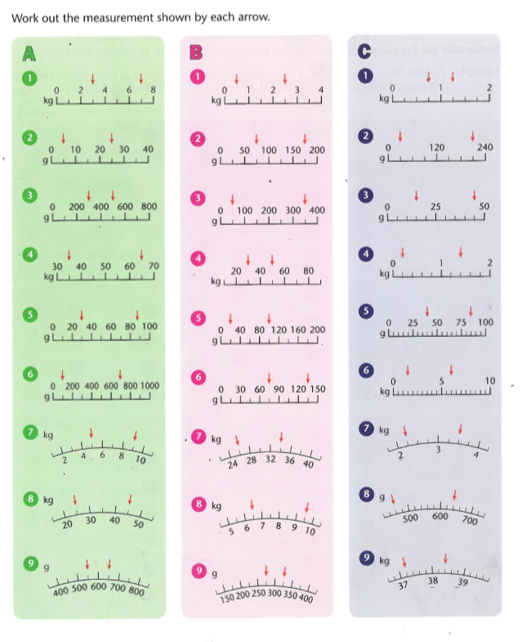

Topic
Pilgrimage
Please watch the lesson video and listen to the story of Bernadette in Lourdes.
Can you retell the key parts of the story in pictures and words, using the 6 keys parts of the story as shown below? You only need one or two sentences for each part.
- Bernadette collects sticks with her sister.
- Bernadette saw the vision of a beautiful lady as she crossed the river.
- Bernadette prayed with the vision then found the water to be warm when she crossed it.
- No-one believed what Bernadette had seen.
- Bernadette went back to the cave and people began to crowd the area to see what was happening.
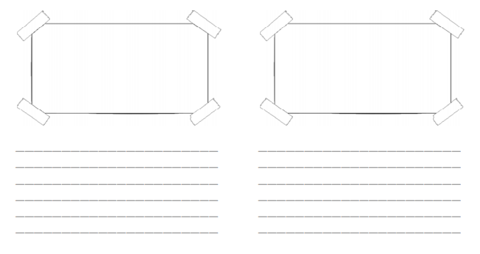
- Bernadette dug into the mud to find the trickle of water that is thought to heal people.

