The Story of Bernadette of Lourdes
Bernadette was born in a small town in France called Lourdes. Her family was very poor and had to share one cold room. The only way to keep warm was to burn sticks which the children had to collect.
One cold winter's day, Bernadette, her sister, Tionette, and her friend, Jeanne, were gathering firewood beside a river. They had been out all day and it was now growing dark. Tionette and Jeanne set off for home, crossing the icy cold river in their bare feet. Bernadette hesitated. She didn't want to cross the river because it was so cold and she felt getting her feet wet might bring on her asthma.
Tionette and Jeanne called to her from the other side of the river. Bernadette was just about to follow them across, when she heard the sound of a great wind. She looked round and out of a cave in the rock, came a beautiful young lady. She wore a sparkling white dress and a veil. She smiled at Bernadette and beckoned to her to come closer. Bernadette could not believe what she was seeing but she was not afraid. She knelt down and began to pray. The lady prayed with her. After a while, the vision of the lady disappeared.
Tionette and Jeanne returned to find Bernadette kneeling. They urged her to hurry across the river. Bernadette put her foot in the water. It felt warm. On the way home, Bernadette told Tionette and Jeanne about the beautiful lady. They didn't believe her. Bernadette's mum did not believe her either. "Such nonsense!" she said, "you are never to go back to that cave again".
Bernadette pleaded with her mum and, after three days, she was allowed to return to the cave. She saw the beautiful lady and, again, they prayed together. After that, Bernadette went to pray with the lady, day after day. People got to hear about Bernadette and her vision and large crowds followed her to the cave. But no one, except Bernadette, could see the vision of the beautiful lady.
One day 300 people had gathered when Bernadette went to the cave. As before, the beautiful lady appeared to Bernadette. This time she told her to dig a hole in the ground, drink the water and bathe in it.
Bernadette looked around but could see no water, so she started scratching away at the mud beneath her feet. As she scratched at the mud, she was amazed to find a tiny trickle of water, so she did what she was told, cupped her hands and drank the muddy water. The people watching were disgusted, for again, they saw no beautiful lady – only Bernadette, drinking muddy water! And as Bernadette drank she was amazed as the trickle of water became a steadier trickle and then slowly turned into a spring. The lady told her that this would be a spring to heal people of their illnesses. She asked Bernadette to build a chapel by the side of the spring, which is just what she did.
Bernadette found out who this beautiful lady was only on the very last time that she appeared.
“Who are you?” asked Bernadette.
“I am the Immaculate Conception - Mary, mother of Jesus.”
Bernadette fell to her knees in a tremble. When she looked up, Mary had vanished.
Some people said Bernadette was mad and laughed at her. Others said she was lying and shouted at her. She was slapped and spat upon. She was spoken to by her teacher, her priest, the local police and other important people who came all the way from Paris. All of these people wanted Bernadette to say that her vision of the beautiful lady was not real.
Bernadette answered all their questions in a quiet, gentle way. But she would not give up her belief that her vision of the beautiful lady was real.
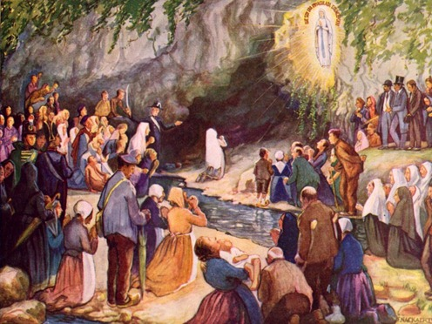
And to this day, ill people travel to Lourdes in France to the stream which still trickles. They bathe in the waters there in the hope that they will be healed. There are many stories of people being healed at the waters of Lourdes and millions travel there each year on pilgrimage.

