Monday 18.01.21
English – reading activity
Please find the reading sheet in the separate document, once you have read the text complete the challenges below. If you find challenge 1 tricky then move on to the grammar activity rather then completing the further challenges.
Challenge 1
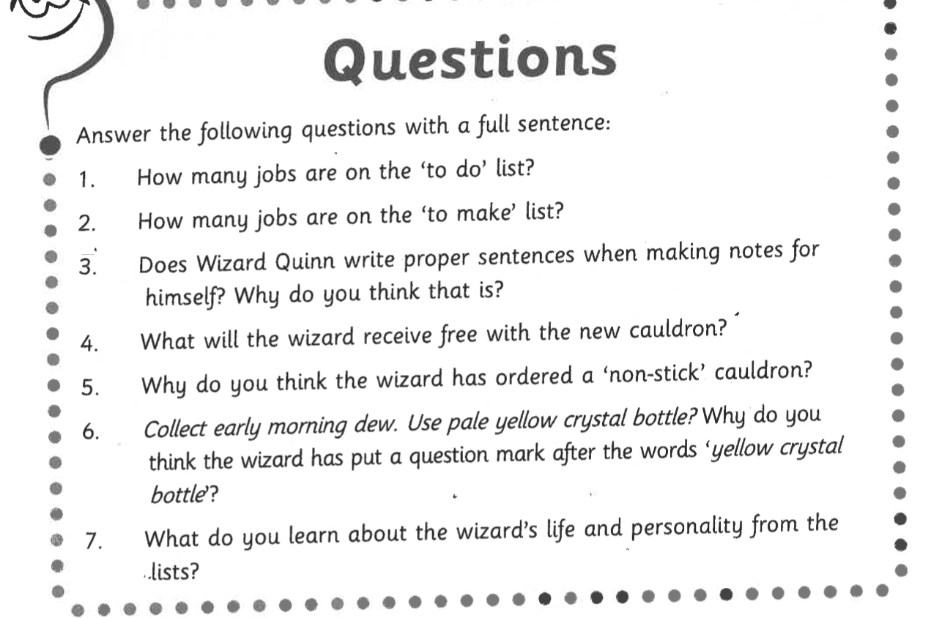

Challenge 2
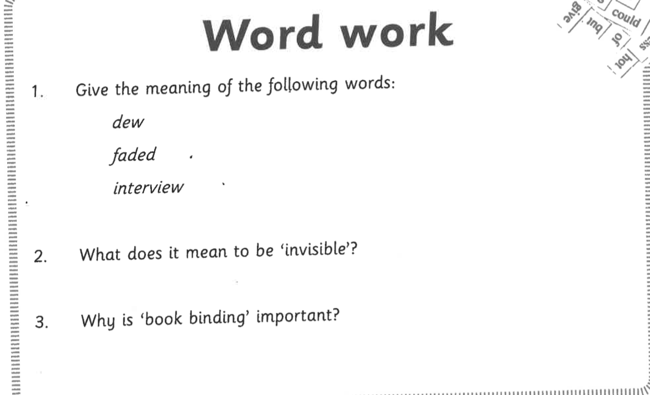

Challenge 3
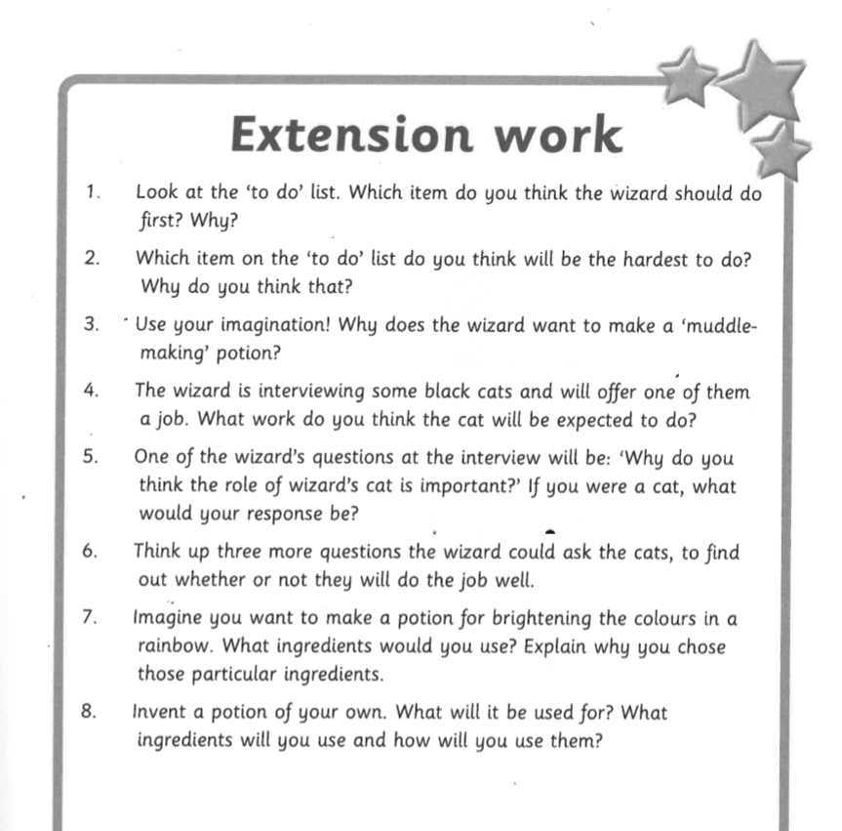

Grammar task - Year 4 Only
Fronted adverbials – L.O. Identify and punctuate adverbial phrases
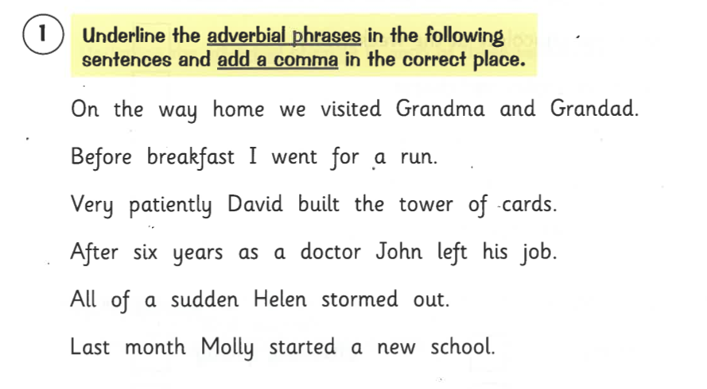
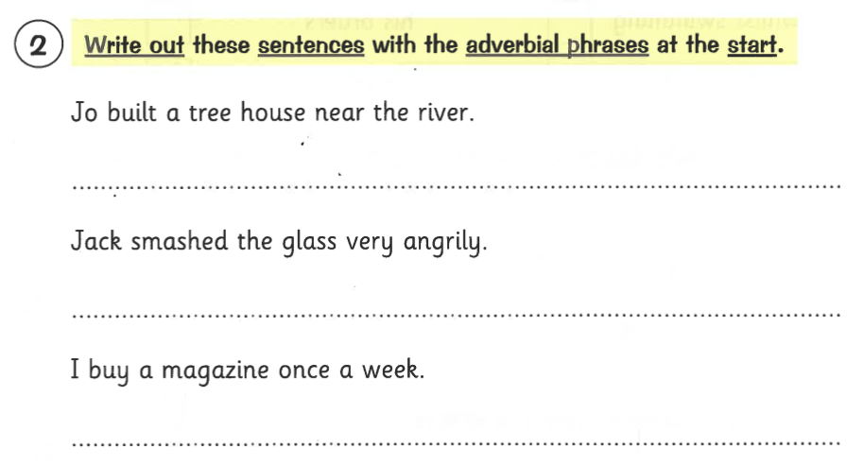
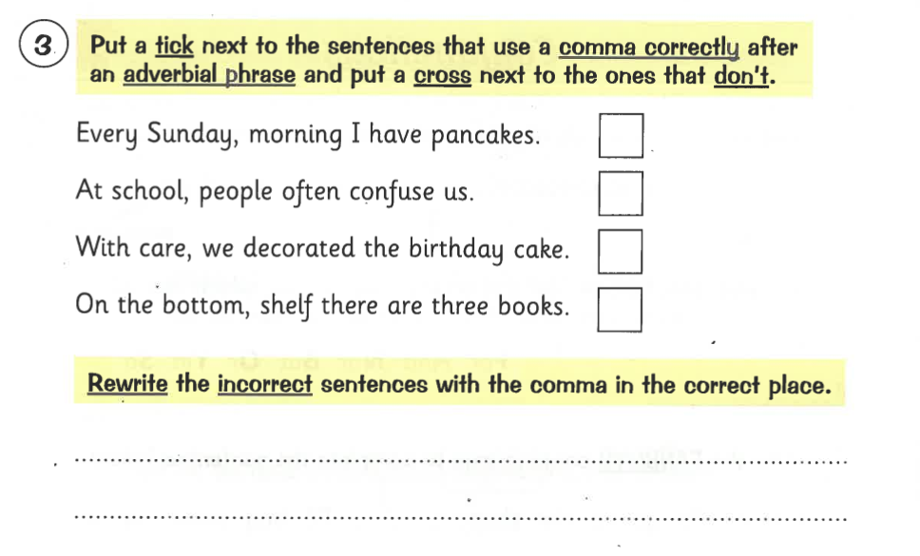
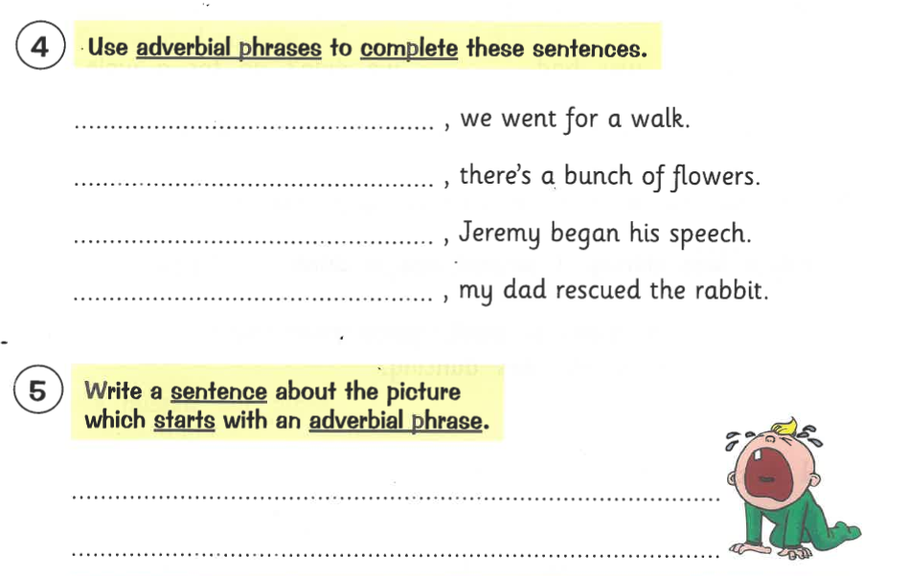

Grammar task Year 3 Only
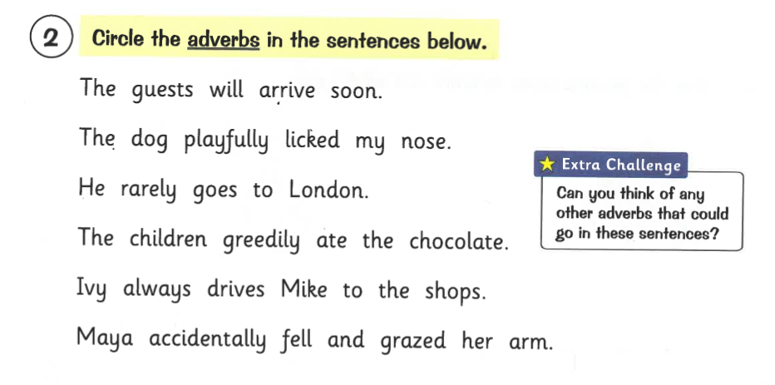
L.O. To identify adverbs and use them in a sentence.
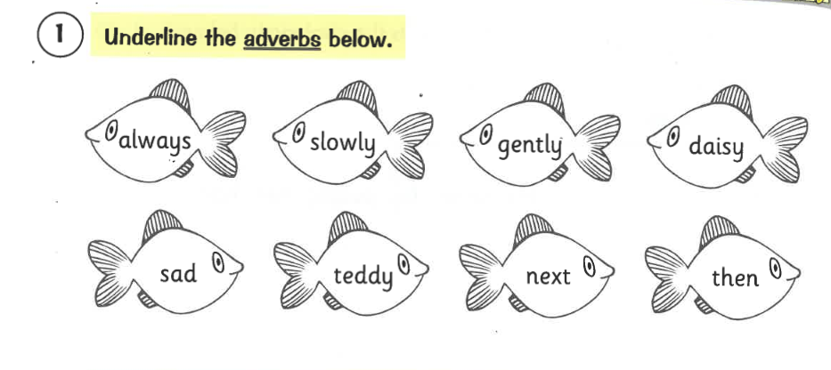
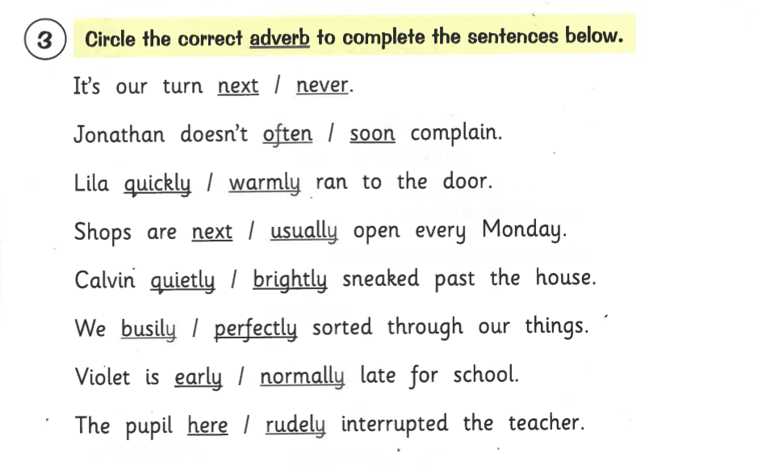
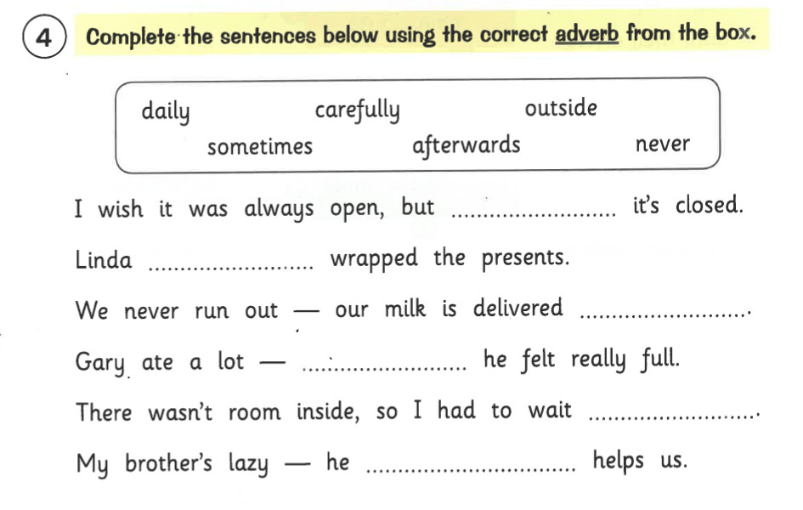

Maths activity
Today we are going to be learning about perimeter and how to measure the perimeter of a 2D shape. Please watch the lesson support video and complete the following pages from your Target Maths books
Year 3 – Page 78/79
Please start on A and complete the questions, if you find this tricky then do not complete B and C.

Year 4 – Page 92/92
Please start on A and complete the questions, if you find this tricky then do not complete B and C.

Topic
Spelling - please practice your spelling using one of the methods from the spelling menu.

unpack
unselfish
unwilling
unwell
unwilling
unaccompanied
unannounced
unappealing
unbelievable
unbreakable
uncertain
uninterested

Geography
Identifying the layers of the rainforest
Can you number each label and fact, to match the correct layer of the rainforest? Use the pictures below.

Extension Task (to be completed after you have labelled the layers of the rainforest
If you finish this task quickly you can create a poster to show the layers of the rainforest and the facts we have learned today.


