Thursday 21.01.21
English Task
Please complete the reading comprehension task which can be found in the separate sheet. There are 3 different tasks depending on which book band you usually read from.
brown/grey book band please complete task A
green/orange/white/lime please complete task B
Free readers please complete task C
Please try to write your answers in a full sentence.

Grammar revision activity
Task one
Underline all of the common nouns and circle all of the proper nouns in each sentence.
- Henry plays games on his computer.
- Mr Fan runs in the park every Sunday.
- Caroline lives in an apartment in Caston St.
- Dr Flood is flying on a plane to Norway.
- Neena’s birthday is in March.
- Fluffy likes playing catch in Victoria Park.
- Did you see William at the party on Saturday?
- Gerrard scored a goal for Liverpool on Tuesday night.
- New Brighton was flooded because of the heavy rain.
- Quinn saw Vebus through her telescope.
Task two
Underline the adjectives in these sentences:
- The little man carried the heavy box across the wide street.
- The red house stood at the bottom of the deep valley.
- The narrow road was long and the children were tired.
- The log burned brightly in the old fireplace.
- The young lady sat down on the soft, green cushion.
- The busy bee flew to the bright flowers to gather honey.

Task three
Write 10 verbs

Maths - YEAR 3 ONLY
Starter activity
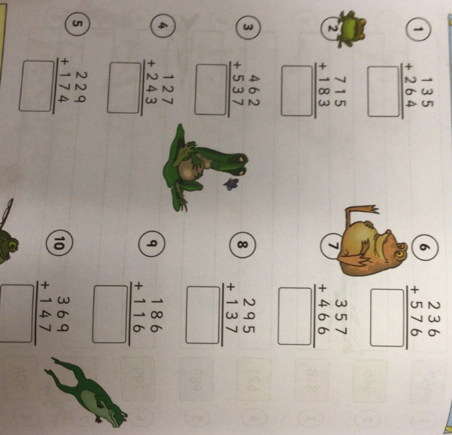
Challenge 1
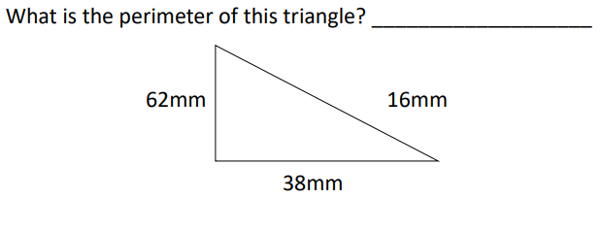
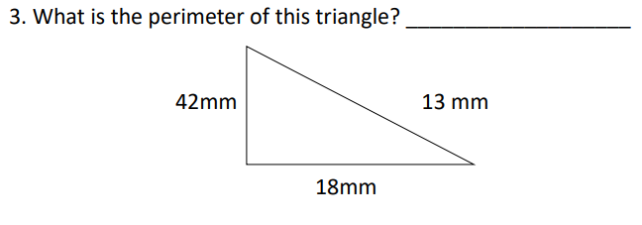
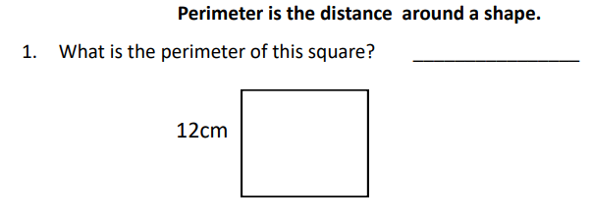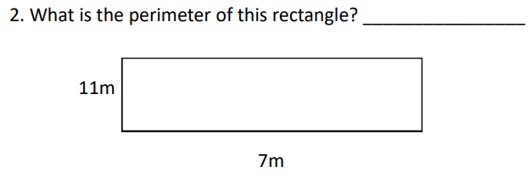

Challenge 2
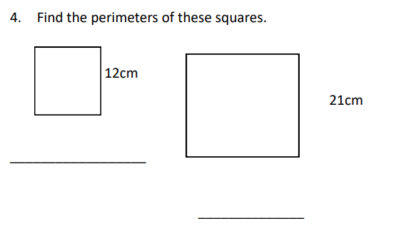
What is the difference between the perimeters of the two squares?

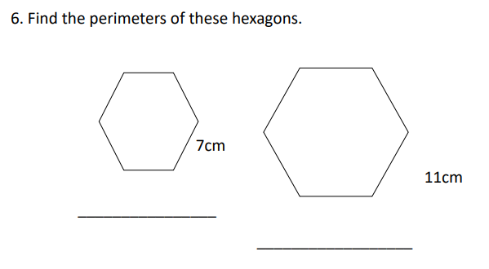
What is the difference between the perimeter of the two hexagons?

YEAR 4 learning
L.O. To find the area of a square or rectangle by multiplication. (See video lesson)
Please complete page 97 of your target maths book (try to work of 1hr including your starter activity then stop) Start with A. You do not need to complete all of the sections.
Topic
Spelling – please complete your spelling test using the words from Monday – prefix un.

P.E.
Please complete the following yoga activity – the link can also be found on the class webpage.
Yoga activity:
https://www.youtube.com/watch?v=X655B4ISakg
If you fancy something more energetic today have a go at the following activity:
Joe Wicks PE
https://www.youtube.com/results?sp=mAEB&search_query=p.e+with+joe

