Friday 5.3.21
English Task
We are beginning to plan a script of a weather forecast in Florida. Use either of the templates below to help you.

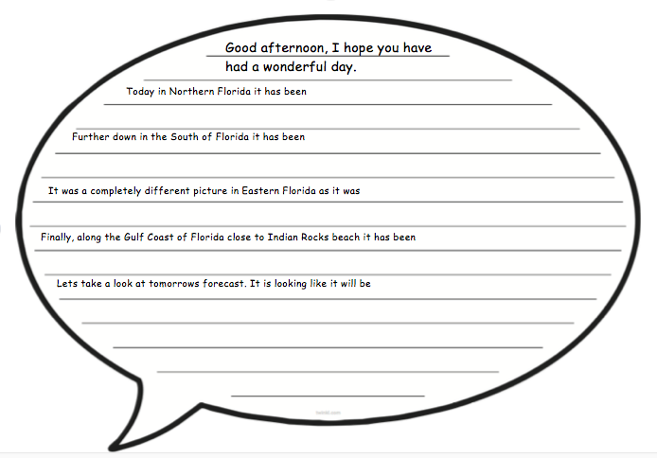

Reading Task
Please watch the video of me reading The Great Kapok Tree. Then answer the questions set out day by day on the separate document.
Maths
Starter
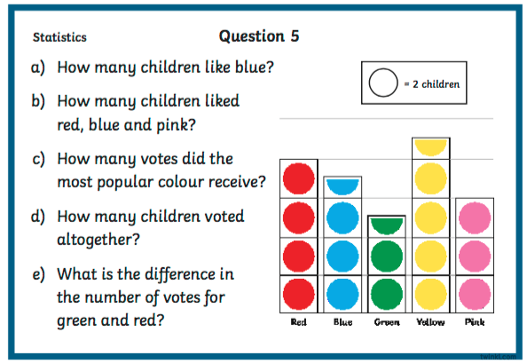

Main Task (see video)
You are going to create a horizontal and vertical bar chart using the information below on how children get to school.
Way of travelling | Number of children
walking | 16
cycling | 2
driving | 8
scooter | 0
Grammar – pronouns
Please see the video below all about pronouns. Then complete the questions from the images on the website.
https://www.bbc.co.uk/bitesize/topics/zwwp8mn/articles/z37xrwx

Computing
Please complete the to do I have set for you on purple mash. Then, practise your times tables on Times Table Rockstars.

