Monday 1.3.21
English Task
For the next two weeks, we are going to be learning about weather forecasts, and presenting our own by the end of the two weeks. Today, I would like you to make yourselves more familiar with what a weather forecast is, and what they include. Below is a number of websites and videos for you to watch. You could make notes on what you find that is similar between all of these. Please note – there is no recording needed in books for today.
Websites to explore:
https://www.bbc.co.uk/weather/2637265
https://www.metoffice.gov.uk/weather/forecast/gcruk9x9k#?date=2021-02-24
https://www.accuweather.com/en/gb/spalding/pe11-1/weather-forecast/324596
https://www.uk-weather.co.uk/East_Midlands/Weather_Forecast_Spalding__Lincolnshire/15-day
Videos to watch:
https://www.bbc.co.uk/weather/forecast-video/21416743
https://www.metoffice.gov.uk/weather/videos
https://www.itv.com/news/weather-forecast
Reading Task (see video)
Please watch the video of me reading The Great Kapok Tree. Then answer the questions set out day by day on the separate document. You may want to come back to the video tomorrow to remind you of what happened in the story.

Maths
Starter
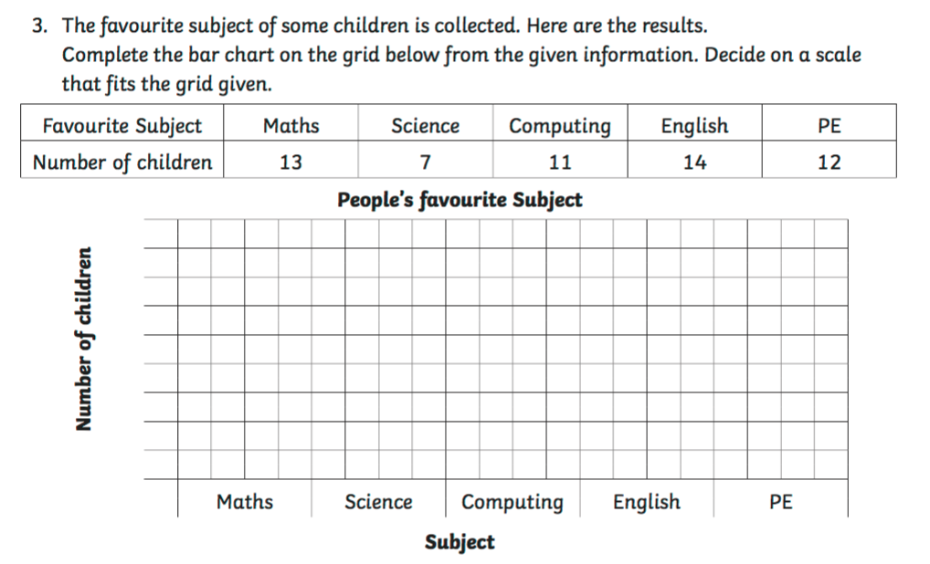

Main Task
We are interpreting and presenting continuous data. Please work through the questions on the separate images (these are only in the year 4 target maths books - please all start on section A):

Spelling
weekly
wisely
blindly
bravely
correctly
fairly
hardly
kindly
lively
lonely
loudly
proudly
Topic
Geography – Niagara Falls
Please refer to the images for the information on Niagara Falls and the questions to complete.

