Tuesday 2.3.21
English Task
Today, you are going to create a spider diagram on the features of a weather forecast.
First, watch a video online of todays weather forecast (you can Google search ‘today’s weather forecast’ and choose a website). I have given you an outline below, or you can draw your own.

Features of a weather forecast

Reading Task
Please watch the video of me reading The Great Kapok Tree. Then answer the questions set out day by day on the separate document. You may want to watch the video again.

Maths
Starter
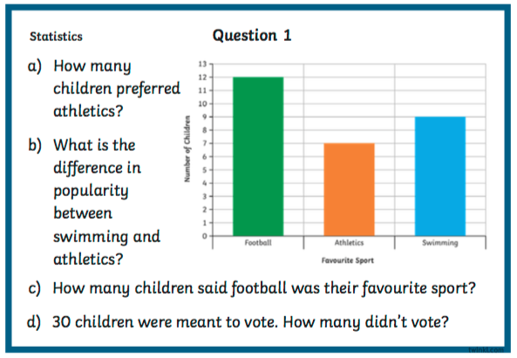

Main Task
Year 3
Please see the separate documents with interpreting pictograms, bar charts and tallies on them.
Year 4
We are interpreting and presenting continuous data again today. Please work through the questions on separate images from pages 134 and 135.

Tomorrow, we will be using data to create our own line graph (year 4) or horizontal bar graph (year 3) based on the outside temperatures. To do this, we will need the temperature outside taken today at different times of the day (if you do not have a thermometer to do this, please don’t worry – you can use the data provided in tomorrow’s overview). If you do have a thermometer, please use the table below to collect your data ready for tomorrow’s lesson:
Time | Outside Temperature
9am
11am
1pm
3pm

Science – pollination (see video)
Please watch the teaching video and then this video that explains how seeds are dispersed.
https://www.bbc.co.uk/bitesize/topics/zxfrwmn/articles/z28dpbk

You are then going to sequence either wind dispersal or animal dispersal. Use the separate document with a sequencing template on to do this. You can draw pictures and write a sentence for each step.
Times tables
Please see separate documents with times tables questions on. You can either choose the one with 52 questions, or the one with 30. The choice is yours. Remember, you can also use Times Table Rockstars to practise times tables too.

