Is Humanity the Next Supervolcano? – KS2 Comprehension
https://www.youtube.com/watch?v=rbHk1ehQJSY
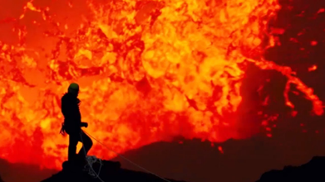
- How many mass extinction events do scientists believe the Earth has experienced in its history?
- Explain as clearly as you can what you understand the phrase ‘mass extinction event’ to mean.
- What has caused the majority of extinction events on Earth?
- Sir David Attenborough says, “Most were caused by cataclysmic volcanic eruptions.’ Which of these do you think is the most accurate definition of the word ‘cataclysmic’? Tick one.
- A small volcanic eruption.
- The global temperature increasing.
- A large-scale, violent event.
- A volcanic eruption caused by cats.
- Which invisible gas is released by volcanoes?

Answers
- At least five.
- Various possible answers – link to a large proportion of life on Earth dying out/becoming extinct at the same time.
- Volcanic eruptions.
- A large-scale, violent event.
- Carbon dioxide.

