Is Humanity the Next Supervolcano? – KS2 Comprehension
https://www.youtube.com/watch?v=rbHk1ehQJSY
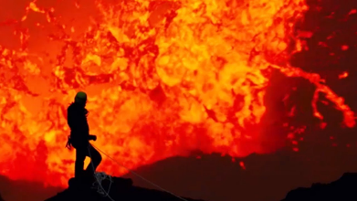
- How many mass extinction events do scientists believe the Earth has experienced in its history?
- Explain as clearly as you can what you understand the phrase ‘mass extinction event’ to mean.
- What has caused the majority of extinction events on Earth?
- Sir David Attenborough says, “Most were caused by cataclysmic volcanic eruptions.’ Which of these do you think is the most accurate definition of the word ‘cataclysmic’? Tick one.
- A small volcanic eruption.
- The global temperature increasing.
- A large-scale, violent event.
- A volcanic eruption caused by cats.
- Which invisible gas is released by volcanoes?
- What does the use of the word ‘most’ in the phrase “most were caused by…” tell you?
- Do you know of any other mass extinction events that were not caused by a volcanic eruption?
- The greatest volcanic eruption of all time is believed to have led to what rise in global temperatures?
- Find and copy a phrase that shows you that scientists are not certain about the consequences to temperature of the greatest volcanic eruption in Earth’s history.
- What percentage of life on Earth became extinct following the greatest mass extinction event?

Answers
- At least five.
- Various possible answers – link to a large proportion of life on Earth dying out/becoming extinct at the same time.
- Volcanic eruptions.
- A large-scale, violent event.
- Carbon dioxide.
- Most is a modal verb – means some but not all.
- Asteroid impact that killed the dinosaurs.
- A rise of 10°C.
- It is thought…
- 90%.

